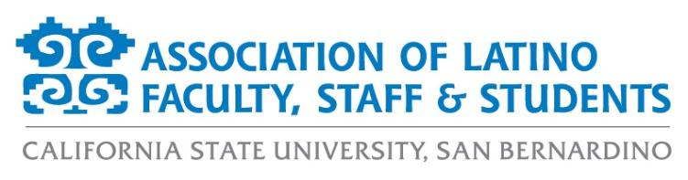
ALFSS General Meeting Agenda
Tuesday, April 6th, 2021
12:00pm – 1:00pm
ZOOM:
https://csusb.zoom.us/j/9710671398

- Approval of the Agenda (2 minutes)
- Approval of the Minutes (2 minutes)
- Old Business (10 minutes)
  - Event Recaps
    - Marchamos Con Mujeres Recap
    - LatinX ZOOMixer
  - ByLaws Revisions Committee
  - 2021 Hispanic Heritage Month Committee Meeting: April 14th at 4:00pm
- New Business (15 minutes)
  - Membership Updates
  - Financial Report
  - President’s Diversity, Equity, and Inclusion (DEI) Board updates
    - April 13th - Conversation with Terisa Siagatonu (Asian Pacific Islander Heritage Month Program)
- Events Calendar (10 minutes)
  - Paint Night Fundraiser (April 13 @ 5pm)
  - LatinX Graduate Recognition Ceremony (May 15 @ 10am)
- Officer Reports (10 minutes)
  - Monica McMahon, President
  - Aurora Vilchis, Vice President
  - Leah Stiff, Executive Secretary
  - Ericka Saucedo, Treasurer
  - Miranda Canseco, Director of Marketing
  - Francisco Alfaro, Director of Programs
  - Jonathan Gonzalez-Montelongo, Director of Membership
  - Edgar Astorga, Director of Scholarships
  - Evelin Ortiz, Spring 2021 Student Representative
- Discussion Topics (10 minutes)
- Adjournment (1 minute)

