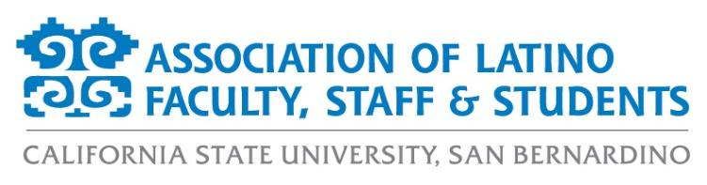
ALFSS General Meeting Agenda
Tuesday, December 1st, 2020
12:00pm – 1:00pm
ZOOM:
https://csusb.zoom.us/j/9710671398

- Approval of the Agenda (2 minutes)
- Approval of the Minutes (2 minutes)
- Guest Speaker: Dr. Daria Graham (5 minutes)
- Old Business (2 minutes)
  - Fall 2020 Event Recaps
- New Business (15 minutes)
  - Membership Updates
  - Financial Report
  - Crowdfunding Report
  - President’s Diversity, Equity, and Inclusion (DEI) Board updates
- Events Calendar (15 minutes)
  - Fall 2020
    - Fall Latinx Graduate Recognition Ceremony | December 5th at 10:00am
    - Random-Act-of-Kindness Exchange
    - December Social | December 15th at 5:00pm
  - Spring 2021 - one event per month
    - February – Happy Hour/Social with lotería
    - March – Women’s History Month Program
    - April – Paint Night Fundraiser
    - May – Latinx Grad Ceremony
    - Continuous – Spring Crowdfunding Campaign
- Officer Reports (9 minutes)
  - Monica McMahon, President
  - Aurora Vilchis, Vice President
  - Leah Stiff, Executive Secretary
  - Ericka Saucedo, Treasurer
  - Miranda Canseco, Director of Marketing
  - Francisco Alfaro, Director of Programs
  - Jonathan Gonzalez-Montelongo, Director of Membership
  - Edgar Astorga, Director of Scholarships
  - Rosemarie Valencia, Student Representative
- Discussion Topics (8 minutes)
- Adjournment (2 minutes)

