A-Team Agenda and Notes November 3, 2020

Participants:
Tanika Gardner, Jesse Juarez, Michael Wong, Amanda Ferguson, Roger Woosley, Jason Wimbley, Ryan Talmadge, Judith Sylva, Natalie Cleary, Jackie Valera, Veronica Guzman, Jessica Madrigal, Ashley Watterson, Jasmine Bustillos, Daria Graham, Pamela Moses, Behrang Toubak
See here for Zoom recording

Agenda
- Check-in updates: Dr. Sylva presents ideas for involving students into the assessment process.
Involving Student Leaders
  - Want to get A-Team thinking and partnering on how to engage our student leaders in discussion of data and closing the loop on what it is telling us.
  - Jasmine recommended engaging the SMSU board, especially as ASI leadership sits on that board
  - Jackie sees OSE as a good partner for this work
  - Daria reminded us of soliciting ASI engagement from other ASI directors beyond President and CEO. Jackie recommended Maria Stone, ASI VP
  - Jasmine recommended that we find opportunities where students are already congregating and engaging, and then take 15 minutes in that venue to have these data dialogues.
Assessment and service internship plan
  - How can we offer meaningful experiences for students that they can get credit for? Look at how to align assessment experience with learning outcomes for student’s programs.
  - Partnering with OCE
  - Jackie: co-curricular transcript
  - Consider a subcommittee on this, team that can get many different stakeholders to the table and come up with actionable steps

- Discussion of Equity and Assessment: Moving towards Culturally Responsive Assessment (Jankowski & Montenegro, 2017).
  - The pdf is also in our Teams files. See also this Socially Just Assessment podcast series, where this paper is discussed in episode 1.
  - Mike led discussion on article:
  - Jasmine’s group: Lots of ways that educators engage students, but the way we assess that learning has largely stayed the same. Perceived fairness and validity. The system for which Higher Education is tailored for, that demographic has changed, and our process has changed with it, although difficult and time consuming. Article starts the foundational knowledge of why we should be thinking about.
  - Mike’s group: Higher Ed as a whole has seen tremendous growth in diversity of students across many aspects. Not one set identity for a person. But when it comes to measuring learning it hasn’t changed much, and that is not good to meet diverse needs. Equality versus equity. Ryan, from I/O background to drive commitment is to drive autonomy. And if there is no choice in assessment they may not be as committed in demonstrating their learning.
  - Ashley: assessment approaches and processes can reinforce a sense of belonging or validate that they don’t belong. Really true for our population, hidden curriculum, terminology, the way we communicate to students can make them feel like they do not belong. To be part of. The application of this to CSUSB campus and our students, everything not equally applicable to our students. The distinct ways that students can demonstrate learning: e.g., student employment survey, how has your experience with SMSU increase your ability to value differences. The way that they perceive those interactions and self-reporting, are you interacting with populations in a way that demonstrates your improved value for them.
  - Ben: experience with international student. Strong factor is cultural issue, combined with religious belief, particularly with certain parts of the world. What here might be fun or positive might for another culture be inappropriate. They may not want to be passive, but they are because of an ideological barrier. One of our responsibilities is to be more engaged with them, gain their trust for them to feel more comfortable so they can be more successful academically.

- Rubrics-Enhanced Evaluation: A practice-grounded, values-infused theory and methodology (E. Jane Davidson, 10/27/20). (recording found here in Teams)
  - It’s one thing to be mindful of culturally responsive assessment. It's quite another to work this into our assessment practice. This recording from a recent presentation at the American Evaluation Association discusses how well-designed rubrics can put equity squarely at the center of culturally responsive evaluation.
  - The beginning of the video is cut off that introduces Dr. Davidson. Jane launched the first interdisciplinary Ph.D. in Evaluation at Western Michigan University, sits on the advisory board of the Faster Forward Foundation, has authored numerous articles, text books & chapters, and is an independent evaluation consultant based in Seattle. See here for her bio.
  - Ashley: Slide that moves evaluation/assessment as done to, for, with, by and as.
  - Jasmine: “Evaluation that presents itself as being “value-neutral” often just thinly disguised Eurocentric assumptions and biases, glossed over with a reassuring-looking “scientific” veneer.” - So powerful.
  - Pamela: put the work in the front end will pay dividends, same adage as in research. Garbage in, garbage out. Being mindful of how this designed
  - (9:55 slide): overlay assessment cycle onto this. What’s common, what’s distinct?
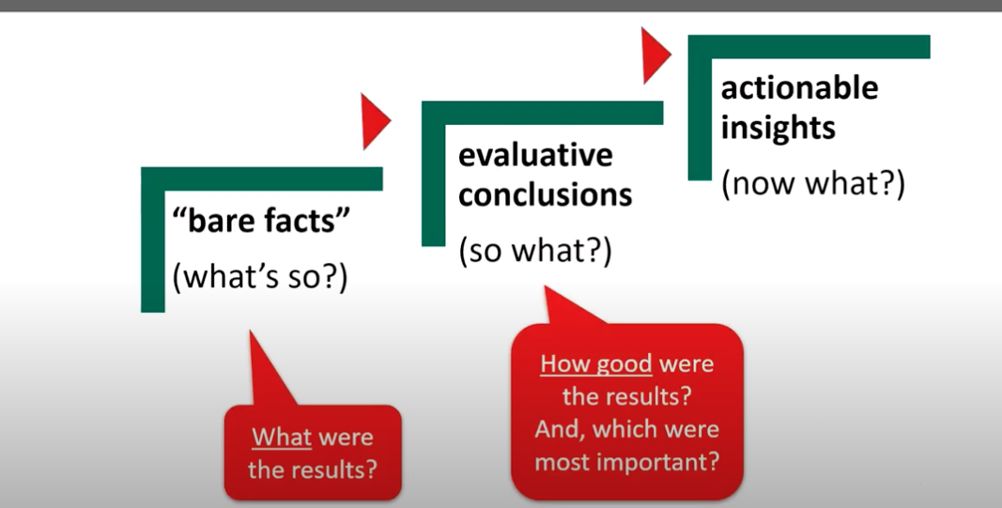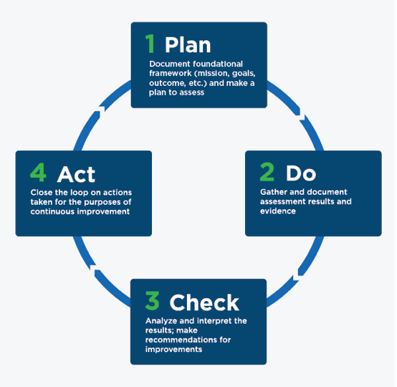
- Do you think we can go from what’s so to now what without the so what?
- Slide @ 11:34: How does this fit (or not) with Montenegro and Jankowski’s paper?

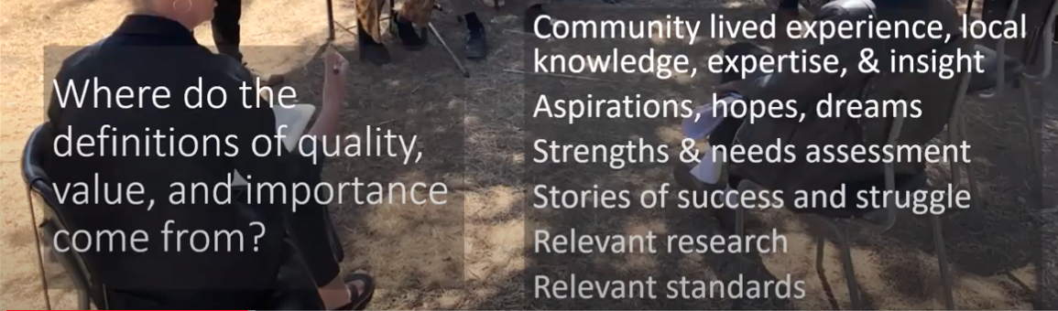
  - Power issue around methods and jargon --> decreases accessibility. Rubrics get very explicit about which values are being applied to the interpretation of evidence, decisions about that evidence counts, and which POV “counts". Explicit examination of the values being applied allows others to look at what you’re doing, makes it more discussable
  - Whose values? Start with the people who have historically experienced the most marginalization—how good is good, what is valued and important for those being assessed.
- Review (or for next time)
  - Ethical standards for website (found in teams here)
  - interjection of values and mission into Impact Areas, funneling from mission, impact, strategic goals and objectives into outcomes.

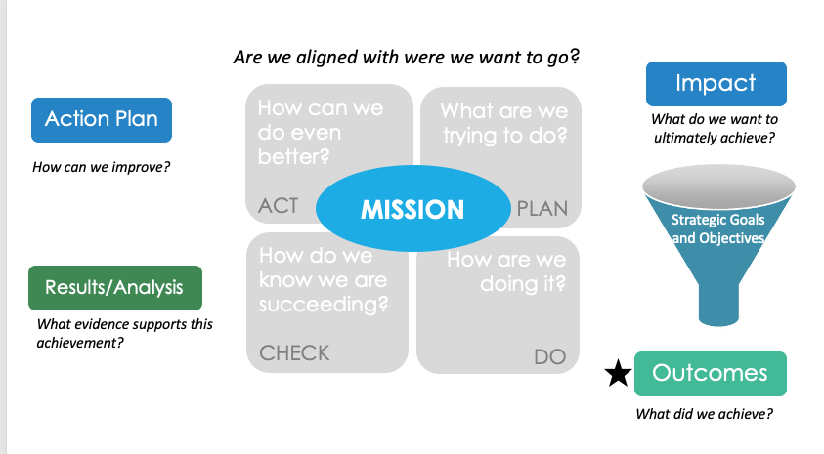

  - revised objectives for SP Goal 2: Assessment

