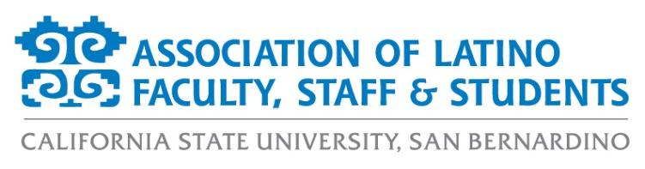
ALFSS General Meeting Agenda
Tuesday, November 3rd, 2020
12:00pm – 1:00pm
ZOOM:
https://csusb.zoom.us/j/9710671398

- Approval of the Agenda (2 minutes)
- Approval of the Minutes (2 minutes)
- Old Business (7 minutes)
  - Hispanic Heritage Month review
    - Thank you notes/gifts for speakers
  - Día de los Muertos review
- New Business (15 minutes)
  - Membership Report
  - Financial Report
  - Crowdfunding Report
  - President’s Diversity, Equity, and Inclusion (DEI) Board updates
  - Scholarship Committee
- Events Calendar (15 minutes)
  - Fall 2020
    - Latinx Grad
    - November and December Socials
  - Spring 2021
    - Spring Convivencia
    - Virtual Paint Night
    - Virtual Loteria
    - Virtual Concert
    - Drive-In and/or Virtual Movie Night
    - Spring Crowdfunding
    - Tentative Food Sale
    - Happy Hours/Socials
- Officer Reports (10 minutes)
  - Monica McMahon, President
  - Aurora Vilchis, Vice President
  - Leah Stiff, Executive Secretary
  - Ericka Saucedo, Treasurer
  - Miranda Canseco, Director of Marketing
  - Francisco Alfaro, Director of Programs
  - Jonathan Gonzalez-Montelongo, Director of Membership
  - Edgar Astorga, Director of Scholarships
  - Rosemarie Valencia, Student Representative
- Discussion Topics (7 minutes)
- Adjournment (2 minutes)

