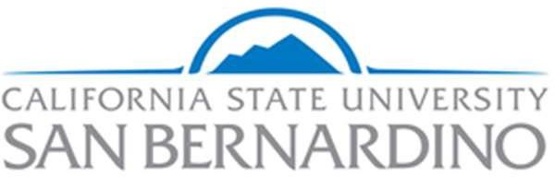

Division of Student Affairs Assessment Committee (A-Team)

February 23, 2021

AGENDA WITH MEETING NOTES

Participants:
Edit List <<Melissa Acuna, Albert Angelo, Jasmine Bustillos, Natalie Cleary, Jackie Gardner, Tanika Gardner, Daria Graham, Veronica Guzman, Jesse Juarez, Jennifer Mersman, Pamela Moses, Avi Rodriguez, Ben Toubak, Conrad Valdez, Ashley Watterson, Shelby White, Jason Wimbley, Mike Wong>>

See Teams for 2021 Zoom Recordings

- Updates and Announcements
  - Volunteers to organize brief ice-breakers for meetings
A-Team Meeting | Volunteer to coordinate kick-off activity
Feb 9 | Conrad Valdez
Feb 23 | Jasmine Bustillos
Mar 9
Mar 23 | Avi Rodriguez
Apr 6 | Jason Wimbley and Jesse Juarez
Apr 20
May 4
May 18
  - Check in with Dr. Graham and Jackie on CCT
  - Check in on campus labs midstream assessment in December

- Culture of Evidence Survey 2.0
  - Link to pilot survey here
  - Do we want to administer again? 1) A-team to track growth from last year, and 2) wider audience this time to directors or everyone in division?

- Events Tagging
  - Process for being designated as a program, service, or event within an impact area/DLO
    - Helps with better data collection in Coyote Connection
    - Helps with better data analysis across DLO’s (see infographic piloted with PDC)
  - Multistep model for being designated under a DLO:
    - Was the purpose of the program/service/event to promote or enhance any components of the DLO?
    - Do the outcomes for the program/service/event align to the DLO?
    - Are you confident you could explain this connection to a student? Your supervisor?

- Campus Labs Student Affairs Assessment Credential
  - Today’s training: Focus Groups: An Underutilized Assessment Tool (55 minutes)

- Action Items

- Discussion items for next meeting
  - Goal 2 Discussion: measurement and reporting on outcomes (draft committee goals were used to inform sp discussions resulting in 3 objectives and corresponding outcomes). Areas of priority: template and training on assessment plans, standard assessment training for division contingent on assessment handbook/glossary as support structure. Threshold levels of competency for this needs to be sketched out before training developed.

- Upcoming Meetings:
- Mar 9, 2021 09:00 AM
- Mar 23, 2021 09:00 AM
- Apr 6, 2021 09:00 AM
- Apr 20, 2021 09:00 AM
- May 4, 2021 09:00 AM
- May 18, 2021 09:00 AM
- Upcoming trainings in Campus Labs Credential
Lesson 5: Assessment Methods and Data Collection
  - Make Rubrics a Best Practice at Your Institution (53 min))
Lesson 6: Analyzing Assessment Results and Research Literacy
  - Analyzing Student Affairs Assessment Results (33 minutes)

Assignment: Create and submit Assessment Project Plan using the "Assessment Project" template, available to download below (email to assessmentcredential@campuslabs.com).

Lesson 7: Communicating and Using Assessment Results
  - Closing the Loop on Student Affairs Assessment: Sharing and Using Assessment Results (37 min)
  - Writing Assessment Reports (video) (42 min)
  - Closing the Assessment Loop: Making Informed Decisions (47 min)

Videos we skipped last year

