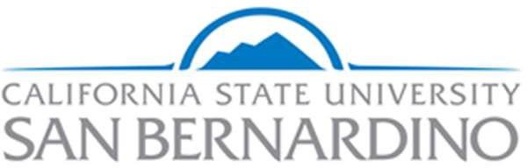

Division of Student Affairs Assessment Committee (A-Team)

January 12, 2021

AGENDA WITH MEETING NOTES

Participants: This meeting was cancelled

See Teams for Zoom Recording

- Updates and Announcements
  - Introduction to the Co-Curricular Transcript by Dr. Graham

  - X

- Review DLOs

- Review DLO Alignment Matrix

- Campus Labs Student Affairs Assessment Credential
  - Assessing Learning and Program Outcomes in Student Affairs

- Action Items

- Discussion items for next meeting

- Upcoming Meetings:
- Jan 26, 2021 09:00 AM
- Feb 9, 2021 09:00 AM
- Feb 23, 2021 09:00 AM
- Mar 9, 2021 09:00 AM
- Mar 23, 2021 09:00 AM
- Apr 6, 2021 09:00 AM
- Apr 20, 2021 09:00 AM
- May 4, 2021 09:00 AM
- May 18, 2021 09:00 AM

