APPROVING A TRAVEL REQUEST OR EXPENSE REPORT

Reviewing and Approving a Travel Request or Expense Report
To approve a request/report "as is":
- On the home page, in the Required Approvals section of My Tasks, click Travel Request or Expense Reports. The Pending your Approval page lists the awaiting requests and/or reports. Select the request or report you want to open.
- Review the request or report details, and then click Approve.

Sending Back a Travel Request or Expense Report
To return the entire travel request or expense report to the employee for correction:
- On the home page, in the Required Approvals section of My Tasks, click Requests or Expense Reports. The Pending your Approval page lists the awaiting requests and/or reports. Select the request or report you want to open.
- Click Send Back to Employee. The Send Back Request or Report window appears.
- Enter a Comment for the employee, explaining why you are returning the request or report.
- Click OK.

Please go to next pages for more specific information regarding the review and approval of a travel request and expense report and items that should be reviewed before approving or returning a request or report.

In general, all travel approvers should be scrutinizing travel requests and reports for the appropriate business purpose, destination, and ensuring the estimated travel costs are reasonable. It is communicated to travelers and approvers that a request is an estimate of expenses, and Concur will not stop a user from entering a different amount in their expense report. However, if the amount exceeds what was included in the request or seems unreasonable, the approver can choose not to approve the expense report and return it to the user to update.

With that being said, below are a few items that should be of particular importance before the first approver (aka Travel Approver) approves a request or a report and moves it forward to other approvers that may be in the workflow.
Travel Request – key items to review (see screen shot below for corresponding numbered items):

- Destination field –
  - travel to certain states is prohibited
- Segments and Expenses tabs –
  - review estimated amounts for reasonableness
  - ensure domestic hotel or domestic meal type is used for domestic stays and international lodging and meal allowance is used only for international trips.
- Personal Travel field–
  - travelers are requested to attach comparison flights when adding personal time (this is not happening)
- Approval Workflow tab–
  - If the approvers listed in the approval workflow are incorrect or any field is blank (other than the last field for AP use), the travel approver should return the request so the traveler can update and resubmit.

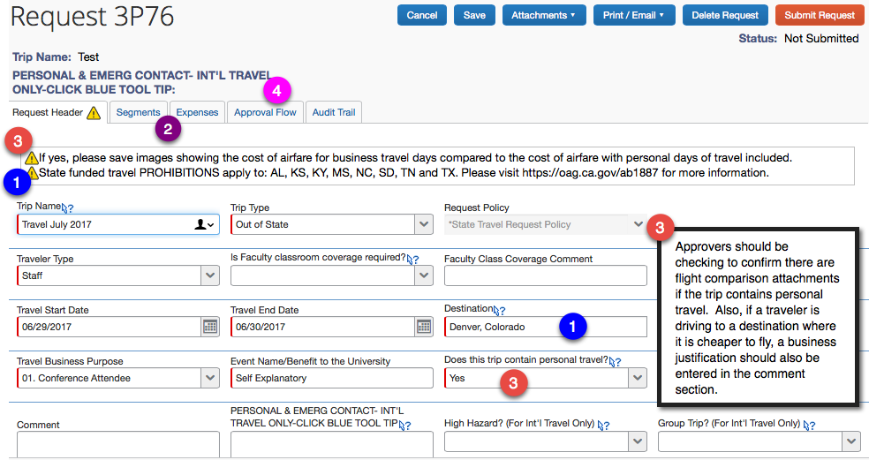
Expense Report – key items to review:

- Review receipts for expenses that are $25 or more:
  - Receipts need to be associated with the specific trip and itemized
- Confirm travel dates align with conference and/or meeting dates
- Ensure meals being reimbursed are reasonable for the travel start and end times/date. (While there are no prescribed meals times (B, L. or D) per the policy, the report does require travel start and end times be entered.)
- Review cost of travel report versus approved travel request amount to ensure that the final travel amount is reasonable if it exceeds the requested amount.

Returned Reports –

Most common reasons that Accounts Payable returns an expense report to the user.
- Receipts – typical issues:
  - Incorrect receipt attached
  - Is not itemized
  - Shows a balance due
  - Does not indicate method of payment
- For a conference registration expense, the conference details are not attached. This is required so AP can match up the dates, location etc. included on the report
- Incorrect payment type selected – airfare and/or conference registration can be prepaid by the university and users need to update the payment type to university paid.

July 1, 2017 – AP/Travel

