| California State University San Bernardino Information Technology Services Logo  CSUSB Logo 1  CSUSB Logo 2 | Absence Management  Timekeeper Training Guide |
| --- | --- |

Last Revised: 04/2019

Final

REVISION CONTROL

**Document Title:** ABSENCE MANAGEMENT Timekeeper Training Guide

**Author:** CMS/Payroll

**File Reference:** /ITS Training Services Team/Absence Management Documents/AMSS_PhaseII_Guides/AM_PhaseII_Training Guides/TIMEKeeper_04_2019_ADA.docx

Revision History

| Revision Date | Revised By | Summary of Revisions | Section(s) Revised |
| --- | --- | --- | --- |
| 02/12/15 | ACBI/DS | Update | 4,6, |
| 02/16/15 | ACBI/DS | Update included Model 1 & 2 image | 6 |
| 02/17/15 | ACBI/DS | Update TK Balance Inquiry Payroll Status options | 33 |
| 02/21/15 | ACBI/DS | Update | 6 |
| 06/18/15 | ACBI/DS | Update | 11, 16 |
| 08/31/15 | ACBI/DS | Update | ALL |
| 9/17/15 | ACBI/DV | Update | ALL |
| 06/15/16 | ITS/DS | Correct Note regarding Partial Days | 18 |
| 11/1/16 | ITS/DS | Update Reporting Flow | 4 |
| 03/15/17 | ITS/DS | Update links for Payroll pages | 39 |
| 06/06/17 | ITS/SF (SA) | Schedules | 3, 12-14, 40 |
| 04/20/18  5/11/18  05/21/18 | Payroll (AH-H) | All | All |
| 08/21/18 | Payroll/ITS Training | All | 4-6, 22, 37 |
| 04/19/19 | ITS Training/DS | All | 5, 6, 35, 37, 39 |

*Material in this guide is subject to change due to system updates and/or Management decisions.*

Table of Contents Page

Business Process Workflow Diagram 5

**Timekeeper IMPORTANT REMINDERS** 5

Calendar 7

Timekeeper Role 7

Timekeeper Role - Absence Entry 8

Dates and Deadlines 9

Alternate Work Schedules 10

1.0 Reporting Absences on behalf of the Employee 11

1.1.1 Reporting for No Leave Taken 12

Reporting an Absence 14

1.2 Absence Takes Delivered Rules Chart 17

1.3 Absence Management Additional Tools 18

1.3.1 Delete an Unapproved Absence 19

2.0 Absence Review 20

3.0 Audit/Approval – Absence Management Reports 22

3.1.1 Audit/Approval Reports 22

4.0 View Absence Balances for Employees 27

**Appendix** 31

**5 Steps to Approval** 31

**Timekeeper Quick Reference Steps** 33

**Forms** 34

**Absence Status Definitions** 34

Business Process Workflow Diagram

The ***Absence Management Business Process Guide*** covers the overall Absence Management business process, including the entry, review, validation, and audit of the Absence Management core and self-service business processes. The Absence Management Process is a tool to manage leaves and accruals. 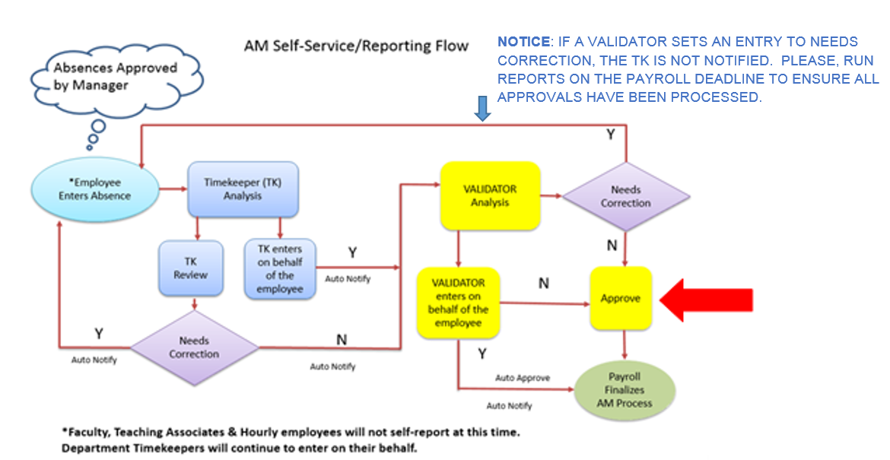

Figure 1 Absence Management Report Flow

The following diagram outlines the overall Absence Management business process for each of the Absence Management roles; Employee, Timekeeper, Validator and Payroll.

**Timekeeper IMPORTANT REMINDERS**

* Exceptions to the use of Absence Management

Do not use Absence Management in the following circumstances:

Catastrophic Leave Donations, Hourly Employees’ Worked Hours (report Holidays [Holiday hours to be paid must be reported] and Leaves as Absence Takes), Paid Overtime and Shift Differentials.

* Absence Validation must occur PRIOR to an employee’s separation from the current department (example: Separation, Leaves, and Promotions etc.). The Validator MUST ensure they approve time for employees who terminate or change departments before the employee separates from the university or department. Once the change occurs the employee is not available to the current Validator.
* Faculty Summer Session - Summer Session does not require Absence Entry (updated email 08/12/14)
* Reports To (Validator Access Only)

PeopleSoft uses ‘Reports to’ is the basis for workflow and electronic approvals. These relationships are so critical to the operation of workflow in PeopleSoft that we must all take special care to ensure these fields are up to date, and accurately reflect the actual reporting relationships between positions. Cont. on following page.

If ‘Reports to’ fields are blank or out of date, the process of approving employee’s time, absences may be impacted. The data must reflect the correct relationship(s) in order for a Validator to appropriately Approve/Validate Absences.

The “Reports To Position” defines the Reports To relationship located on “Job Information” page in Job Data. The populated field identifies the Reports To structure. Displayed is the Reports To position number, the title, the employee id and the Reports To Name. On-going maintenance by your area representative is required to perform Absence Management tasks.

***The 634’s should be retained by the timekeepers/departments in the event of an audit or a question concerning reported time.***

*Review the guidelines to be used to implement Absence Management (AM) are outlined in the AM tech letter.  Reference:* [*2011-01*](http://www.calstate.edu/HrAdm/pdf2011/TL-LVS2011-01.pdf)*.  See “Section 9.0: Forms/Supporting Documentation”.*

[***634’s should be retained four (4) years per the retention schedule published by the Chancellor’s Office.***](http://www.calstate.edu/recordsretention/documents/Personnel_Payroll.pdf)

***Exceptions to the use of Absence Management***

*Don't use Absence Management in the following circumstances:*

*Catastrophic Leave Donations, Hourly employees’ Worked hours (report Holidays [Holiday hours to be paid must be reported] and Leaves as absence takes), Paid Overtime and Shift Differentials.*

*If the employee is self-reporting but the supervisor is not the person approving/validating in the system, then, the 634 or another form of documentation with the immediate supervisor’s or manager’s signature is recommended.*

Calendar

All known Absences must be reported in advance or when the time is taken by the end of the pay period, per Payroll guidelines in collaboration with the respective departments’ policies and procedures.

Late submission of Absences for prior payroll cycles may be entered for Absences that took place 90 days prior to the current date. Changes to Absences previously reported or Absences more than 90 calendar days must be reported to Payroll for processing using the AM 634 form.

Please visit the Payroll website to view the current Absence Management deadlines.

Timekeeper Role

The PeopleSoft Human Capital Management (HCM) system provides the ability to report and track Absences online. This guide provides instructions for timekeepers, who will perform Absence Management activities. As a Timekeeper, depending on departmental access, you can:

1. Report, Review, Correct*, and Delete Absences for employees
2. View balances for employees
3. Review and send Absences back for correction for employees
4. Ensure Approvals are complete by Validator by Payroll deadlines.
5. Run Audit absence reports

Each units’ internal business process for recording Absences may vary (time cards/634’s etc.) by the unit/department.

*\*Corrections can be made within the Open Month Calendar Period based on specific statuses and security role.*

Timekeepers, Validators and Employees are expected to communicate regarding Absences as they relate to reporting in the system. Employees will be notified by the timekeeper (email notifications) when Absences require corrections. Once the employee submits the correction to the Timekeeper the Absences will be entered/reviewed by the Timekeeper and/or the Validator. It is highly recommended that the Timekeeper make comments in the comments field as needed.

Corrections to reported Absences for an employee in the system, will generate an email notification to the employee. The Absence Management email notification uses the employees’ user Profile Email Address maintained by Security.

Possible circumstances for email notification may include:

• Absences reported on behalf of an employee by Timekeeper or Validator

• Corrections to an employees’ reported absence entries

• Deletion of an employees’ absence entry

***Important – Email updates***

If an Employee requires to have the Absence Management user profile email updated in the System contact the ITS Support Center at [support@csusb.edu](mailto:support@csusb.edu) or 77677. The user profile email is maintained by the ISO.

The Validator MUST ensure they approve time for employees who terminate or change departments before the employee is terminated and/or before the employee moves to another department. Once the change occurs the employee is not available to the Validator.

Time Keeper Absence Entry steps are required first. When this step is skipped the Timekeeper cannot see time entered for Review process.

Timekeeper Role - Absence Entry

Timekeepers view the employees based on the employees department. Validators view the employees based on the “Direct Reports To Position*” assigned. The Division/College designee should maintain accurate Reports To maintenance in order to perform accurate Absence Management validation.

The Timekeeper Absence Entry Page is available for Timekeepers to enter Absences on an employees’ behalf. Time is reported based on Timesheets received in the Department by the Employee. Timekeeper entries are automatically updated to an Absence Status of “Reviewed” upon submission.

Timekeepers may delete Absence entries which are in a status of “Reviewed”.

Timekeepers may navigate through their employee list by using the “Next Employee in List”, “Previous Employee in List”, and “Return to Employee List” links and use the Find feature to view a specific employee absence data.

Timekeeper may enter absence at any time during the open period up to 30 days in the future.

An email notification is sent to the employee to confirm Absence was entered and with any associated comments which were entered by the Timekeeper.

* **Entry Comments link** – Displays the comments entered when the absence was first submitted (by employee) – Employee comments can be viewed only and cannot be changed by the timekeeper
* **Edit Comment** **link**– Allows the timekeeper to enter a ‘**new’ comment** (Add Comments link) for the employees’ absence or **edit an existing comment** (Edit Comment link).
* Comments entered will display in the following pages: Approve Reported Absences, Approve Reported Time & Absences, Absence Event, Manage Prior Period Entries and several Absence Management CSU Reports.

Email notification: Absences entered on behalf of employees will generate an automatic notification to the employee.

***Important – Email updates***

If an Employee requires to have the Absence Management user profile email updated in the System contact the IT Support Center at [support@csusb.edu](mailto:support@csusb.edu) or 77677. The user profile email is maintained by the ISO.

The Validator MUST ensure they approve time for employees who terminate or change departments before the employee is terminated and/or before the employee moves to another department. Once the change occurs the employee is not available to the Validator.

Time Keeper Absence Entry steps are required first. When this step is skipped the Timekeeper cannot see time entered for Review process.

Refer to Timekeeper IMPORTANT NOTICE as needed on page 5.

Dates and Deadlines

All known Absences must be reported in advance or when the time is taken.

The deadline for entering and correcting absence transactions are as follows:

| **Absence Management Leave Deadline Calendar**  *Departments may be required to resolve exceptions in collaboration with Payroll as needed.* | **Monthly Time Entry Deadline** – **Timekeepers enter and reviews absences** for their departments(s) by 5 PM.  **Monthly Approval Deadline – Validators review and** validate transactions for their department(s) by 5 PM.  **Monthly Posting of Leave Accruals –** Accruals are posted and available for review after Payroll has closed the calendar. |
| --- | --- |

Prior Period Absences can be entered up to 90 calendar days prior to the current date. If there is a change after the 90 calendar days, then a AM 634 form is submitted to Payroll for processing.

Validators MUST ensure Validation occurs prior to an employees’ termination and/or before the employee moves to another area.

Alternate Work Schedules

**Absence Management requires the use of employee schedules for both exempt and non-exempt employees. Work schedules track for proper absence takes, holidays and excess plus/minus hours (for non-exempt employees). Managers and Timekeepers have access to review schedules.**

**Default Schedules**

**Default schedules are associated with each employee through the employee’s Absence Management pay group. The CSU default schedule is Monday – Friday 8 hours per day.**

**Alternate Work Schedules**

**Employee work schedules that deviate from the normal 8:00am to 5:00pm., Monday through Friday schedule must be approved in advance by the designated MPP for the organizational unit and be on file in Payroll Services prior to the effective date of the alternate work schedule.**

[**Notice of Work Schedule Change Form**](https://www.csusb.edu/sites/csusb/files/Notice%20of%20Work%20Sch.%20Change%202016.pdf)

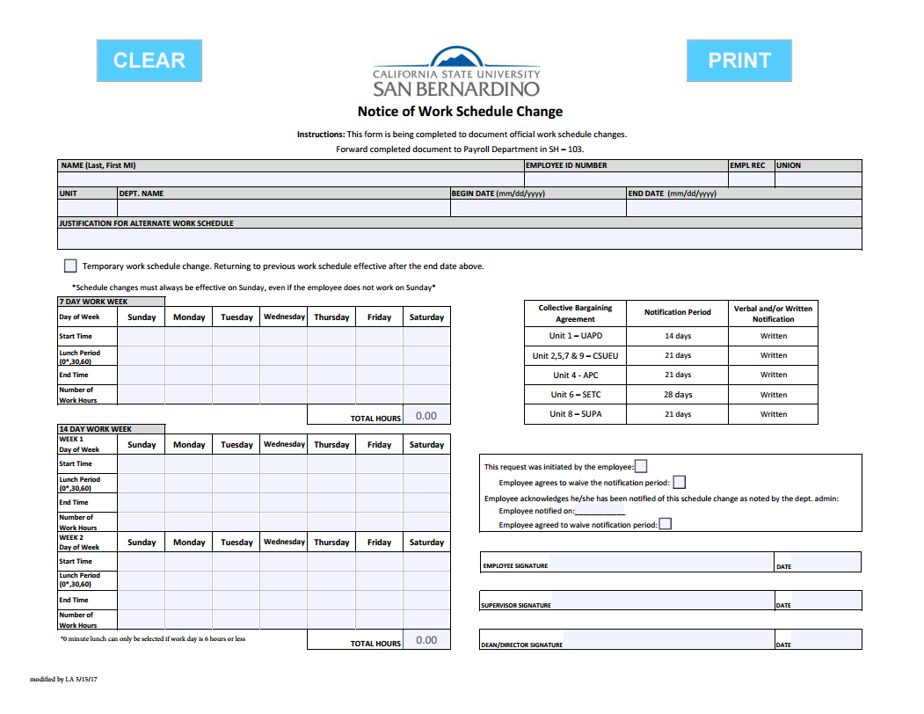

# Reporting Absences on behalf of the Employee

**From the Main Menu Navigate to: Manager Self Service > Time Management > Report Time > Timekeeper Absence Entry**

The list of employees* may be sorted by clicking on a column name for any of the displayed columns.

***Tips***

* To locate a specific employee use the Find option on the Navigation menu to search by last name or ID.
* Sort the grid by clicking any hyperlinked column title.
* Selecting the Continue button will automatically sort by last name alpha.

Select the box in the ‘Select Column’ for the employee or use the Select All button at the bottom of the page.

exclamation point Selecting All Employees brings all employee absence data available for view. The data is viewed one employee at a time on the Report and View Employee Absences page.

exclamation point **If multiple records display for an employee, ensure that the correct record number is selected.**

Scroll down to bottom of the page and

Select the **Continue button**.

The system processing icon 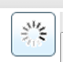 appears in the top right corner of the page.

The “Report and View Employee Absences” Page is displayed. 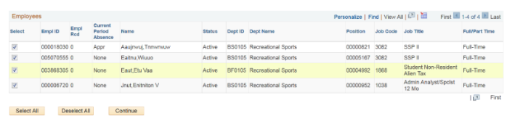

**“Current Period Absence**” column indicates the status of entries for each employee:

a. **Appr** – All reported Absences for this employee have been approved

b. **Sub** – Absences have been submitted that still require approval

c. **None** – No Absences have been reported for this individual this period

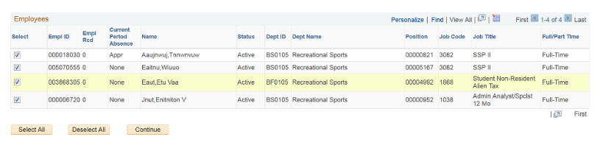

*Employees viewed are available based on the Direct Reports To and Effective Date setting in Absence Management.

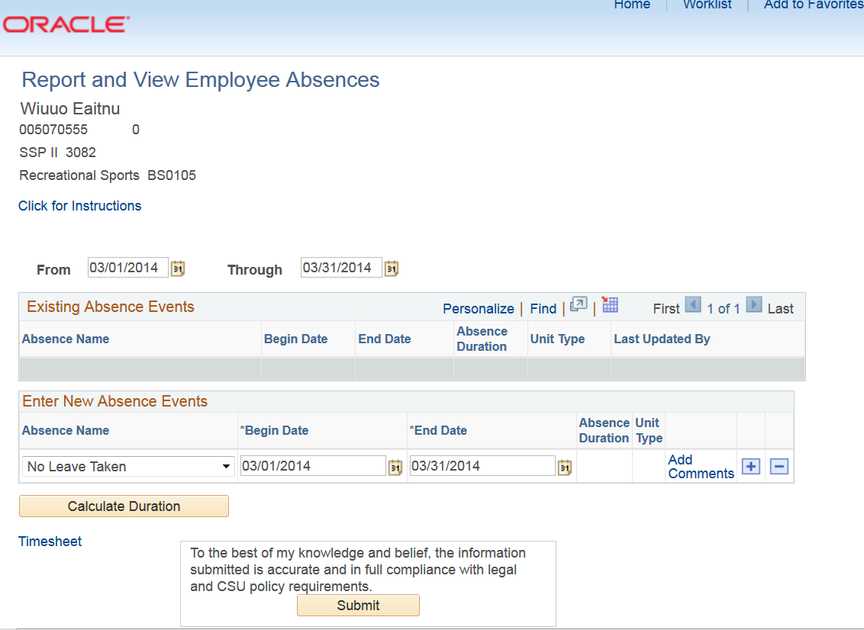

## Reporting for No Leave Taken

On the Timekeeper Absence Entry page, select the employees that require an absence reported. Employees who have not self-reported and are in the following categories require the Timekeeper to report on their behalf:

* Casual Workers
* Reported Comp Time earnings
* Retired Annuitant
* 2360 FERPs

exclamation point **If multiple records display for an employee, ensure that the correct record number is selected.**

The Report and View Employee Absences screen appears.

Current Open period defaults on the page and in the bottom grid, the Absence Name “No Leave Taken” defaults to the current pay period Begin Date and End Date.

No leave taken is required when no time is taken (includes Faculty (F/T & P/T, Graduate Assistants).

NOTE: When completing an Absence Entry for an earning of Compensatory Time-Off (CTO) or Holiday Additional Day Off (ADO), the system requires an entry of ‘No Leave Taken’ or a take such as Vacation, Sick, etc. for the current period.

If applicable: Change the **From** and **Through** dates to show Absences from other pay periods.

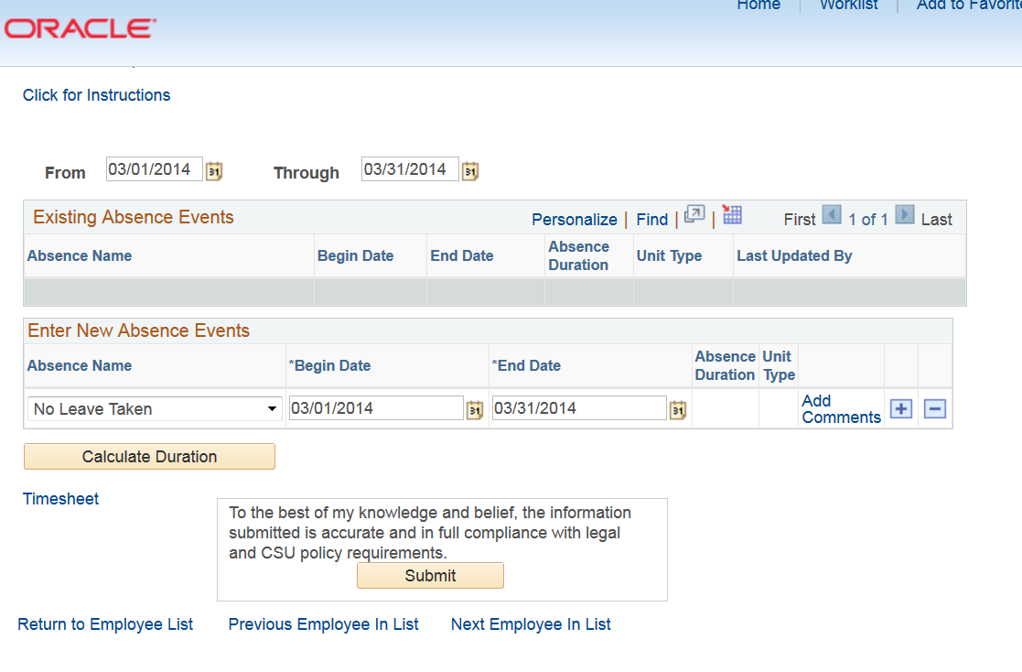

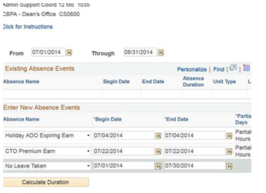  


  
  
If no changes are required **select the Submit button.** No further action is necessary.  
  
Select OK in the Submit Confirmation screen  
  
The System will return to last submission.

Use the Hyperlinks at the bottom of the page to navigate to next employee, previous employee etc.

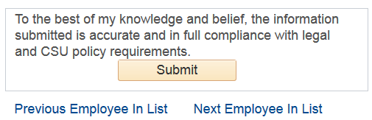  
Selecting OK

.

All schedules that are not on the drop-down menu, must be entered by Payroll.

Complete the Notice of Work Schedule Change form (Appendix) and submit to Payroll[. Visit the Payroll website for the request form.](http://payroll.csusb.edu/)

Refer to Timekeeper IMPORTANT NOTES as needed on page 5.

### Reporting an Absence

Contact your Payroll Technician for Leave deficits and any other leave questions not addressed in this guide.

On the Timekeeper Absence Entry screen, select the box under the Select column for the Employee for whom you want to report an absence. An Employee can only report Absences/time for which they are entitled to.

exclamation point If an employee holds more than one position, you will be prompted to select which job you want to enter Absences for.

The Report and View Employee Absences screen appears.

exclamation point Carefully read all types of leaves prior to making your selection. This will ensure proper leave has been selected.

Refer to Absence Takes delivered rules chart (also refer to current Bargaining Unit Agreements for the proper Leave eligibility. If interpretation is required contact Academic Personnel or Human Resources).

To record an absence, Click on the dropdown Dropdown arrow icon under Absence Name to see the list of Absences valid for the employee.

Select the appropriate absence name.

exclamation pointOnly the “Absence Name” that the employee is eligible for will appear for selection.

After selecting the absence, additional fields are displayed as applicable. For example, the selection of “Vacation” displays the vacation balance and the “Partial Days” field

Enter the Begin and End dates for the absence event and Tab out of the field. System updates end date for one day only. If more than one day reported enter the correct end date.

Confirm that the Balance covers the absence you are recording.

Use the default Partial Days ‘None’ only if a standard shift is applicable (M-F 8 hours).

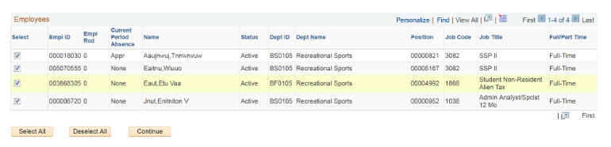

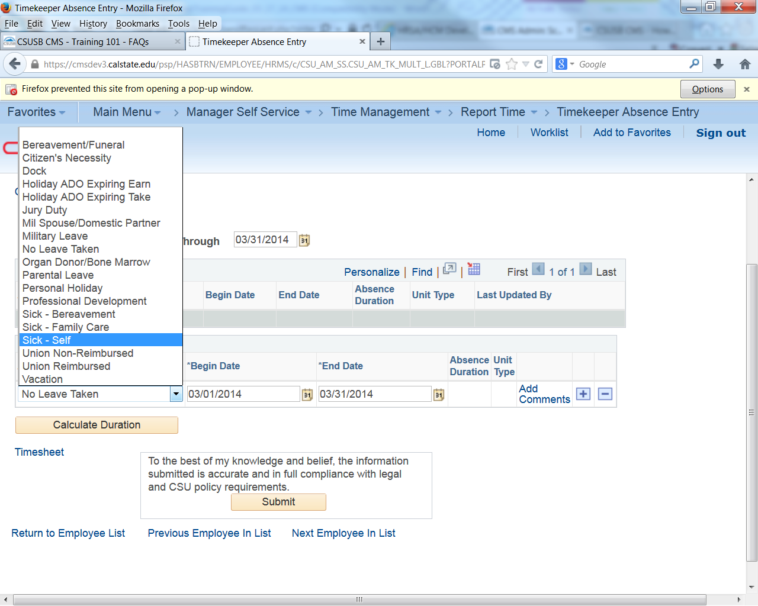

* Verify work schedules prior to posting the leave usage.
* When completing an Absence Entry for **an earning of Compensatory Time Off (CTO) or Holiday Additional Day Off (ADO),** the system requires an entry of ‘No Leave Taken’ **or** a take such as Vacation, Sick, etc. for the current period. [Refer to Payroll FAQ’s](http://payroll.csusb.edu/payrollProcessing/AMS.html)



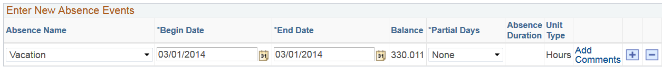

**NOTE:**

**If full day is taken leave Partial Days field to NONE.**

Select Partial Hours from the Partial Days dropdown menu for other than an 8-hour day.

Select Partial Hours and enter the number of hours taken **if less** than the employees’ scheduled workday.

Enter the Hours per Day (if using Partial Hours).

Select the Calculate Duration button.

Select Add Comments (if applicable). i.e. Family Sick/Funeral Leave etc. The system will prompt the Timekeeper when Comments are required.

Use the plus Additional icon icon to add rows for additional Absences.

Select the Calculate Duration button.

Enter the information as prompted.

Add the information at the end of the prompted text or use the enter button on the keyboard to insert a return.

“Please enter relationship of family member, i.e. Child”

exclamation point **Be brief.**

Select the ‘Save Comments’ button.

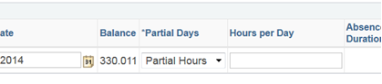

Entering the Hours per Day 

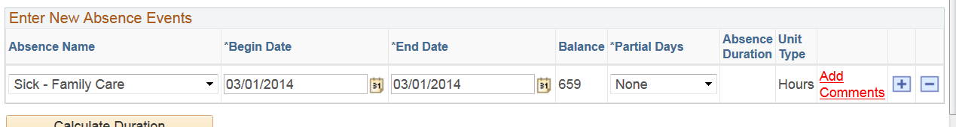

exclamation point Comments are only required if the Add Comments link is red. The comments link reads Edit Comments once comments are entered.

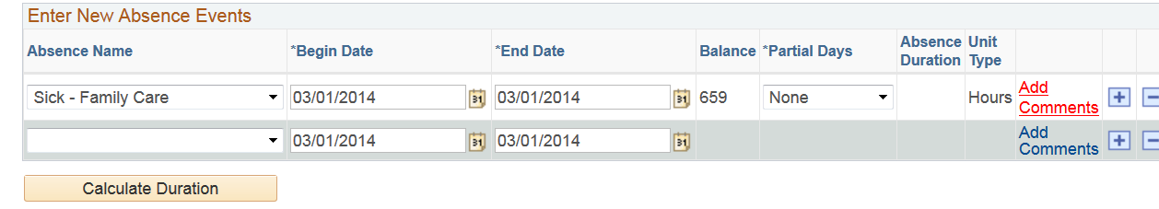

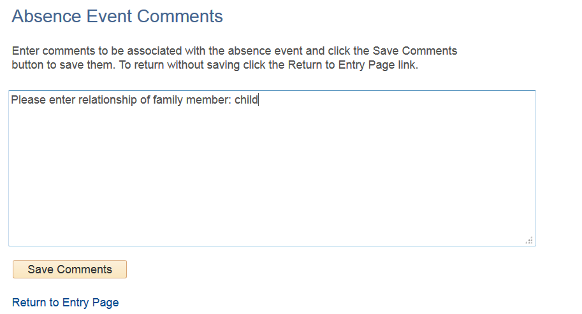

**If no changes are required select the Submit button. No further action is necessary.**

Use the Hyperlinks at the bottom of the page to navigate to next employee, previous employee etc.   
  
Select OK in the Submit Confirmation screen  
  
The System will return to last submission.



Select OK 

Refer to Absence Takes Delivered Rules Chart below for additional information.

## Absence Takes Delivered Rules Chart

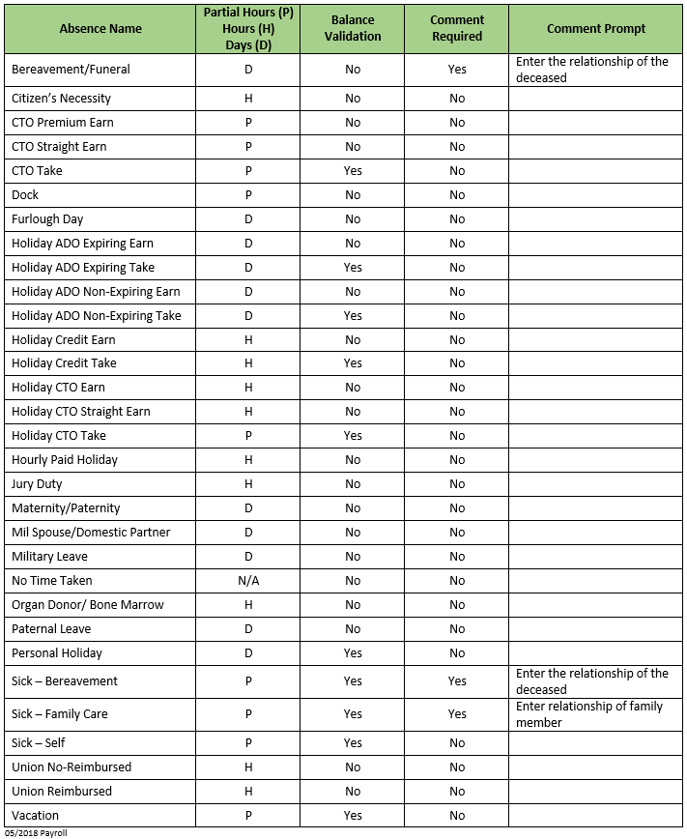

## Absence Management Additional Tools

The following sections provide additional tools for viewing Absence Management transactions within Timekeeper Absence Entry page.

Using **Breadcrumbs** navigate: **Manager Self Service > Time Management > Report Time > Timekeeper Absence Entry**

After selecting the list of employees,

Select the Continue button.

The Report and View Employee Absences screen appears. The current pay period is displayed.

Change the From date and Through dates to view a different set of absence transactions.

The page refreshes displaying absence events for the requested time period indicated.

exclamation pointSort by Column headers

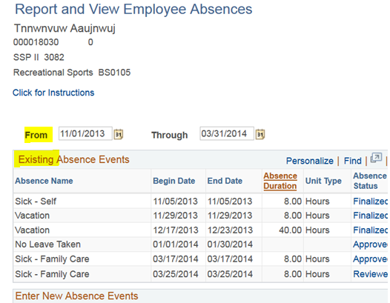

### Delete an Unapproved Absence

Timekeepers can only delete Absences with a Reviewed status within the open Leave calendar dates for the period. An Approved status within the open Leave calendar dates for the period can be deleted by the Validator. Processed/Finalized **Absences can only be deleted by Payroll.**

On the Timekeeper Absence Entry screen, select the box of the employee you want to edit. Select the Continue Button.

The Report and View Employee Absences screen appears.

Select the Trash icon icon in the far right column to delete an absence.

Choose **Yes**, if appropriate, to continue deleting this absence event.

Confirm that the absence is no longer listed in the Existing Absence Events section indicates that they deletion was successful.

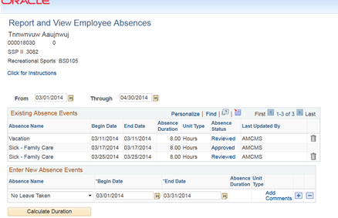  
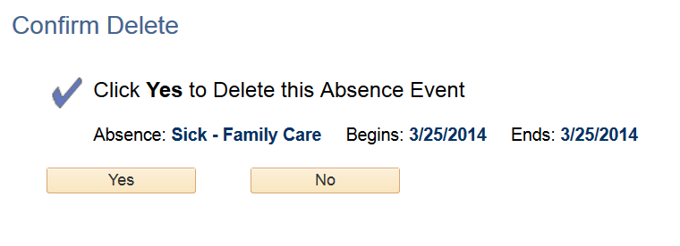  
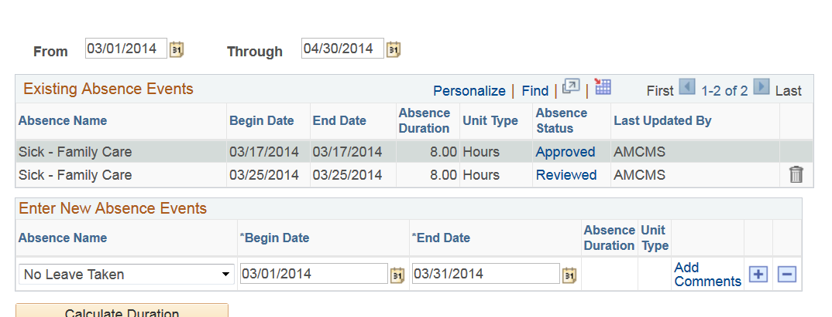

# Absence Review

Timekeepers are required to set absences to Reviewed within the Absence Management calendar deadlines. This ensures a timely transition for Validator process.

**Ensure all absences for the current period have been reported.**

Reported Absences status must be set to ‘Reviewed’ for Validator Approval.

A ‘Needs Correction’ status requires the employee to review and correct the entry. Communication is required between Employee, Timekeeper and Validator (if needed).

Navigate from the Main Menu>Manager Self Service>Time Management>Approve Time and Exceptions>Timekeeper Absence Review.

**“Current Period Absence**” column indicates the status of entries for each employee:

**Appr** – All reported Absences for this employee have been approved.

**Sub** – Absences have been submitted that still require approval.

**None** – No Absences have been reported for this individual this period.

Definition Descriptions: Appendix 9.3

To select individual review, select the Check box in the Select column for the row of the desired employee(s) or use the Select All button at the bottom left of the screen.

1. To select ALL Employees, select the Select all box button.
2. Select the Continue box button.

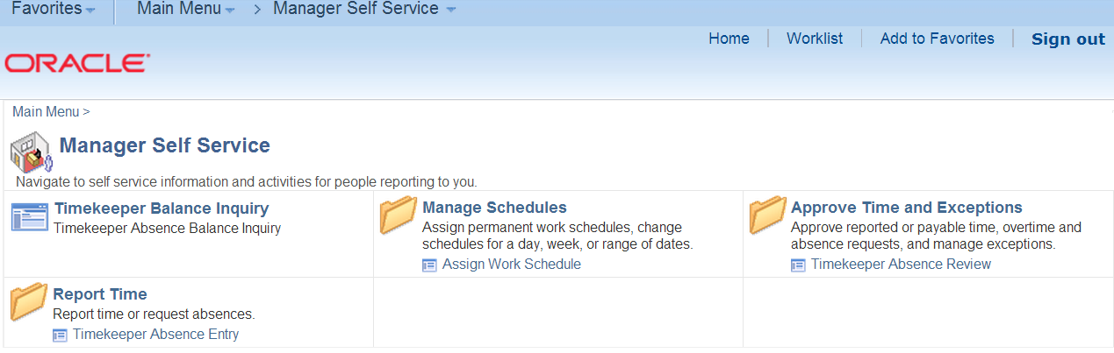



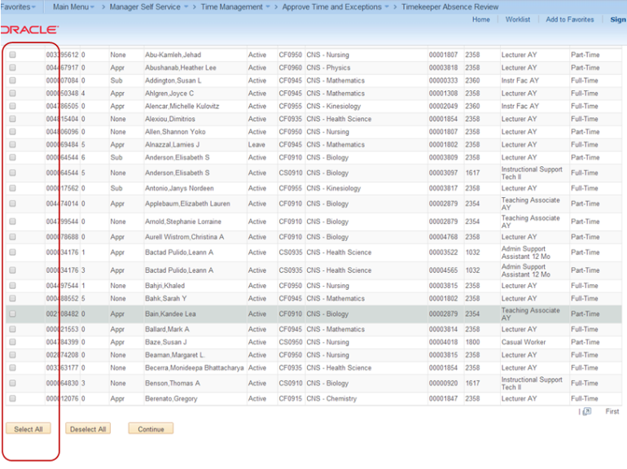

Review each absence entry and verify its accuracy. If the absence is **correct**, **select Reviewed** from the Review Status drop down list.

If the absence is **NOT correct**, select **Needs Corr** from the Review Status drop down list.

*The ‘****Needs Corr’*** *status* ***initiates an email notification to the employee.*** *It is highly recommended to use the Add Comment link to enter a comment by selecting the link. In the comments, provide a clear explanation or reason for the correction to assist the employee in correcting the entry.*

1. If the absence is **correct**, **select Reviewed** from the Review Status drop down list.
2. If the absence is **NOT correct**, select **Needs Corr** from the Review Status drop down list.
3. When satisfied, select the Submit box button to save the Review Status updates.

Selecting the ‘Return to Employee List’ link prior to submitting will not save “statuses’ reported by Timekeeper. Use this link to cancel or use it after selecting the ‘Submit’ button.

1. Select the Okay box  button on the Approval Confirmation page.

The system returns to the Existing Absence Events page.

*.*

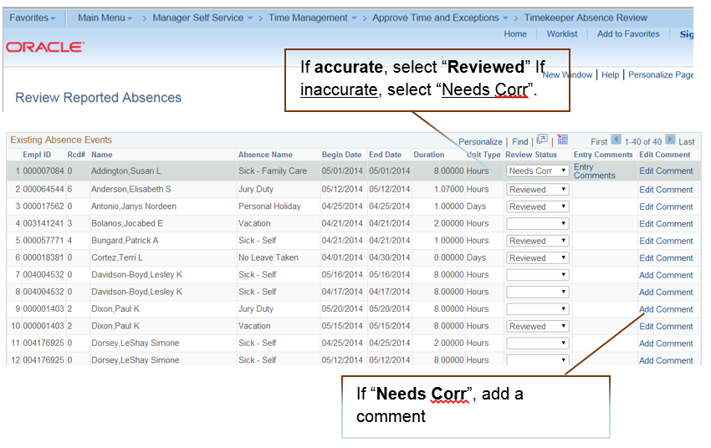

*A “Blank” status indicates that the employee has reported and is awaiting ‘Reviewed’ status*

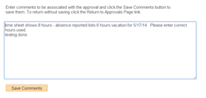

Validators MUST ensure Validation occurs prior to an employees’ termination and/or before the employee moves to another area.

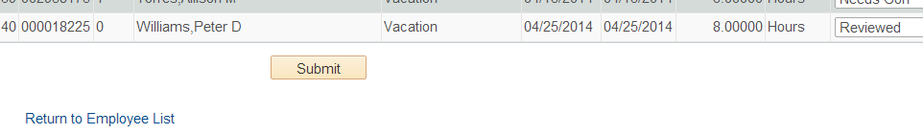

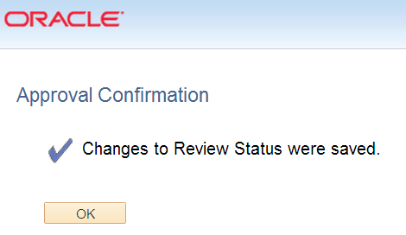

*Refer to Timekeeper IMPORTANT NOTES as needed on page 5.*

# Audit/Approval – Absence Management Reports

Based on granted Security, the Timekeeper has access to Absence Management reports.

**It is CRUCIAL** that Absence Management activity is reviewed by the Timekeeper as part of their monthly process. Timekeeper reports provide a summary of the information entered into the system.

## Audit/Approval Reports

No Leave Taken– Report is run by department Validator/Timekeeper.

Reported Absences – Report is run by department Validator/Timekeeper for a specified period. This report provides a summary of reported Absences by employee.

**Reported Absences Not Approved** - Report is run by department Validator/Timekeeper.

Reports can be run and downloaded to Excel for more detailed analysis.

*Refer to Timekeeper IMPORTANT NOTES as needed on page 5.*

All approvals must be completed by the campus deadlines. Visit the campus Payroll website to view [Absence Management deadline calendars.](http://payroll.csusb.edu/payrollProcessing/payrollDeadlineCalendars.html)

**Navigation: Global Payroll & Absence Mgmt > CSU Absence Management > CSU – AM Inquiry > Multi Report**

Select the Add a new Value tab to create a Run Control ID (Once the Run Control ID is created, for future use the Find an Existing Value tab. Refer to “Find an Existing Value” page 28).

Name the Run Control then

Select the Add button.

Set up the Run Control criteria.

Enter the search criteria. It is recommended to run these reports by Department and Period. The reports can be run using any of the fields available.

Select **Refresh Employee List** button if needed.

**Use CSxxx for Staff or CF for Faculty**

In the Monthly Processing box select the reports to be run by checking the box to the left of the Report Name hyperlink.

**Select Save.** The saved Run Control ID and criteria will be available for future use.

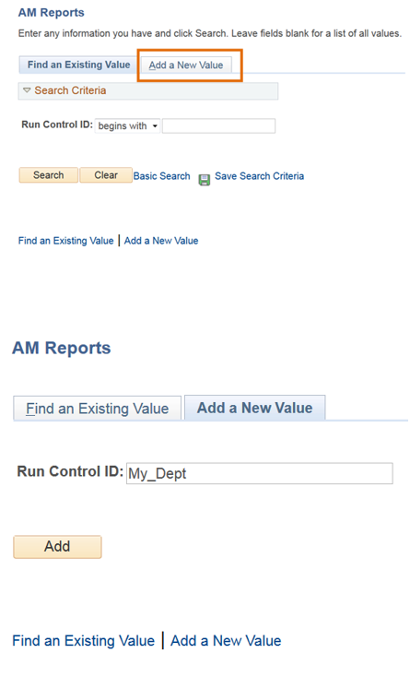

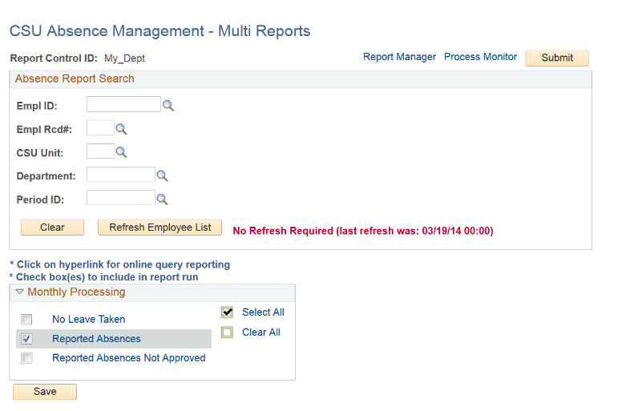

On the **Find an Existing Value page**, Click the “Search” button

To continue go to ‘Submitting the Report’.

The Saved Reports will appear.

Select the Run Control ID

The report Run Control Page is displayed.

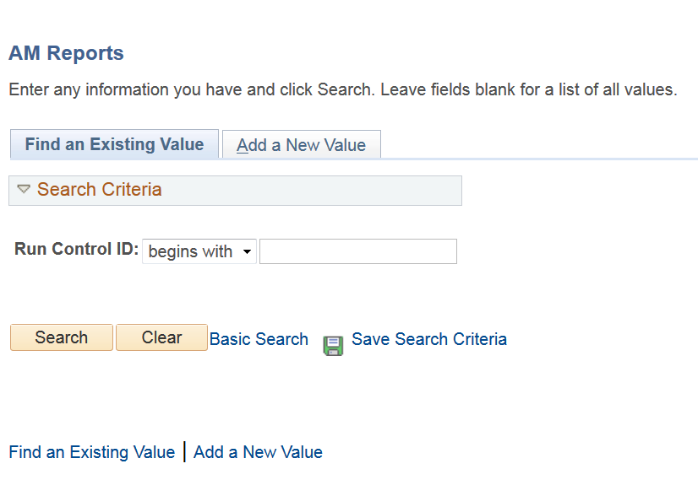 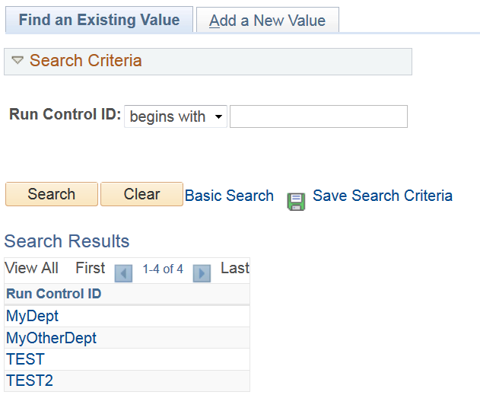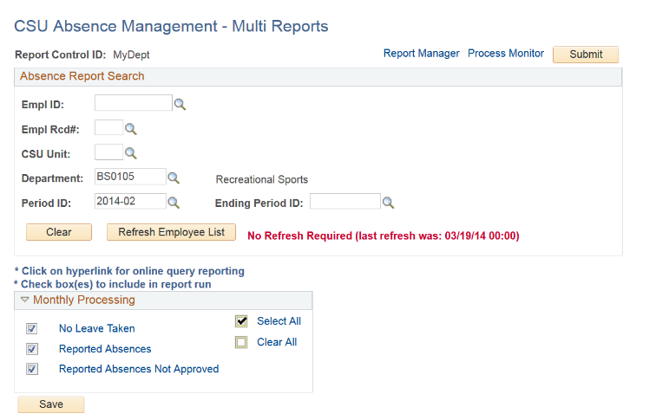

**Submitting the Report:**

The criteria defaults as saved previously. Changes can be made and resaved before running the report.

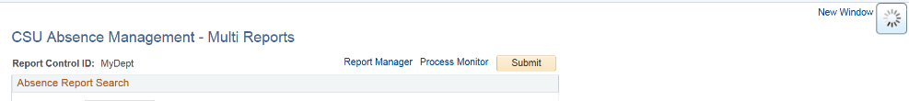Use the existing criteria or enter new search criteria (Save criteria), **and click on the Submit button.**

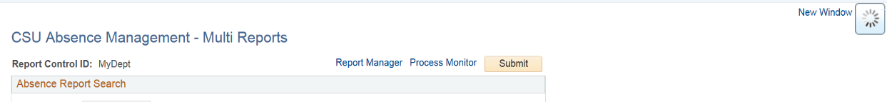

Select the Process Monitor link if not automatically taken to the Process Monitor page to access the report results.

Select the Refresh button to update the report Status.

The Process Monitor page displays

The Run Status will change from Qued to Success and the Distribution Status reflects Posted.

Select the Details link on the far right of the screen.

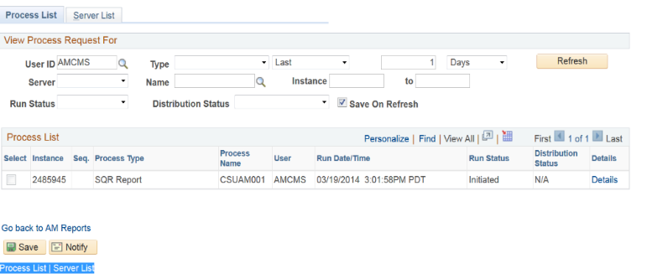

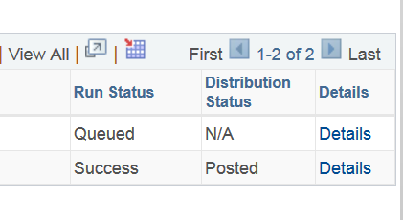

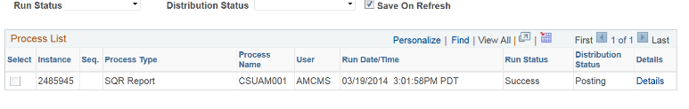

The Process Details page displays.

Select View Log/Trace link.

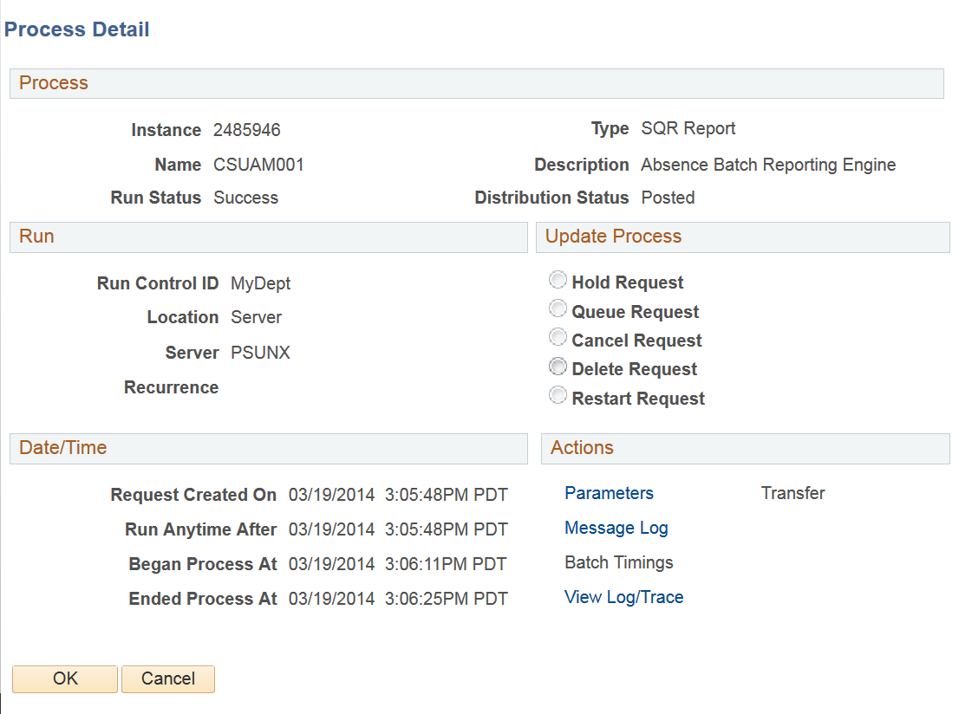

Select the .csv file to view results for each report ran.

exclamation point Options for opening the csv file may vary at each station.

If you select the hyperlink for the csv file and it does not open, it is recommended to right click on the link>save target as >Name.csv>Save>then open the file

Open in New Tab or New Window.

exclamation pointIf the file doesn’t open properly contact your department Technician for additional assistance.

Open the File or Save to your Desktop  
  
  
  
 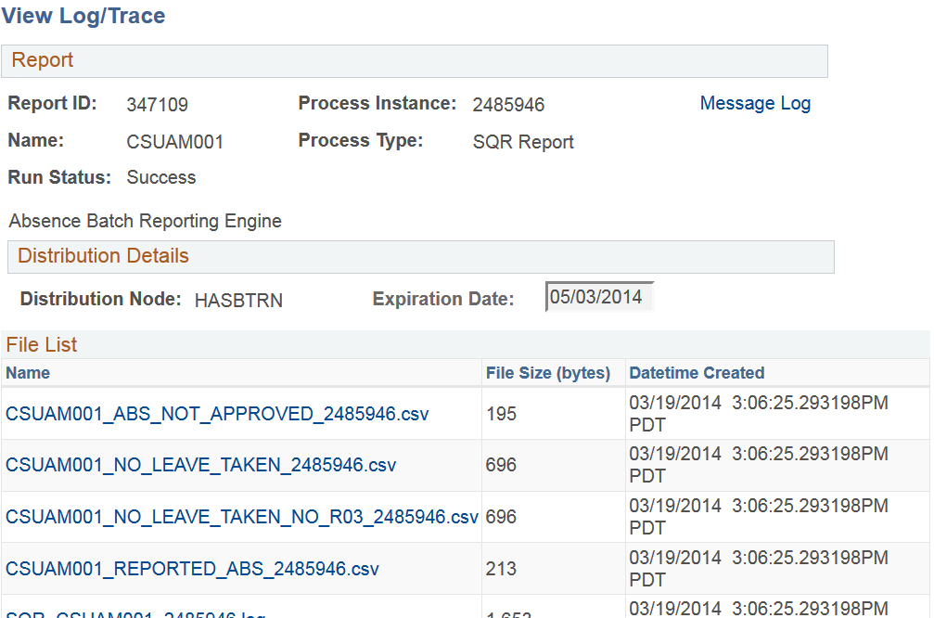

**It is CRUCIAL to ensure ALL Absences are APPROVED by the Campus Absence Management Deadlines and Separations.**

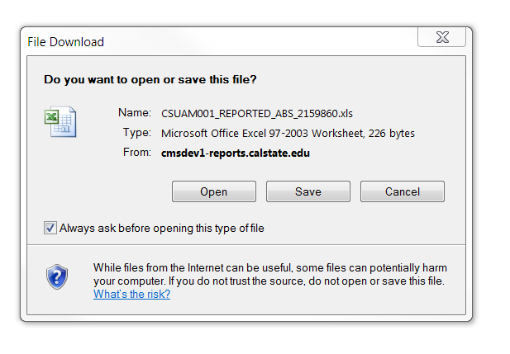

# View Absence Balances for Employees

The current period balance will not be available until after the period is finalized by Payroll.

Navigate to Timekeeper Balance Inquiry

**Main Menu >Manager Self Service**

**>Time Management >Timekeeper Balance Inquiry**

The Timekeeper Balance Inquiry page displays

**Payroll Status** dropdown menu provides access to other than Active employees.

**Leaving the Fields blank will return all employees assigned to your specific department (both Staff and Faculty). Based on your security access the data will appear.**

**Use CSxxx for Staff or CF for Faculty when searching by department.**

Use the Lookup Icon to search for department.

Use the search fields by typing a Department ID or EmplID to search by department or employee.

Search results provide Column header sort capabilities.

Select the OK button in the Building Security List of Employees screen.

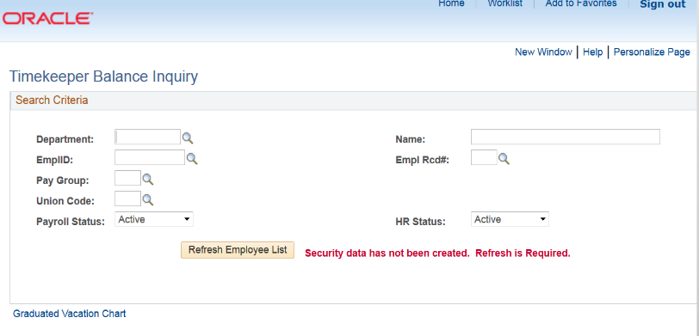

Select the Refresh Employee List for Current Activity updates.

***Important – Email updates***

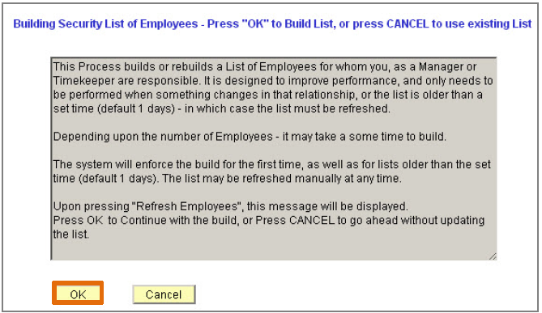

Use the search fields by typing a Department ID or EmplID to search by department or employee.

exclamation pointIf you need to look up your corresponding Department ID(s):

Use the magnifying glass next to the field boxes to look up.

Or visit the [CMS How To page](http://cms.csusb.edu/support/how_to.jsp).

Select the dropdown menu> General Information> then select Lookup HR Department Name and ID.

Select the Search button to begin the search.

Absence Balances are displayed.

Select the Details link for each employee to view monthly usage.

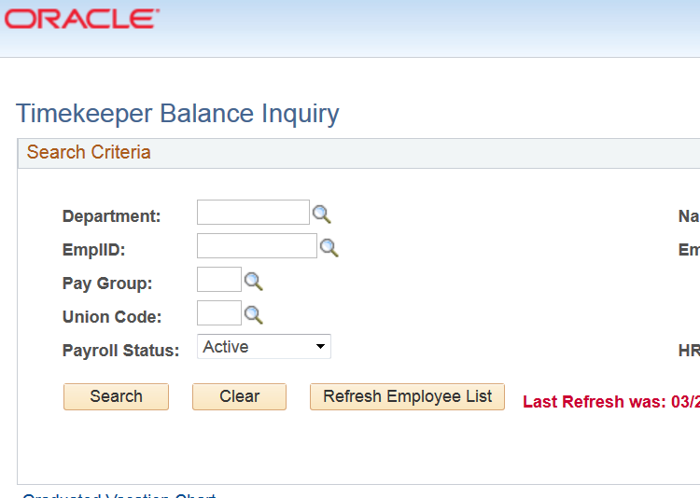  
  
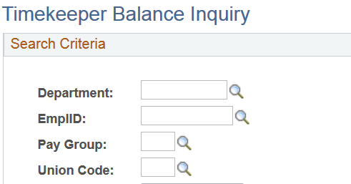

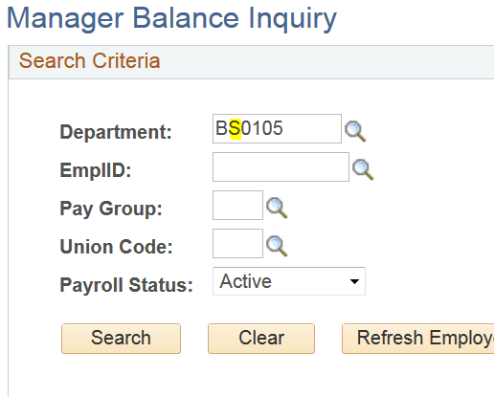

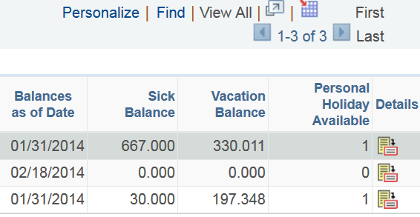

Use the Excel download icon to access the data in Excel.

***Tip:*** Select the View All link on the results page navigation bar when searching by department.

exclamation pointUse the Show All Columns icon to view all tabs on one page.



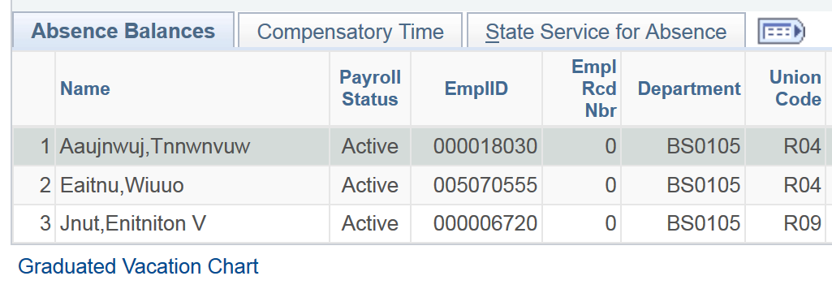

**Appendix**

Timekeeper – the following information is provided as a reference to assist your area Validator if needed.

**5 Steps to Approval**

**Navigation:** After logging into the MyCoyote Portal, select Administrative Systems tile, then select the HR tile. Main Menu **> Manager Self Service > Approve Time and Exceptions > Approve Reported Absences.**

Navigation from the Main Menu drop down at the top left of the page is also available (Breadcrumbs).

***Absence Validation must occur PRIOR to an employee’s separation from the current department (example: Separations, Leaves, and Promotions etc.).***

Take noteIf using breadcrumbs for navigation rather than the Home Menu **‘Time Management’** link will appear.

Breadcrumb navigation

Basic steps to Validate Time after logging into the campus MyCoyote Portal.

1. Select **Manager Self Service > Approve Time and Exceptions > Approve Reported Absences**
2. Select the “**Select All**” button to select all employees in the list (or select the box next to an employee name/ID to select the individual employee(s), then select the “**Continue**” button to display the list of employee Absence entered requiring validation (approval).
3. The “Approve Reported Absences Page” is displayed – Validator will review entries and select All and Submit.
   1. Absence **Status set to ‘Reviewed’ status (entered by Timekeeper).**
   2. Absence Status set to **blank** (‘Self-Reported” entered by Employee).

* **Validator will approve “Reviewed” Statuses** (please refer to Timekeeper for your Unit Business Process) and review Timekeeper comments as needed.
* Validator can set to Needs Corrections and enters comments as applicable (review campus department communication processes with your Timekeeper).

**Needs Corrections**: if selected in error, the Manager must set back to Reviewed and Select the Approval box.

**Enter comments** as applicable. The Add Comment link will change to Edit Comments.

1. Click the “Select All” button to select all Absences for approval and Select the “Submit” button to update the status of all selected Absences to “Approved”.

If there are additional Absences awaiting approval, the Manager is returned to the approval page otherwise the confirmation page appears.

To **Delete an Approved absence** not processed by Payroll, navigate to Manager Absence Entry page to view the delete icon Trash Icon

##### Validator Reports To

**Direct Reports Direct Reports icon\*** - The icon will display for an employee who has ‘direct reports’. Click on the Direct Reports icon button to see the employee(s) that reports to this employee.

Select Direct reports icon to display reports for that emoloyee


Reports To – Validators (who have Managers with validating access) are able to view the list of corresponding employees for the Manager (Validator) within their areas. Using the Reports To icon permits the area Validator to approve on behalf of each Manager.

“Reports To Position” - Defines the Reports To relationship located on “Job Information” page in Job Data. The populated field identifies the Reports To structure. Displayed is the Reports To position number, the title, the employee id and the Reports To Name.

On-going maintenance is required to perform Absence Management tasks..

*Employees viewed are available based on the Direct Reports To and Effective Date setting in Absence Management.

**Columns Displayed on the Employee Selection Page include**



**Select** – Use the check box to select the employee(s) for review (does not have sort capabilities)

The list of employees may be sorted by clicking on a column name for any of the following columns.

**Emplid** – Employee ID

**Empl Rcd** – Employee record number

**Current Period Absence** – The “Current Period Absences” column indicates the status of entries for each employee, including:

* + **Appr** – All reported Absences for this employee have been validated
  + **Sub** – Absences have been submitted that still require validation
  + **None** –No Absences have been reported for this individual this period

**Name** – Employees’ name

**Status** – Employees’ HR status (Active)

**Dept ID** – Employees’ department number

**Dept Name** – Employees’ department name

**Position** – Employees’ position number

**Job Code** – Employees’ job code

**Job Title** – Employees’ job title

**Full/Part Time** – Designates employment Full/Part Time status

Timekeeper Quick Reference Steps

***Select the Administrative Systems tile to access PS HR modules.***

Assign Work Schedules – View only page

Payroll enters Work Schedule updates from the [Notice of Work Schedule Change](https://www.csusb.edu/sites/csusb/files/Notice%20of%20Work%20Sch.%20Change%202016.pdf)

Reporting an Absence on Behalf of an Employee

**Manager Self Service > Time Management > Report Time > Timekeeper Absence Entry**

Deleting an Absence in Submitted Status

**Manager Self Service > Time Management > Report Time > Timekeeper Absence Entry**

Select the Trash icon icon in the far right column to delete an absence. Absences in Approved status must be coordinated with Approver to delete. All other status must be coordinated through the manual process (consult with your unit Timekeeper).

Timekeeper Absence Review

**Manager Self Service>Time Management>Approve Time and Exceptions>**

**Timekeeper Absence Review**

View Employee Balances

**Manager Self Service >Time Management >Timekeeper Balance Inquiry**

Audit/Approval Reports

***Global Payroll & Absence Mgmt > CSU Absence Management > CSU – AM Inquiry > Multi Report***

*Steps 1 – 4 are required* ***the first time you are running the report****.*

1. *After navigating to the Multi Report page, Select Add a New Value tab.*
2. *Name your report (xxxxx no blanks use d_xx) next, Set up the Run Control criteria*. Enter the search criteria.
3. Select the reports to be run by *checking the box or boxes* to the left of the Report Names hyperlink in the Monthly Processing box.
4. *Select Save* (to save a new Run Control Id). The saved Run Control ID and criteria will be available for future use.

Submitting the Report:

1. Select the *Submit* button, next Select the *Process Monitor link* (if not automatically taken to the Process Monitor select the link) to review the results.
2. Select the *Refresh button* to update the report Status until status reflects ‘Success’ and the Distribution Status reflects ‘Posted’.
3. Select the *Details link*, next Select *View Log/Trace link* in the Action Section.
4. Select the *.csv file* to view results. If you select the hyperlink for the csv file and it does not open, it is recommended to right click on the link for other options. Open the File or Save to your Desktop.

Important Links for your review:

Payroll Services webpage <https://www.csusb.edu/payroll>

**Payroll Services** is dedicated to processing accurate and timely pay warrants for our “State” faculty, staff, and student employees while adhering to university guidelines as well as federal and state regulations. We are a service-oriented department committed to assisting employees and administrative departments.  
  
**Payroll Services**, under the authority of the Chancellor and under the direction of the Controller of the State of California, is responsible for the areas of payroll operations pertaining to establishing and monitoring leave accruals, maintaining the employment history database, and processing disability payments, levies, and garnishments.

**Forms**

**Absence Management 634 - Monthly Attendance Summary Form**

**Required form** for **entering absence takes** that are **90 days** older than current open calendar date and to correct/adjust absence takes. Refer to Payroll website for current form.

**Notice of Work Schedule Change**

The Notice of Work Schedule Change form should be submitted to the Payroll Office for processing.

**Absence Status Definitions**

The Absence Status displays the status of absence entries. The following chart shows the different statuses and their meanings.

 