Set User Preferences in PeopleSoft via MyCoyote

Step 1. Login to MyCoyote

Step 2. Select the Faculty and Staff tab
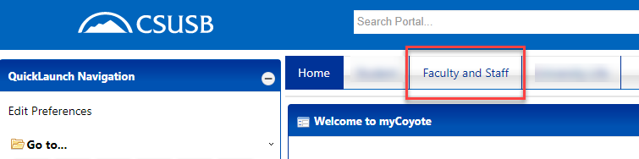

Step 3. Under the Self Service section, select User Preferences
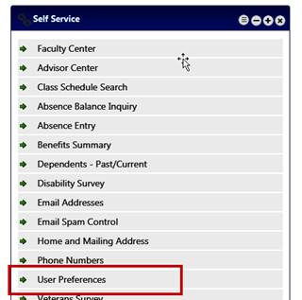

Step 4. Set your preferences
