Natural Reader 14

User Guide
“NaturalReader 14 is a text-to-speech software for Windows. Easy-to-use software with natural-sounding voices can read to you any text such as Microsoft Word files, webpages, PDF files, and E-mails”
www.NaturalReader.com/index.html

What is Natural Reader?
- Natural Reader is a Basic text to speech software and is currently the “most understandable free TTS (Text-to-speech) software around” (Informer Tech., Inc.)
- It is free to download and free to use across platforms (some options expire)
  - Android, Apple, Mac and Windows
- It works well with PDF, Word and Webpages (i.e. Blackboard, E-mail, etc.)
- There are different: voices, languages, fonts and font size, speeds and much more!

How Does NaturalReader (NR) Work?
- NR must be open before you can read anything using the program
- You can upload documents into the software to be read or read material with the Floating Bar (Windows) or the Mini Board (Mac)
  - Unfortunately, there is not a Floating Bar, nor a Mini Board for mobile devices: An alternative of copying and pasting text into a blank document does exist
  - When Copying and Pasting text into a new document in the NR, it is best to choose “without formatting”. If not, the program will scramble the text
- If a document is on Blackboard (BB) you may access it through the webpage portion of NR, and have it read from there or use the Floating Bar / Mini Board
NR can be used offline if documents have undergone OCR and are already loaded, or are located on the device (i.e. PDF’s saved on your computer or flash drive)

Visual Impairments and NaturalReader
- The ability to change font type and size is available in the free version.
  - Select “. . .” The settings bar will open Select display, and choose the appropriate font type and font size.
  - The largest font size is “97” and the recommended font for visually impaired persons is “Verdana”
    - No matter how big or small the font size is, it will still scroll and highlight in WORD documents.
- Visually impaired students will need DOC files when using the NaturalReader Software, so that a greater distinction between what is being read, and what is not being read is made.
- Unlike Adobe, or Zoom Text, NaturalReader not only highlights what is being read, but naturally scrolls down as the text reads, no matter how large you’ve made the text in the settings.
  - If you’re using NaturalReader on a PC, in addition to scrolling down, it will also scroll left to right!

Time saving Benefits
- NaturalReader could potentially save students from waiting extended periods for their requests to be fulfilled
  - Allowing Alternate Media to Cut, Scan, Separate and OCR texts
  - Using the Floating Bar / Mini Board to select the portion of the text student wants read, cuts out the Touch Up Reading Order process completely, shaving days and even weeks off of production turnaround time
  - Need a syllabus or Power Point Converted? Do it instantly using a combination of a PDF/OCR function App. and NaturalReader, to achieve an accessible format from any hard-copy or electronic format text (i.e. Kindle e-books, iBooks, Online Articles, etc.)

NaturalReader and Foreign Languages
- NaturalReader reads in Spanish amongst many other languages
  - It is 100% compatible with the FREE version of NaturalReader for Mac.
  - It is 100% compatible with the FULL version of NaturalReader for Windows
While NaturalReader reads in over 11 Languages and 50 Voices

Reading with NaturalReader
- How can I read the webpages in IE, Chrome or Firefox?
  - Please use the Floating Bar / Mini Board of NaturalReader to select the text on the webpages and click “play” button to read.
- How to read PDF & DOC files?
  - There are three ways to read PDF/DOC files:
    - Open NaturalReader click “add new” click "open" button to open the file The file will open, simply press “Play”
    - Using the Floating Bar / Mini Board, highlight the text you want to read and press “Play” *THIS IS OUR RECOMMENDED SETTING *
    - If the PDF file is a scanned file or it is protected by copyright, please use the Floating Bar / Mini Board and select the text you want to read.
- Kindle, eBooks, Images
  - In the Natural Reader Main Screen, select “Add New” Under Images (OCR) select “Capture”.
  - Open the eBook or Image, choose the appropriate application, then select “Start” Select the area you want to have read.
    - If there is more than one page, select how many you wish to capture, but be aware it only goes up to 21 pages.
  - Finally, select the “Check” button to capture the text.
    - It will automatically save and upload into NaturalReader
- Copying and Pasting into Natural Reader
  - If a text is being stubborn, there’s always a “Copy and Paste” option. Select the text you want to copy, open a “Blank” document and paste the text there. Once it has finished copying over, simply press “Play”.
- Can I add an extra pause in the text?
  - Please use “Conversation Controls” to add pause in the text.
    - Conversation Controls are not available in the Free Desktop Version of NaturalReader
- Can NaturalReader read a PowerPoint file directly?
  - Please use the Floating Bar / Mini Board to read the selected text in the PowerPoint file.
  - Opening a PowerPoint through blackboard in the webpage portion of NaturalReader will also allow you to read PowerPoint files, taking away all but the text for a more reader-friendly experience.
- Can I Read my book offline?
  - Natural Reader can be used offline if the documents have undergone OCR and are already loaded in the NR App.
- How to read the emails?
  - To read the emails, please use the Floating Bar / Mini Board of NaturalReader, select the text and click "play" button on the floating bar to read.

Reading in the webpage setting

Windows / Android
- Enter the website
- Listen now
  - Listen now removes all images and captures the text of the webpage turning it into a reader friendly document, removing anything that is NOT text *This is currently the only option in the App., there is no Floating Bar to avoid the loss of pictures, graphs, tables, etc.
    - If you’re not using it the webpage setting to simply read an article, email, or anything reduced for simple reading, it may be better to use the Floating Bar on a desktop or laptop.
- How to use the Floating Bar & the web
  - Open up a web browser and the Floating Bar Highlight the text you want to have read Press the “Play” button
  - Before selecting new text, you must press the “Stop” button Select the new text Press the “Play” button

Mac / Apple
- Enter the website
- Listen now
  - Listen now removes all images and captures the text of the webpage turning it into a reader friendly document, removing anything that is NOT text *This is currently the only option in the App., there is no Mini Board to avoid the loss of pictures, graphs, tables, etc.
    - If you’re not using it the webpage setting to simply read an article, email, or anything reduced for simple reading, it may be better to use the Mini Board on a desktop or laptop.
- How to use the Mini Board & the web
  - Open up a web browser and the Mini Board Highlight the text you want to have read Press the “Play” button
  - Before selecting new text, you must press the “Stop” button Select the new text Press the “Play” button

Example from the Webpage Setting in NaturalReader:

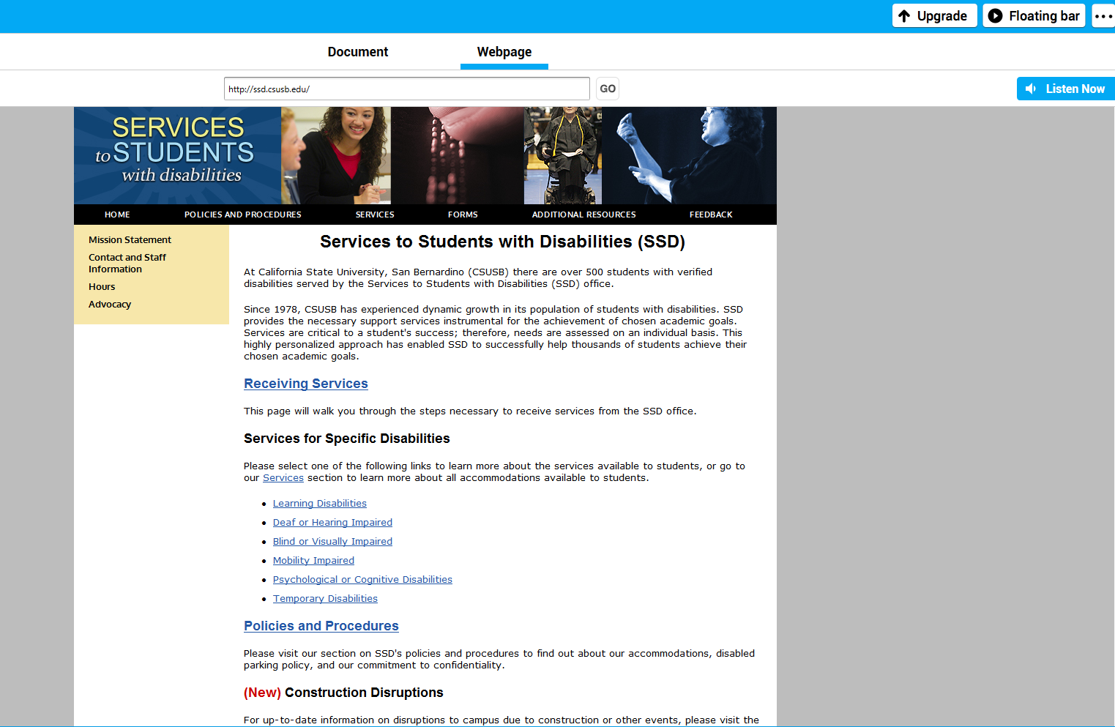

Image 1: This is what it looks like when you first access the page through NaturalReader after pressing “listen now” the page will remove all images and produce only the text of the webpage (see Image 2)
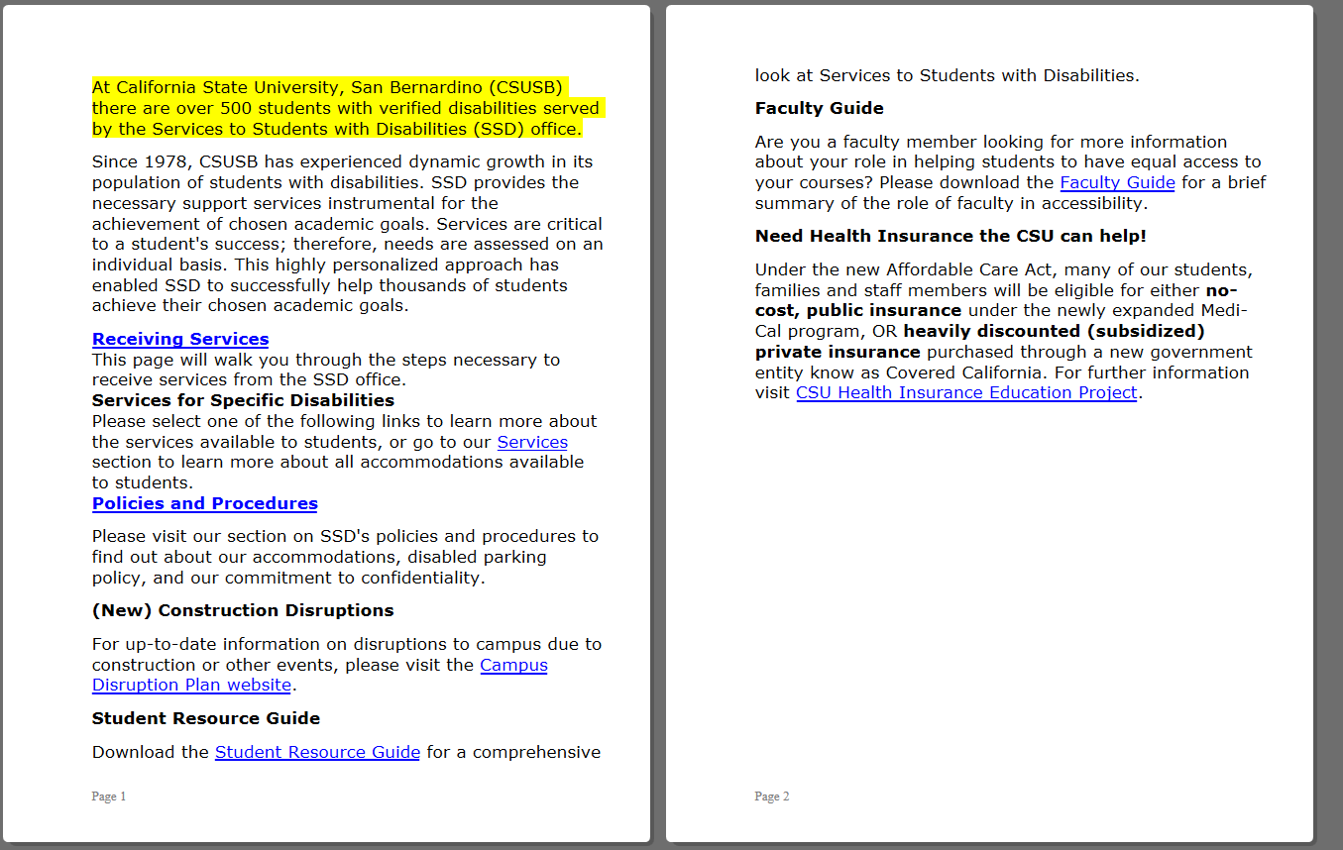

Image 2: The “listen now” button has been pressed. All of the images have been removed and a reader friendly page is presented if you want to keep all of the images, figures, tables, etc. please see Image 3 for use with the Floating Bar.

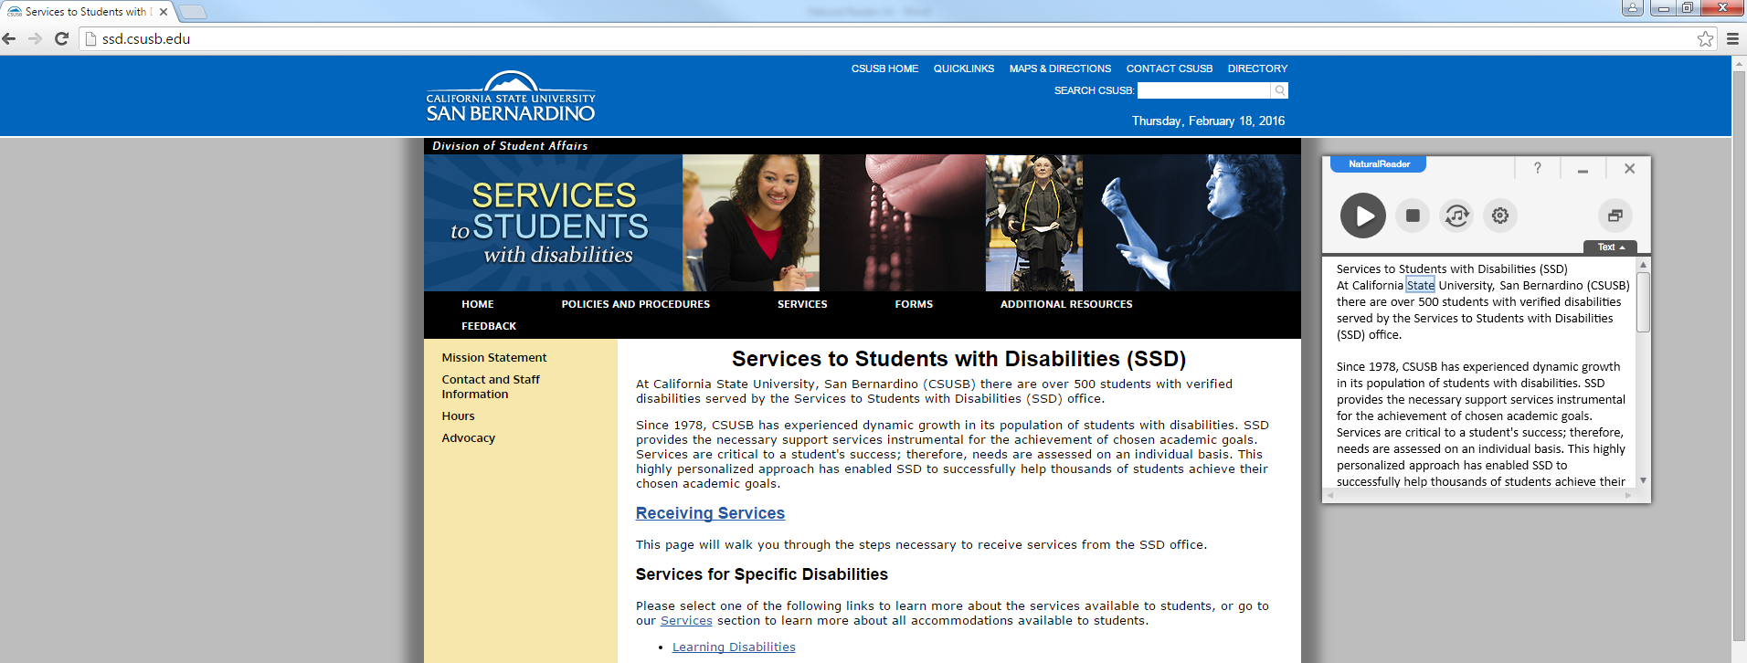
Image 3: The SSD page is being accessed through Google Chrome and the Floating bar is being used. You would select the text you want to hear read (highlight it with your mouse) and simply press the play button. It will highlight the text it is currently reading in the floating bar, and you also still have access to all of the images and functionality of the page. Please remember to press the stop button before selecting new text. Also, keep in mind you may have to select the text more than one time, as the program doesn’t always get it on the first try.

Highlighting Mechanism’s

Windows Running Software:
- Word documents – Natural Reader will highlight the text it is reading in a word document in yellow. It will also scroll side-to-side no matter how large you’ve made the text, so there is no need to manually scroll, unlike Zoom Text.
- PDF files – Natural Reader will highlight the text it is reading in blue.
- Floating Bar – No highlight exists on the webpage, however it does highlight the word it is reading in blue once the text box is dropped down. It even scrolls in the text box (it does not scroll on the webpage).

Mac Running Software:
- Word Documents – Natural Reader will highlight the text it is reading, by making the sentence it’s currently reading blue.
- PDF files – Natural Reader will highlight the text it is reading in blue.
- Mini Board – No highlight exists on the webpage, however NaturalReader will highlight the text it is reading, by making the sentence it’s currently reading blue. It even scrolls in the text box (it does not scroll on the webpage).

Converting to Audio Files with Natural Reader
Natural Reader will convert all text files (PDF, Word, etc.) to audio files in the full version.
Converting with Natural Reader is an easy 3 step process. The voice and speed will need to be selected before conversion begins:
1) With Natural Reader open and the document loaded, select all of the text you want to convert to an audio file (i.e. if you want to select the entire chapter, you would have to highlight all of the text by selecting the text at the top of the first page and dragging your mouse down until you get to the last page of the chapter.
2) Once the desired text is highlighted, press the audio conversion button: It looks like this
2a) There will be two options: 1. Split 2. No Split and the decision is up to you. On average they take about the same time to convert, however the split files are going to be easier to transfer / download.
3) Pick the format best suited for you, but remember! MP3 is the most universal audio file available to date. Press Convert and within minutes you will have your audio file.

Where Can I Find Natural Reader?
- Free NaturalReader 14 can be downloaded directly from the NaturalReader website for both Mac and Windows at http://www.naturalreaders.com/index.html
- It is also available through:
  - The Google Play Store
  - Apple’s App. Store
- The full version may be purchased for*:
  - PC’s Personal Use $69.95
  - Apple’s App. $9.99 (iPhone/iPad)
  - Android’s App. $Free with PC purchase
    - Please note that when switching over from the Free to Full version all documents will be lost unless saved else-where
*Prices are subject to change and may vary by package*

How Do I Install NaturalReader?

Windows Desktop / Laptop Installation Procedures:
- Be Sure to Select the Windows “Free” Download from the NaturalReader website
- Run the installation process
- Follow the installation process and/or window prompts for your computer

Mac Desktop / Laptop Installation Procedures:
- Be Sure to Select the Mac “Free” Download from the NaturalReader website
- Run the installation process
- Follow the installation process and/or window prompts for your computer

Android Installation Procedures:
- In the App. Store or Google Play Store, search for NaturalReader
- Install the App.
- Open the App.

Apple Installation Procedures:
- In the App. Store search for NaturalReader Free
  - Please note a $9.99 Full Version is available for purchase and is available on the device you purchase it on i.e. Either the iPad or iPhone only – Not both
- Download the App.
- Open the App.

Video Help
- For a quick reference to problems with NaturalReader software, please refer to the NaturalReader video help website page. The average length of a video is only 1 minute: http://www.naturalreaders.com/video.html
- There are various videos for self-help for:
  - Quick Start
  - How to listen to documents
  - How to add documents
  - How to listen to webpages
  - Mini Board / Floating Bar
  - OCR function to listen to printed documents and much much more. . .

Trouble Shooting – FAQ

iPad / iPhone
- NaturalReader Closes immediately when I try to open a file!
  - There is an issue with the coding of the file. Copy and Paste the text to a word document, open the word document with NaturalReader to listen to it.
- How do I read my books?
  - In NaturalReader interface, tap “+” button from “add new”, find the book from the source it’s saved in (i.e. webpage, drop box account or a one drive account)
- Reading from DROPBOX
  - Open NaturalReader, tap “+” button Dropbox
- Opening attachments with NaturalReader14
  - When you view a document email attachment, simply tap “open in,” it should be located in the upper right corner of the screen (it has an arrow pointing to the right) choose to open in NaturalReader

Android
- How do I read the webpage using the App.?
  - In web browser, tap Share Button NaturalReader Icon, NaturalReader will load in the webpage, tap Play button to listen to.
- How do I read my books?
  - In NaturalReader interface, tap “+” button from file explorer, find the book from the list.
- Reading from DROPBOX
  - Open NaturalReader, tap “+” button Dropbox
- Why won’t my PDF file upload?
  - There is a limit on file size. The size of the file cannot be bigger than 20mb

Common Issues
- For a quick reference to common issues with NaturalReader software, please refer to the NaturalReader help website page http://www.naturalreaders.com/help.html
- Floating Bar / Mini Board disappears
  - Restart NaturalReader, the floating bar will show up again.
- How do I toggle back and forth with the Floating Bar / Mini Board and the Console?
  - From the console
    - Press Floating Bar / Mini Board
  - From the Floating Bar / Mini Board
    - Below the exit button, and above the “text” view, there is a bubble with dual screens inside Press the button

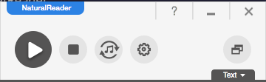

Image 4: This image shows which setting allows you to toggle back and forth between the NaturalReader Console and the Floating Bar / Mini Board. Simply press this window and you will return back to the NaturalReader Console.

- I can’t hear anything!
  - Mac – Alex: Go to “Tools” “Settings” and pick “Alex” as the default voice
    - From here you can also Change the speed, the font, and view (shortcuts)
  - Windows – Anna: Go to the “. . .” listed to the right of the Floating Bar “Settings” and pick “Anna” as the default voice
    - From here you can also Change the speed, the font, and view (shortcuts)
- NaturalReader only loads part of the PDF file, how could I get it to read the whole file?
  - This is due to the special text formatting of the pdf file. For this kind of the PDF files, please open the PDF file in Adobe Reader, use the Floating Bar / Mini Board of NaturalReader to select the text (it must be highlighted) in the file to listen to

Team Viewer Software
- Team Viewer is free and downloadable straight from www.teamviewer.com
- This software will be used for trouble shooting / technical support and for electronically transferring textbook files.
  - If the student does not wish to use Team Viewer to receive their books via file transfer, a brand-new-in-package flash drive must be purchased and provided to the Alternate Media team.

What Does Alternate Media Need?
- When using alternate media technical support the representative will need two things from you in order to connect with you via Team Viewer:
  - 1) Your ID #
  - 2) Your password

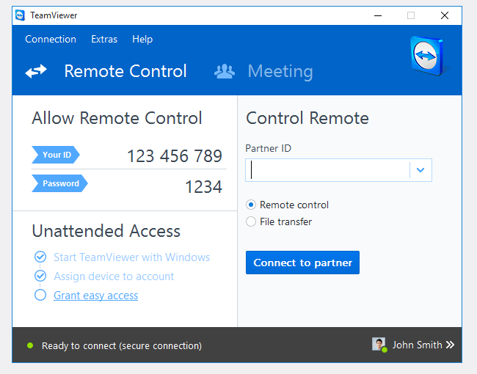

Image 5: This image shows the two pieces of information Alternate Media will need from you in order to connect with you via Team Viewer.

Password Regeneration
- “Access protection: In addition to the Partner ID, Team Viewer generates a session password that changes with every software start in order to provide additional security against unauthorized access to remote system. Security relevant functions like file transfer require additional, manual confirmation from the remote partner. Also, it is not possible to invisibly control a computer. For data protection reasons, the person sitting at the remote computer has to be able to detect when someone is accessing the machine” (Team Viewer Website)

Recommended Apps. For PDF and OCR Functions

Apple
- Our number one choice − PIZMO ($9.99)
  - PDF & OCR in one
- Our number two choice – SharpScan (FREE) This App. will automatically stabilize the photo for you.
  - PDF & OCR in one (Please be advised you will need to copy and paste into the “input” option when using Natural Reader)
- Our number three choice − CamScanner (FREE)
  - PDF & OCR in One
    - (Please be advised that you cannot export to Natural Reader with this Application, although it will read what you scanned in the App.)

Android
- Our number one choice – Text Fairy (FREE)
  - PDF & OCR in one
- Our number two choice − CamScanner (FREE)
  - PDF & OCR in one
    - (Please be advised that you cannot export to Natural Reader with this Application, although it will read what you scanned in the App.)
- Our number three choice − Genius Scan (FREE)
  - PDF only

Works Cited
Explore, Download, and About Us Tab. Team Viewer. N.p., n.d. Web. 27 Feb. 2016. <http://www.teamviewer.com/en-us/>.
Home, Video, Help, Features and Exploring Tabs. NaturalReader. N.p., n.d. Web. 27 Feb. 2016. <http://www.naturalreaders.com/index.html>. All Copyrights of naturally voices™ are owned by AT&T Co. 2015 NaturalSoft Limited, all other rights reserved

Last Updated April 2016
Created by Breanna Montague

