FACULTY & STAFF INTERNATIONAL TRAVEL REQUEST INFORMATION

International travel that is funded by either state or auxiliary funds requires additional information be included in the Concur travel request so the CSU required international travel insurance can be issued in a timely manner. Listed below are some guidelines to be aware of when submitting an international travel request in Concur.

The international travel request with ALL pertinent information and attachments should be submitted in Concur at least 30-45 days before the trip start date. The request workflow should include the following approvers:

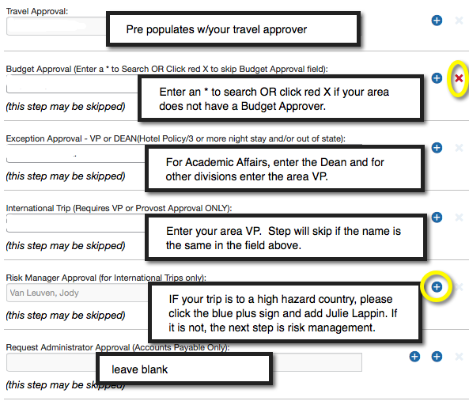

Continue to next page to see what specific information should be included in the int’l travel request….

An international travel request should include the following information in addition to the fields on the Concur request header.

- Clearly state the business purpose of your international travel in the “benefit to the university” field or in the comment box. If there is not sufficient space, please attach the business purpose/benefit to the university to the request.

- If your trip includes students, please attach a list of student travelers to the request. The list should include the following:
  - The student contact information that includes an email address, a phone number,
  - Additionally, please include the student’s emergency contact name, email and phone number.

- If your trip is high hazard, please attach a document that specifies the safety measures you will be taking when traveling in a high hazard country. Also, please include if you will be visiting any tourist locations or if you are planning to attend local events such as concerts, sporting events, etc.

- If your trip includes personal travel, please attach a document that outlines specific dates of the personal travel and the business travel. Please note: insurance coverage is provided for up to 14 days of personal travel IF the personal travel is included in the itinerary that is submitted on the Concur travel request.

- An estimate of airfare and departure and arrival locations must be included in the request, please attach a detailed itinerary (even if the itinerary may change) that includes any layovers or excursions to the request. If the itinerary information does change after your request has been submitted and approved, please update the itinerary in the request by attaching the updated version to the approved request.

- For international lodging, please include specific information about where you are staying while in another country. Provide the name and address for each location in the International Lodging Allowance comment field in the Concur travel request. Feel free to attach a document with multiple locations if needed. Simply put in the comment box “please see attachment”.

If you need further information or have questions:

Contact Risk Management (travel insurance) 909-537-3937

Contact Accounts Payable (Concur travel request) 909-537-5155

