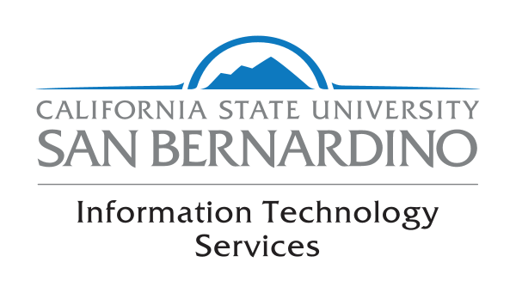
Faculty Senate Report June 2017
I am pleased to announce that Academic Technologies and Innovation (ATI) received two grants from the Chancellor’s Office:
- Quality Assurance program to conduct activities leading to the development of quality online/hybrid courses: $19,000
- Supporting Faculty-Student Collaboration for Producing Engaging Virtual Reality Instructional Content: $10,000
ITS launched its new service and support focused website on June 1st. You can find us at: https://www.csusb.edu/its
The ITS Team will work with the Campus Community in the evaluation of a new Campus Portal and Mobile Application Development platform for the University. The new solution will offer new and innovative services for our students, faculty and staff.
The team will also be working with Professors Kurt Collins and Mihaela Popescu and the University Facilities Unit in the evaluation of several Smart Campus solutions.
Your ITS Team will be busy this summer working on several projects including the following:

ITS Summer Projects

Academic Computing & Business Intelligence
- CS 9.2 Upgrade
- EMS Event Management system
- EMS Academic Scheduling
- Cal State Apply
- AIM Project for the SSD Office
- CFS Year-end Closing
- CHRS Project
- Q2S Evaluation
- Portal evaluation and selection
- Mobile evaluation and selection
- FI$CAL Project: Financial Information System for California. (One State. One System)
- Faculty Grade Change Form
- ALMA Unified Library Interface
- U.Direct ( Coyote Planner)
- Advance upgrade project
- Advance student data project
- Migration of ACBI Servers to VM
- 1098T Conversion to PS
- Analytics
- CFS – AP Auto Term the ISA
- Production on SUMMER SOTES (3 sessions)
- SOTE’s queries improvements in PS
- ClassClimate Upgrade to version 7.0
- Qualtrics cleaning user’s database
- Sponsored Programs IDC calc
- Sponsored Programs Invoicing-testing (CMS-CFS Project)
- SimpleK Program Rewrite
- HR Absence Management – Convert Summer Schedules for EE’s

Academic Technologies & Innovation
- Completion of PL013 active learning space furniture upgrade (end of June)
- Media storage and management platform implementation (ready for Fall quarter) An online/hybrid institute with TRC which is a pilot for the e-academy
- An ATI resources page that organizes the considerable resources we have amassed
- A campus AL$ page
- The Introduction to Blackboard module

Distributed Technology Services
- Library Public computer image
- Library staff computer patch management
- SB365 Upgrade
- SBS -> CSUSB migration
- CSBS - Migration from SBS to CSUSB domain of staff computers
- Visual Arts - Art department - Image 3 labs
- JAMPF
- Adobe - Work on adding accounts and software for the CAL
- ITSM -Identify single 'ticketing' solution for campus use starting with ITS

Enterprise & Cloud Services
- Further development of the DEV VMware rack adding systems to clusters and establishing storage common to the VMware vSphere infrastructure.
- Establishing best practices and comparing of services of cloud providers focusing on MS Azure and AWS cloud solutions.
- Development of VMware VMs on an as requested basis.
- Renewal of the VDI- vCenter.csusb.edu SSL certificate.
- Compellent update and Patches, requires the system downtime, we are planning to perform this task during the week of June 18.
- POC for Phoenixnap and Dataoffsync cloud solutions.
- POC for Cloudlanes.
- Working with the April Wing, our Emergency Manager, on coordinating Campus Commercial Radios and getting them programmed.

Information Security & Emerging Technologies
- Science DMZ
- Blackboard Dishonesty
- Deferred maintenance
- Niagara
- Incident Handling
- PS Delegate Student Liaison Accounts
- Delegate CIA Request Process
- CSU HIPAA Assessment
- Incident Response Standard
- Sensitive Data Inventory
- Plan for Oct. Cybersecurity Awareness Month
- Business Continuity Planning
- Password and activation reset in Role lookup
- SSO fraud
- PeopleSoft Feed with timestamped Data
- Activation and error report in graphic
- AWSPDC Guest Account
- AD-SSO Group Sync
- Sync Bot (python-iam)
- Shibboleth v3

Technology Support Center
- Refresh of PL-1109 lab
- Prepping for 24/7 Study Area in Fall (new vending machines, finalizing security guard options, cameras, etc.)
- TSC Staff Training (Windows 10, ITIL Foundation training, A+ certification possibly)
- ECS Staff Training (Cloud-based solutions, SQL training, etc.)
- Facilities’ WebTMA implementation
- Other upgrades/tasks

Telecommunications & Network Services
- Outdoor wireless expansion (PA, SU, PL)
- PAN Server Farm completion and close out
- Science DMZ
- Voice gateway upgrade
- Re-architecture of campus analog services
- AD/CallManager integration
- Alertus/CallManager integration
- Online directory launch
- Jabber roll out beyond pilot group
- Infrastructure upgrade assessment
- Cellular coverage expansion
- ITSM Pilot (with DTS and other areas)
- Construction projects design (with FPDC, Facilities)

