Instructions to Print Class Rosters and View Student Photos
In addition, attached in the Faculty Self-Service document (page 19-20) which can be downloaded from your MyCoyote, under the Faculty and Staff tab, located under the How To’s link.
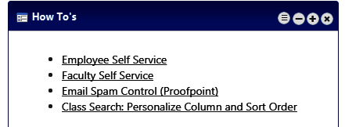

Class Rosters – Printing
Print out your class roster by selecting the Printer Friendly Version link.
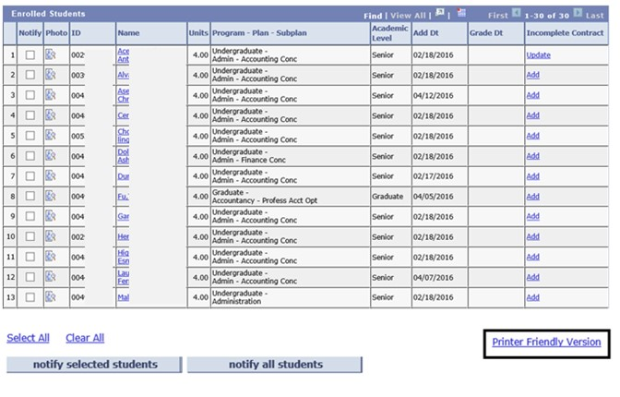

Class Rosters – View Student Photos
To view student photos, do one of the following:
➢Click the Photo icon to the left of the student’s name.
➢Click the Include photos in list radio button.
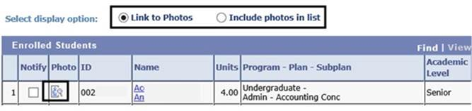
- Not all photos for students will be available. (If the student did not take a photo for the Coyote One card, a photo is not available)
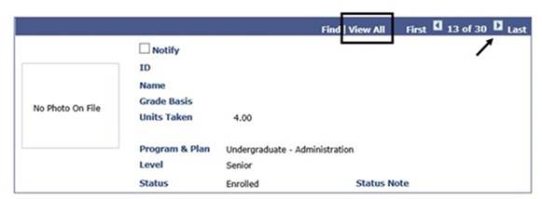
➢On the photo page, click the View All link or use the arrow buttons to scroll through the student photos.
➢After clicking the View All link, use your browser print button to print the entire list.
Note: To return to the Class Roster page without photos, click the Link to Photos radio button.
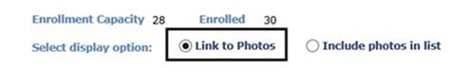
Tip! If you want the student photos to display in the printed version, do NOT use the Printer Friendly Version button. Instead, click the View All link and use your browser print button.

