How to do Wireless Printing from laptop
- Go to www.csusb.edu/mobileprint
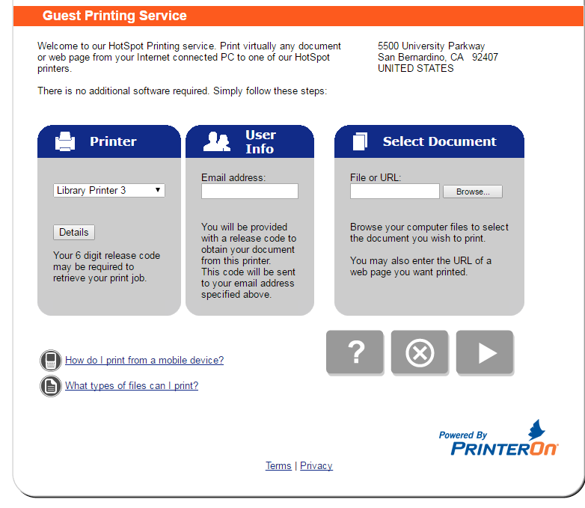

- Select the Printer you wish to print to, enter your email address and upload your file.
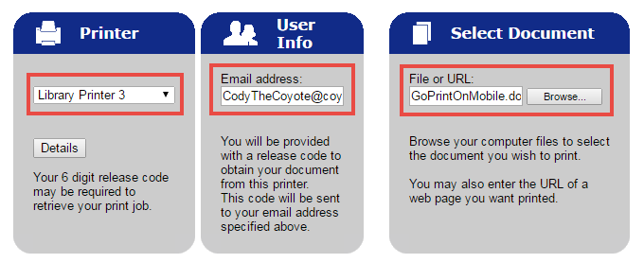

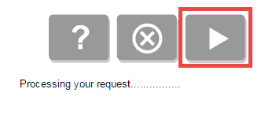
- Click on the Submit button

- Enter in the amount of copies and pages you want to print
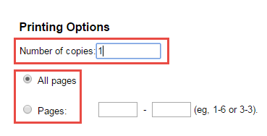

- Click on the Submit/Print button
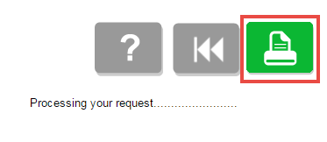

- Confirm your request was successfully Processed and write down your unique Release Code.
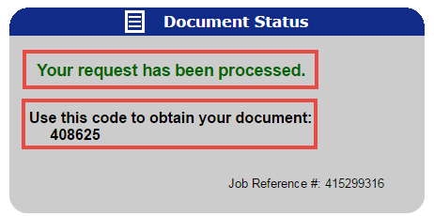

- Go to the printer selected, locate the nearest GoPrint Pay station, select your file via email address, use your unique Release Code, pay and collect your print job.

