Documentation on How to Use Go-Print Mobile App
*Important Notice: All instructions may vary depending on current Operating System, the Current Apps on phone, and the Type of phone.
- iPhone – Running iOS 9.0
  - Please download the “PrinterOn” App from the App Store. (Depicted in the picture below)
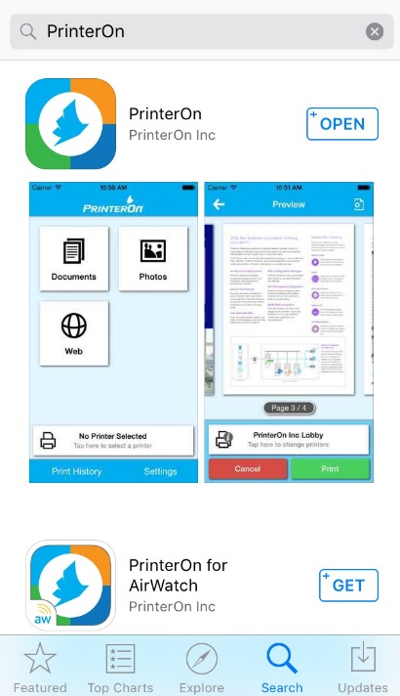

  - Once downloaded you will be given 3 options of how to locate and Select the File type you wish to print: Documents, Photos and Web. After choosing the file type, click on the “Printer Icon” to confirm the file chosen and then you will be taken to a preview page. (Depicted in the pictures below)
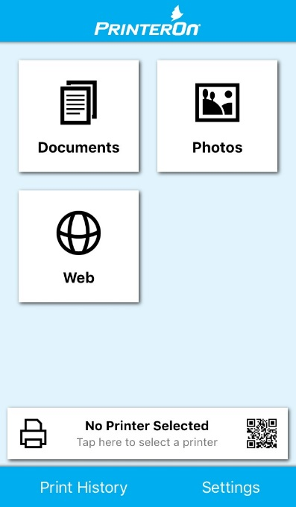
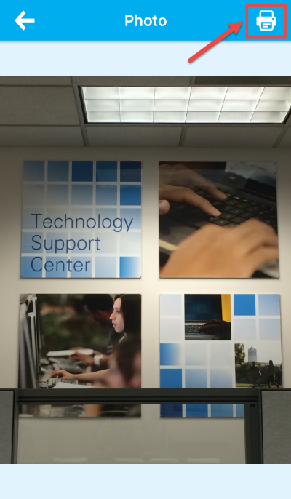

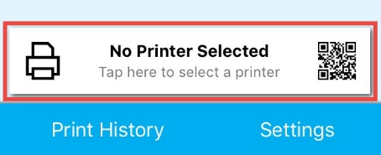
  - After locating and selecting the Document/File type you wish to print you will need to setup the printer you want to print from.
    - Click on “No Printer Selected”

    - Click on the “Location” Tab located on the bottom. You will have to zoom in to the area where the University appears on your screen. (Depicted in the picture below)
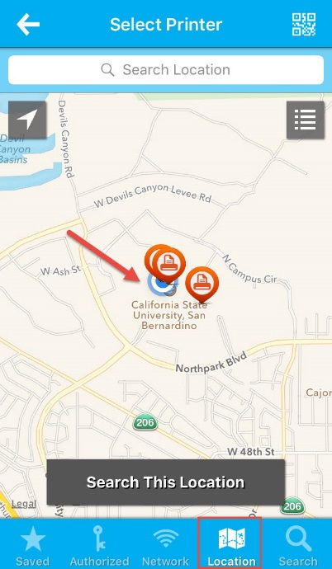

  - Click and Select on the “Printer Station” The CSUSB Main campus currently has 5 print stations that allow you to use this Mobile Print feature: 2 printers in the Library (Black & White and Color) 2 printers in the Self Instructional labs in the Wedge PL-1108 (Black & White and Color) and 1 printer in Jack Brown Computer Lab JB-123. Some locations will have multiple Printer Stations so you will need to click on “i” symbol to show the list of Printers. (Depicted in the picture below)
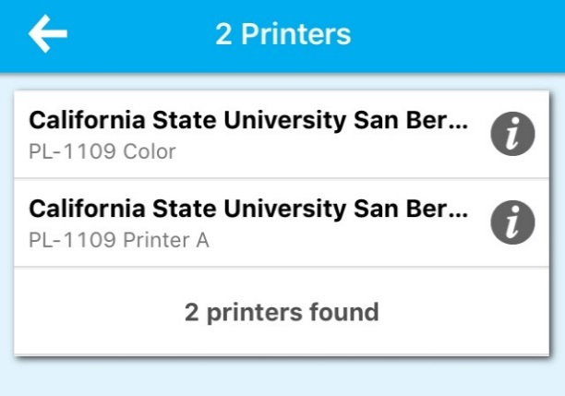
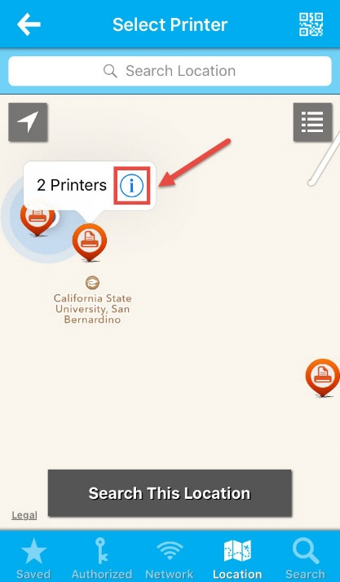

  - After verifying that you have the desired printer and file Click on “Print” and then you will be asked to enter your campus email address (this is what your print job will be displayed as on the print station) and click on the Check mark in the Right Corner.

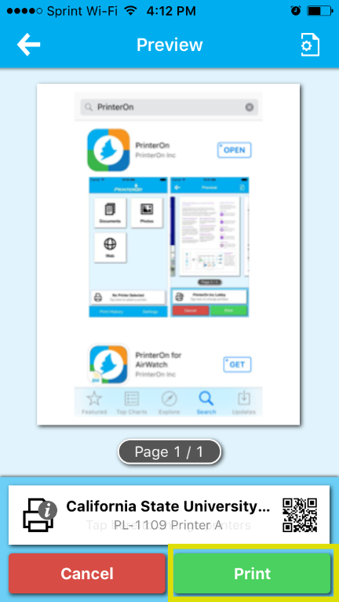

  - Your print job will be processed. You can check the status on your request by clicking on “Print History” You will see a “Green Check Mark and Success” if your print job was successfully sent and received at your desired Print Station on campus. (Depicted in the picture below)

  - Once on campus and at the print station Click on the Print Job from within in the Print History menu and click on “Unlock Job Release” you will then be asked to use your iPhones Touch ID to confirm and release of the Print Job. (Depicted in the picture below)

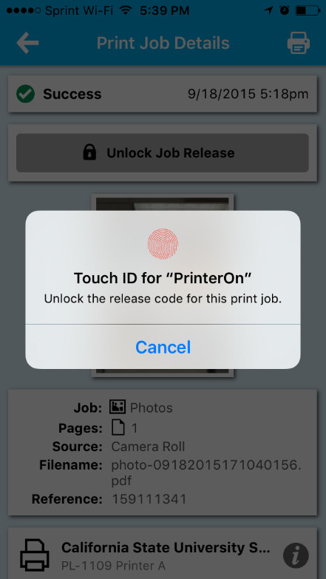
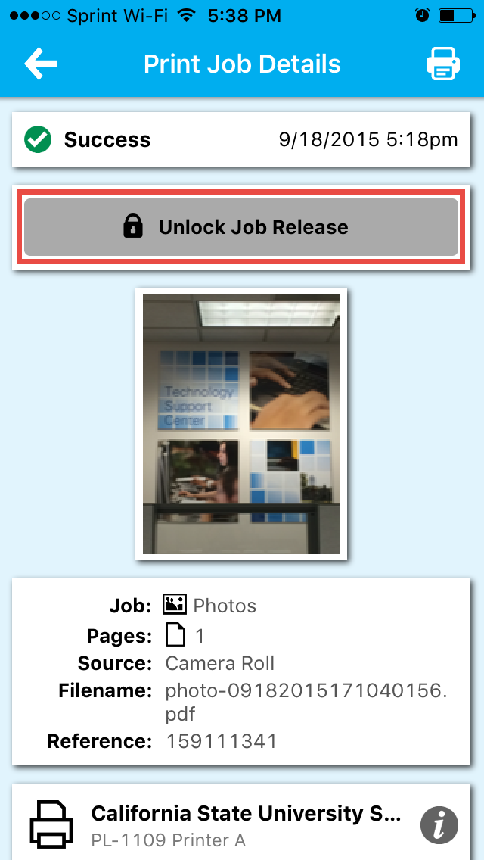

  - Once you have released the Job you will be given a code (Code will always be random) that you will need to type in at the print station in order to print. (Depicted in the picture below)
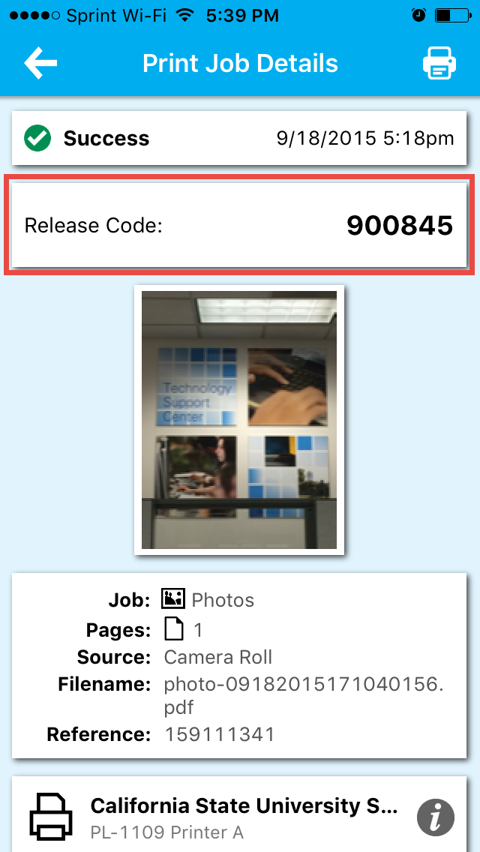

- Once at the pay station you will need to locate your email address and click on it and type in the code that you were given. (Depicted in the picture below)

