How to Use Cash Value Machine
- To add Money onto your Coyote ID card please swipe your card with the BLUE Strip.
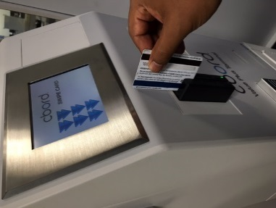

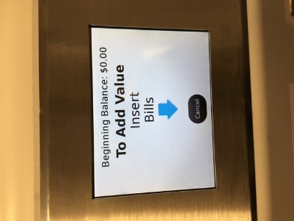
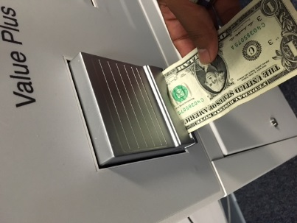
- Insert Dollar Bill(s) $1, $5, $10, $20

- You will receive a confirmation the bill(s) have been accepted.
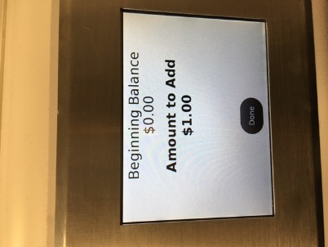

- After you have added all the money you want click on “Done” or “Print Receipt” for your records.
