Graduation Rates by Department Dashboard
What data am I looking at?
Historical graduation rates are shown where those data are available (e.g., 2-year graduation rates for 2016 entering Master’s & Doctoral students, 4-year graduation rates for 2014 entering Master’s & Doctoral students, etc.).
How do I interact with this page?
Use the drop-down menus at the top of the page to select a college and department.
It is important to note that the data are based the start major (i.e., major at entry). If a student changes to a major in a difference department or college, they will be still be tracked as part of the starting department/college cohort.
Terms and Definitions:
The following terms and definitions were chosen to maintain consistency with the CSU graduation initiative and campus tracking.
URM/Non-URM: (Underrepresented Minority and Non-Underrepresented Minority) URM students are African-American, American Indian, or Latino/a. All other students (including mixed-race students) are categorized as non-URM.
1st Gen/Non-1st Gen: While the definition of first-generation college students varies, for the purposes of this dashboard, first-generation students are defined as students among the first generation of their families to attend a college or university. Non-first-generation students have one or more parents with a bachelor’s degree or higher.

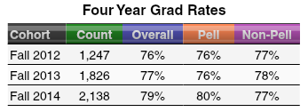
In this chart, the Fall 2012 cohort has a four-year graduation rate of 12%. Pell students (i.e., those receiving Pell in their first term) have a four-year grad rate of 9%, while non-Pell students have a four-year grad rate of 21%. This is a 12% achievement gap.

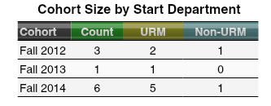
Be sure to note the cohort size for each of the sub-populations in your selected department to determine if the comparisons are appropriate. In the above chart, the small cohort size is problematic overall, and at the sub-population level.

