Compliance Sheriff User Guide
Contents
Compliance Sheriff User Guide 1
The Accessible Technology Initiative at CSUSB 3
Compliance Sheriff 3
Logging into Compliance Sheriff 3
Quick View of Scans 4
Running a New Automated Scan 6
Document Properties 7
Revision Log 7
Approval Control 7

The Accessible Technology Initiative at CSUSB
The Accessible Technology Initiative reflects the California State University’s commitment to provide access to information resources and technologies to individuals with disabilities. This commitment is articulated in Executive Order 1111 (EO 1111), the CSU Board of Trustees Policy on Disability Support and Accommodations. The initiative will facilitate improvements in the following three priorities:
- Web Accessibility
- Instructional Materials
- Procurement of Electronic & Information Technology (E&IT)

For more information on the Accessible Technology Initiative at CSUSB email accessibility@csusb.edu or call 909.537.5079

Compliance Sheriff
Please keep in mind that Compliance Sheriff Automated Scans cannot find all of a website’s accessibility and usability concerns. However, monthly automated scans are useful to gauge the overall accessibility

Logging into Compliance Sheriff
Web Developers and Designees can still log into Compliance Sheriff to see results. Please contact webaccessibility@csusb.edu if you forget your password, we can reset it for you.
The URL for Compliance Sheriff is: https://hosted11.compliancesheriff.net/CSU001h06/Login.aspx

Screenshot of login page:
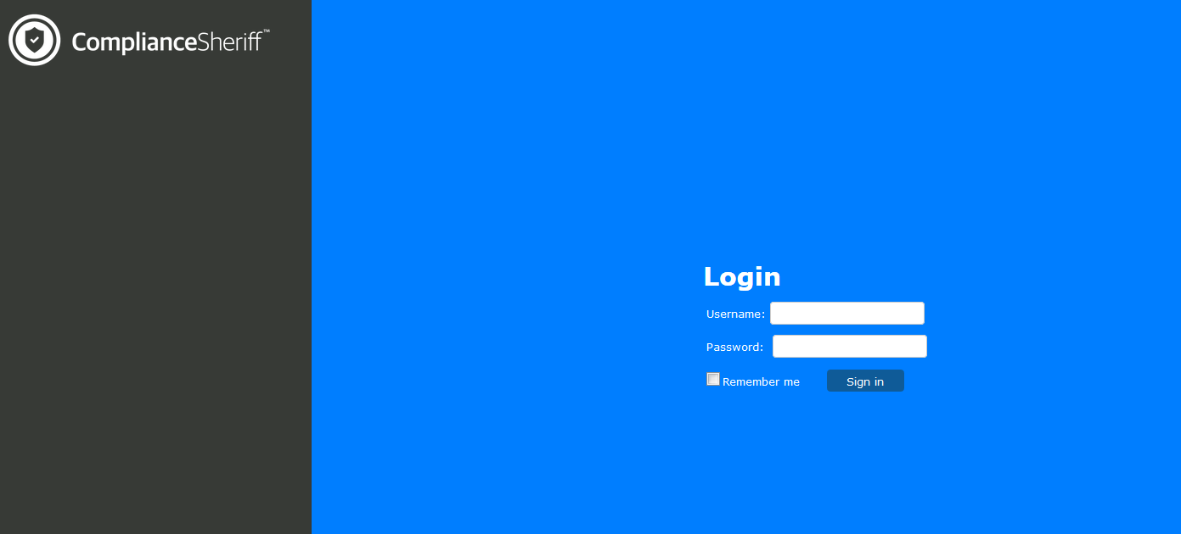

The landing page is the Dashboard that is currently not being used:

Screenshot of landing page:
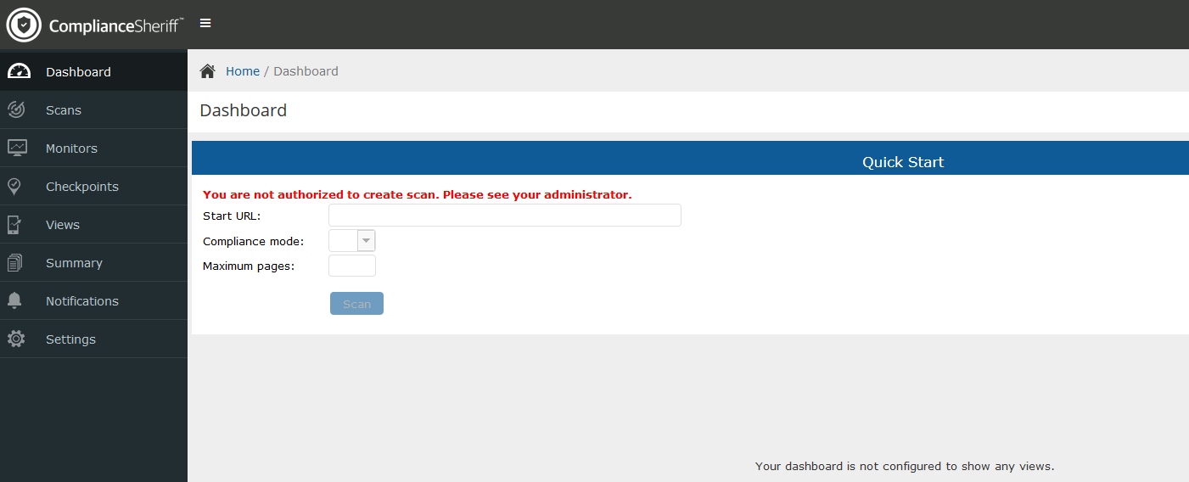

Quick View of Scans
- Navigate to the Scans tab, located on the left panel
- On the far right is a drop down menu, “Scan Group”, select your College/Division
  - AA – AA - Academic Affairs (Academic Affairs related but not within a College)
  - AA – CAL -
  - AA – CEL -
  - AA – CNS -
  - AA – COE -
  - AA – CSBS –
  - AA – JHBC -
  - AA – GRAD -
  - AA – LIB -
  - AA – PDC -
  - AA – UGS -
  - AF -
  - ITS -
  - Pres - (site MPP reports directly to the President)
  - SA -
  - UA –
  - CORE
  - Performance Reporting

Once you select your group, a quick view of all sites in your College/Division will be listed.
Screenshot of quick view:
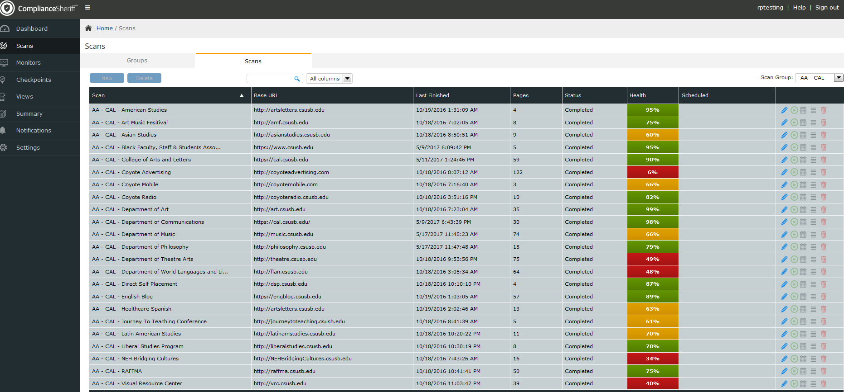

View the details of your report:
- The easiest way to find the results of your scan is to select the “Score Link” located in the “Health” column
Screenshot of Health column, click select the Score you would like to review
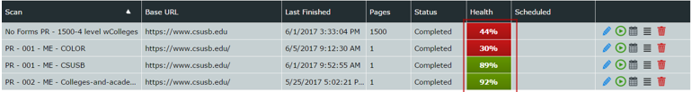

Screenshot of Scan Summary
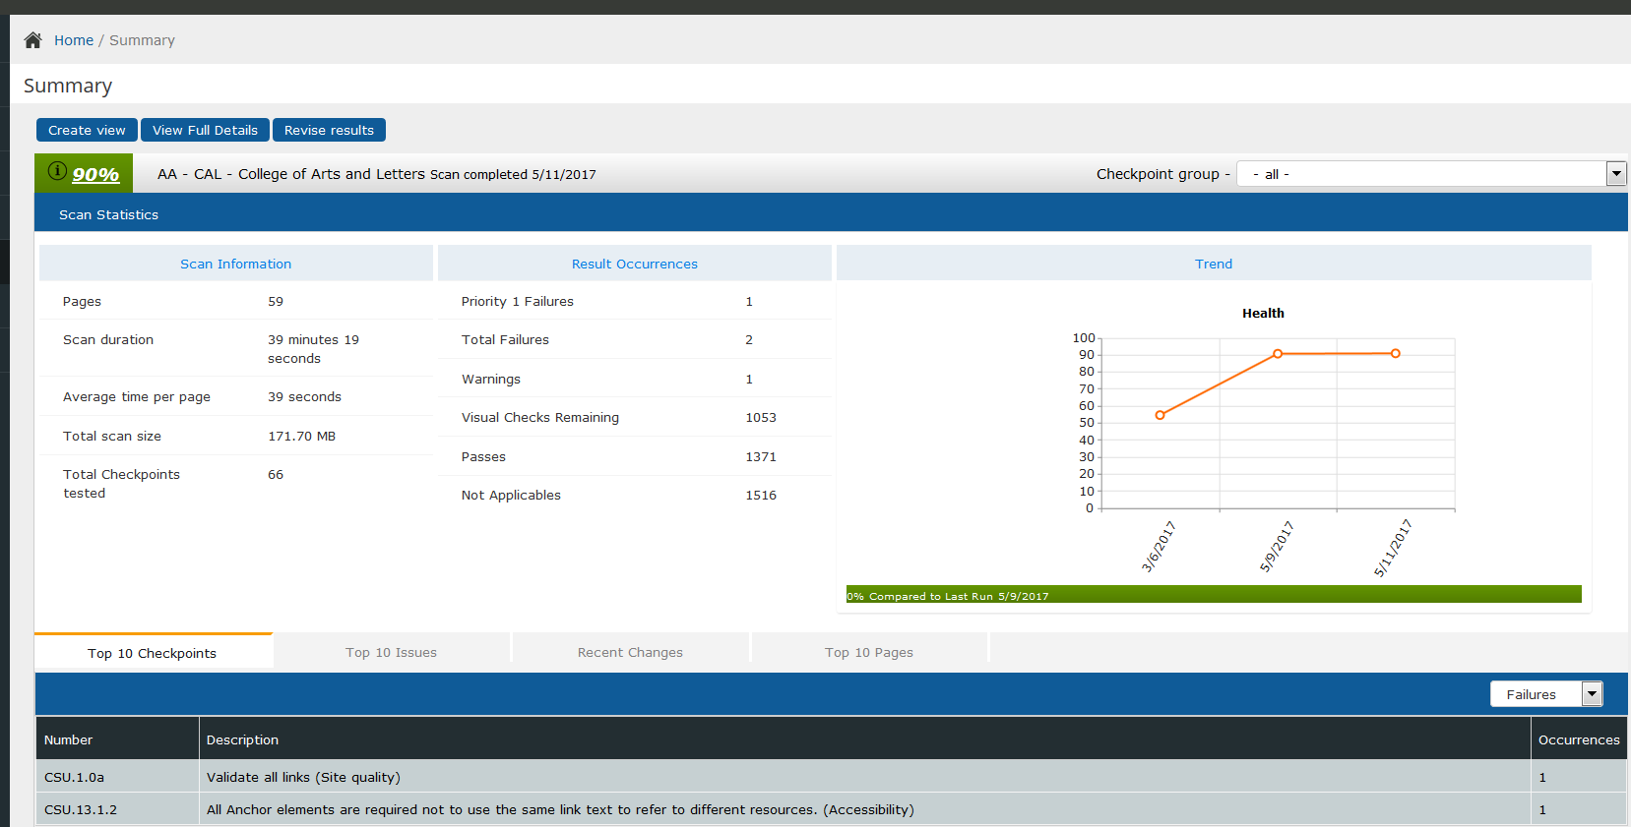
On the top left of the window you can select “View Full Details”
Screenshot of “View Full Details”
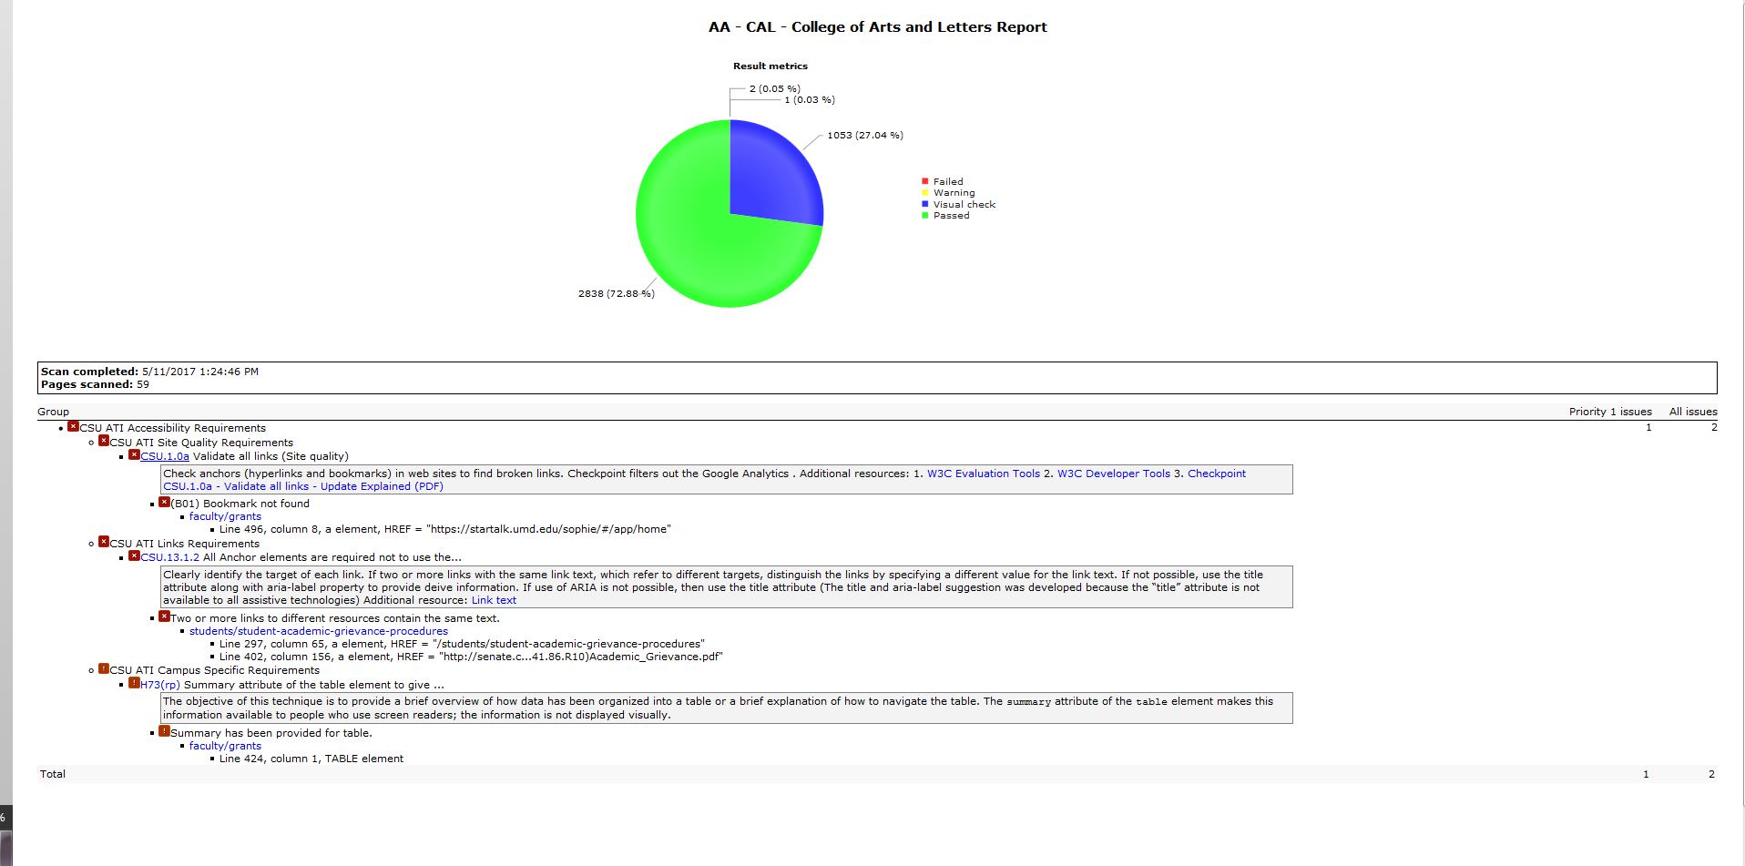

Additional views:
On the bottom left of the screen you can see the errors identified by Compliance Sheriff. The issues are “Failure and/or Warnings”
Screenshot of “Top 10 Issues”
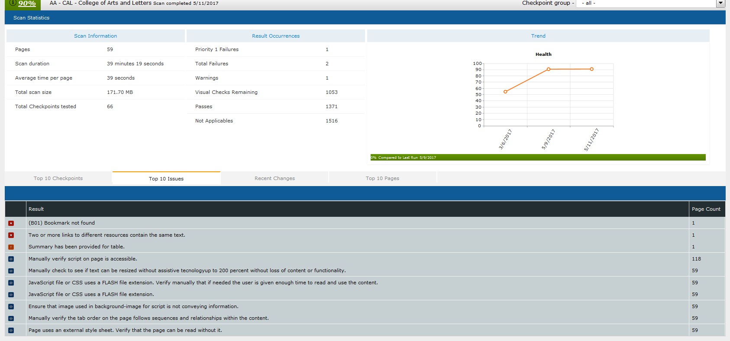

Running a New Automated Scan
Scans are configured to run on a monthly basis. The preferred method to run scans is using the Scan Group Run button. This allows for Cryptzone servers to load balance and avoid performance issues. If you need one or two scans re-run, please select the run button for one scan and wait until that scan has completed before selecting additional scans to run. For large scans the process can take several of days.

Please feel free to call 75079 or email accessibility@csusb.edu and we can help run any scans or answer any questions.

Document Properties
Last Revision: 06/01/2017
Accessibility: “ComplianceSheriffUserGuide.071018.docx” is fully accessible and suitable for electronic distribution
File location: Network/datastore/Dept/ISO/Web Accessibility/18.19 documentation/18.19 Compliance Sheriff/ComplianceSheriffUserGuide.071018.docx

Revision Log
Revision Date: 07/10/18
Author: Rosa Padilla
- All pages updated
Creation Date: 06/01/2017
Author: Rosa Padilla
- Standardized and documented the Compliance Sheriff User Guide

Approval Control
Next Scheduled Review: June 2019
ATI Coordinator Approval: _____________

Next Scheduled Review: June 2018
ATI Coordinator Approval: LJM 6/28/17

