Compliance Deputy Toolbar User Guide

Contents
Compliance Deputy Toolbar User Guide 1
The Accessible Technology Initiative at CSUSB 3
Compliance Deputy 3
Scanning a page: 4
Scan Results for Compliance Deputy 4
Headings Map 5
Broken Links 5
Training on Compliance Deputy 5
Temporary Scans: 6
Document Properties 7
Revision Log 7
Approval Control 7

The Accessible Technology Initiative at CSUSB
The Accessible Technology Initiative reflects the California State University’s commitment to provide access to information resources and technologies to individuals with disabilities. This commitment is articulated in Executive Order 926 (EO 926), the CSU Board of Trustees Policy on Disability Support and Accommodations. The initiative will facilitate improvements in the following three priorities:
- Web Accessibility
- Instructional Materials
- Procurement of Electronic & Information Technology (E&IT)
For more information on the Accessible Technology Initiative at CSUSB email accessibility@csusb.edu or call 909.537.5079.

Compliance Deputy
This guide provides systematic instructions using Compliance Deputy Accessibility Toolbar.

The Compliance Deputy Toolbar can be installed on your computer to run on demand scans of your web page. The tool has been added to the Software Center download page. You can reach out to the Technology Support Center (TSC) for support on installing Compliance Deputy. We have provided step by step instructions as well, our tech community can also review Compliance Deputy Advanced User Guide.

Installing Compliance Deputy in IE:
- Windows Navigate to Start > All Programs (Windows 10 All Apps) > Microsoft System Center >Software Center
- Select Compliance Deputy and Install
Screenshot of Software Center:
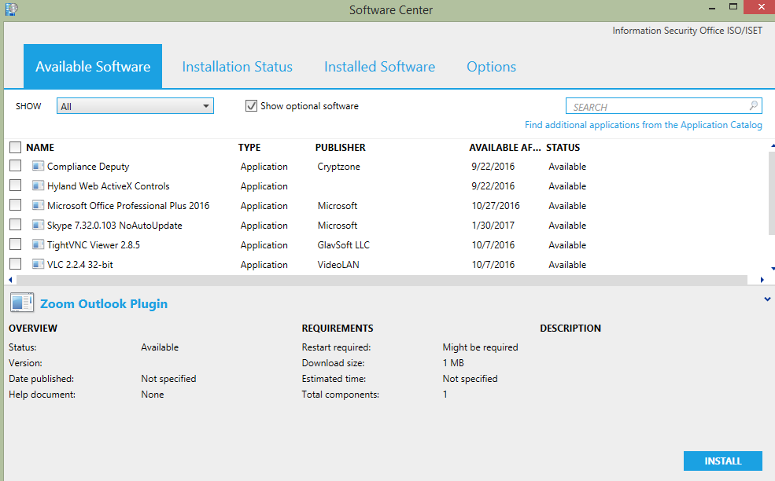

The installation will appear under Installation Status.

Screenshot of installed Compliance Deputy:
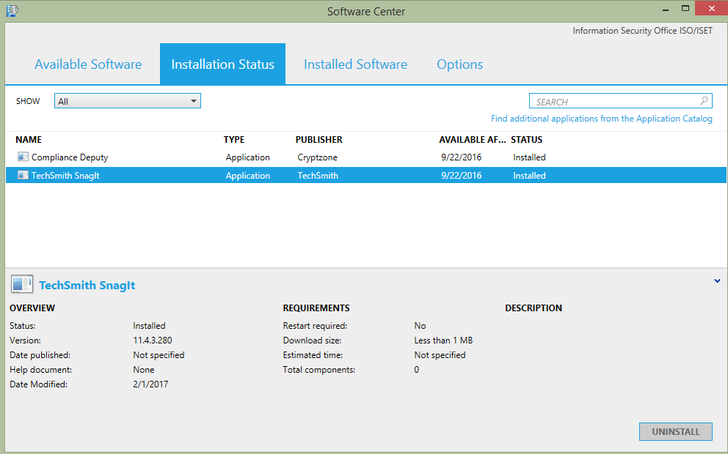

Scanning a page:
- In the browser, type the address of the page you want to scan.
- In Compliance Deputy, select the Checkpoint group you want to scan the page against.
- Click Start Scan. A scan status of “Scan running” will be displayed. When the scan is completed, a new tab is opened to display the scan result, and the status changes to “Complete”.
- To view the scan status, click the status message in the toolbar.
- To view the scan status, click the status message in the toolbar.
- The result allows you to review the page you’re currently developing, make the necessary changes, save and deploy the page, and re-run the same scan.
Screen shot of Compliance Deputy Tool:
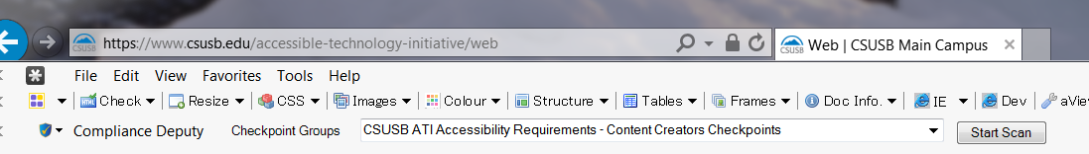

Scan Results for Compliance Deputy
Compliance Deputy will scan a web page for a selected number of checkpoints:
- Same link text but different resources.
- Links that contain the text of “here, click here, click” links should be descriptive.
- Identify Headings that are not properly nested.
- Images must use an “alt attribute”, images that convey meaning must have the words in the image as part of the alt attribute but purely decorative images must contain an empty alt attribute.
- Screen readers cannot read alt attributes longer than 150 characters (including spaces). Place a short alt attribute in the image and the full description below or above the image.
- Alt attributes should not contain the alt attributes of: .jpg, .gif, .bmp, .jpeg, .png
- Alt attributes should not contain the alt attributes of: image
CSUN’s Web Accessibility Problems Overview Webpage:
http://www.csun.edu/udc/udc-training/accessibility-problems.html

Screenshot of Compliance Deputy Scan:
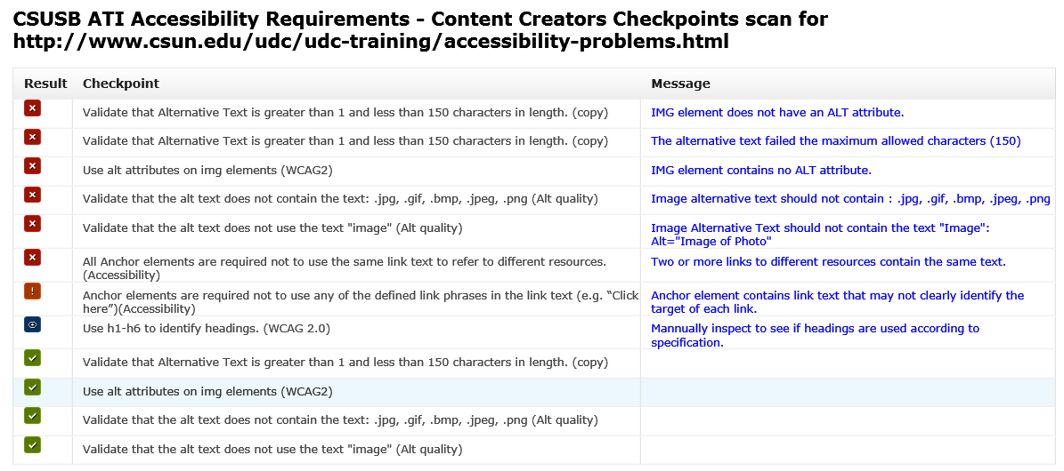

Headings Map
Firefox headings map: https://addons.mozilla.org/en-US/firefox/addon/headingsmap/

Broken Links
W3C Link checker: https://validator.w3.org/checklink

Training on Compliance Deputy
Web Services includes Compliance Deputy in its Drupal training as of September 29, 2016. Content editors and web developers are shown how the tool works and to use the tool after updating/changing content. Documents are located on the Web Services > Support > Guides website: https://www.csusb.edu/its/support/web-services/drupal-guides

Temporary Scans:
Compliance Deputy Scans are stored in Compliance Sheriff in a “Temporary file”. Content editors should check web pages every time content is changed/added. These files are stored in case the CSUSB Campus auditor and or Chancellor’s Office audit team would like to verify that content is reviewed for accessibility.

Document Properties
Last Revision: 6/13/17
Accessibility: “ComplianceDeputyToolbarUserGuide.061317.docx” is fully accessible and suitable for electronic distribution
File location: Network/datastore/Dept/ISO/Web Accessibility/17.18 1.1 Compliance Deputy/ComplianceDeputyToolbarUserGuide.061317.docx

Revision Log
Revision Date: 6/13/2017
Author: Rosa Padilla
- Updated all pages
Creation Date: 2/20/17
Author: Rosa Padilla
- Documented Compliance Sheriff User Guide

Approval Control
Next Scheduled Review: June 2018
ATI Coordinator Approval: LJM 6/28/17

