NEOGOV
Perform Training Guide

Part 3: The Evaluation Process
for Managers & Employees
Topics in this section include Objective Setting, Rating, and Approving, as related to the Employee and Manager roles in the evaluation process.

- Starting Evaluation(s) ……………….…………………………………………………………………………… pg. 3
- Rating a Performance Evaluation (RoR Role) ……..………..…………………………..……………….. pg. 4
- Approving & Signing an Evaluation(s) ………………….…………………………..…………………..……. pg. 6
- Other Tasks ……………………………………………………………………………………………………..………… pg. 9
- Notes & Attachments………………..………………………………………………………………….……………. pg. 12

MODULE A – Starting Evaluation(s)

Step 1: The evaluation can be activated by selecting “Start Evaluation”.

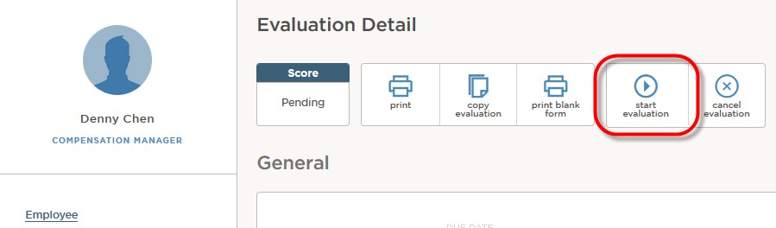

Once the Start Evaluation button is selected, a popup message will appear advising that the evaluation will no longer be in Draft mode:

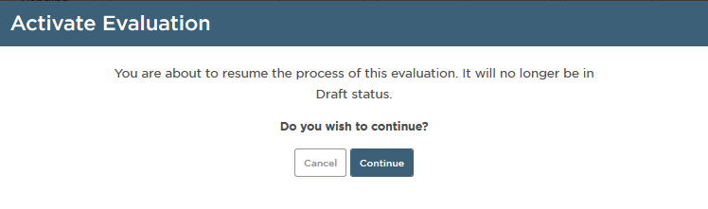

Step 2: Click Continue to activate the evaluation.

Note the status immediately changes to Not Started, and the evaluation (rating) process is ready to begin.

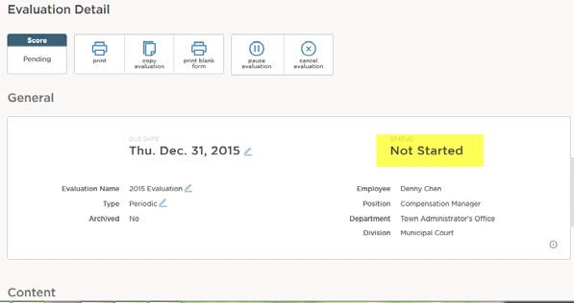

MODULE B – Rating a Performance Evaluation (RoR Role)

The process to rate an evaluation is essentially the same for all raters, i.e. for self-raters, peer reviewers, or Raters of Record. Each rater can access rating tasks requiring their action directly from My Dashboard, then click into each “item” in the evaluation rating form to enter their rating and/or comments.

The actual content in each evaluation rating form, however, may differ by rater as configured in the Evaluation Program or as additional raters have been added to the evaluation. Some sections may not appear to all raters, while other sections may require ratings from some raters but comments only from others.

The visibility for each rater can be configured in the Process section, to restrict or grant access to see what others have submitted in the evaluation rating form. Typically any Rater(s) of Record can see what all other raters have submitted. These comments and ratings from additional raters appear in the Reviewers section within each item on the rating form.

NOTE: if a rater’s visibility has been configured to “See Only Own Ratings” the Reviewers
section will not appear.
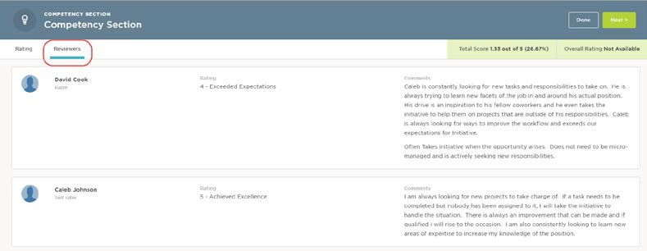

Click on Rating Chart in the Summary section to see a comparative view of all ratings submitted thus far.

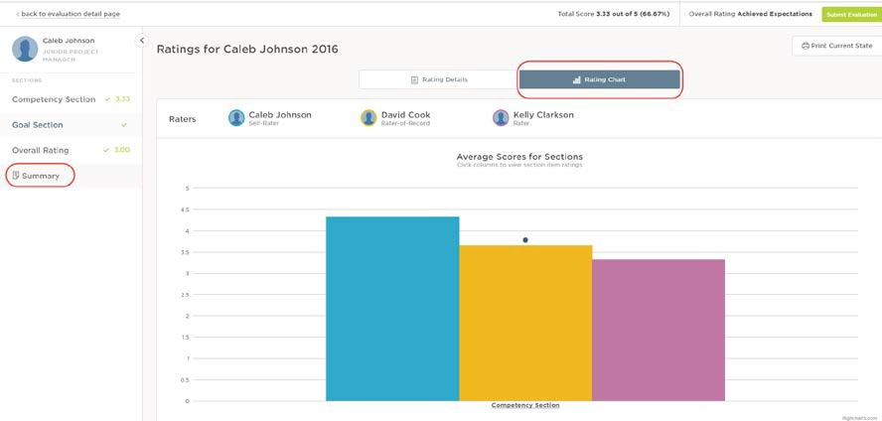
NOTE: Ratings and comments will only appear for those who have actually submitted their reviews. Raters cannot see ratings that have been drafted, but not yet submitted by other raters.

When all required items have been completed, click Submit. Confirm that the rating is complete and accurate by selecting Continue once more. Otherwise, select Cancel to return to previous page.
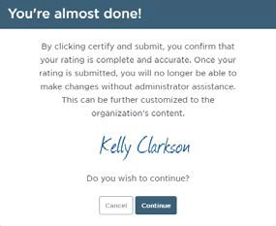

Once successfully submitted, if an approval process is required, an email will be automatically triggered to the first approver.

MODULE C – Approving & Signing an Evaluation

Evaluations may be subject to an approval process, as configured by HR in the After Ratings section of an Evaluation Program or an individual employee evaluation.
Acknowledgment tasks can be in the form of an approval, a signature, or a combination of both.

When the Rater of Record submits an evaluation, the approval process is officially kicked off, generating an email to the first person in the approval process. Once their action is recorded, an email is automatically triggered to the next person in the sequence When ready for action, the approval task becomes Current in the My Tasks section of My Dashboard. These tasks will reside in the Approve & Sign, Sign or Approve boxes on the Dashboard, as seen below.

To approve and/or sign, click on the icon or task title under the Task column:
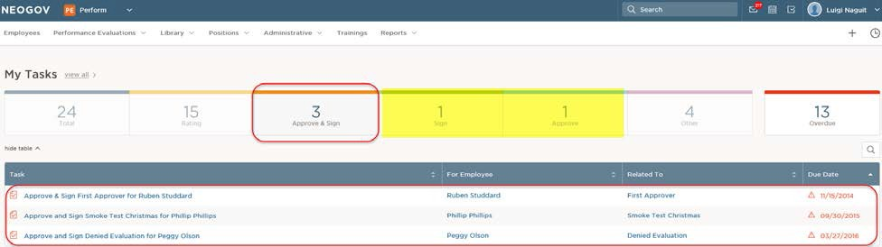

Once the Evaluation Approval page appears, click through each Content section to view full details of the evaluation before recording the approval or denial:

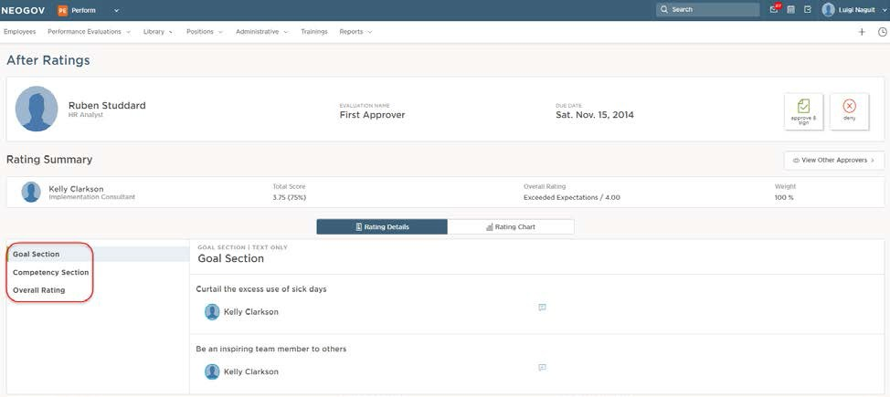

In this example, the 1st approver has both approval and signature rights. Hence, the approval icons and the signature line will appear once you select Approve & Sign.

Click the Approve & Sign (or Approve) icon and select Submit, if you agree with all ratings and comments.

If you disagree with anything, and would like to see changes made, select the Deny icon. Be sure to enter comments, and when ready click Submit. An email will be generated to any rater(s) the evaluation has been sent back to for changes.

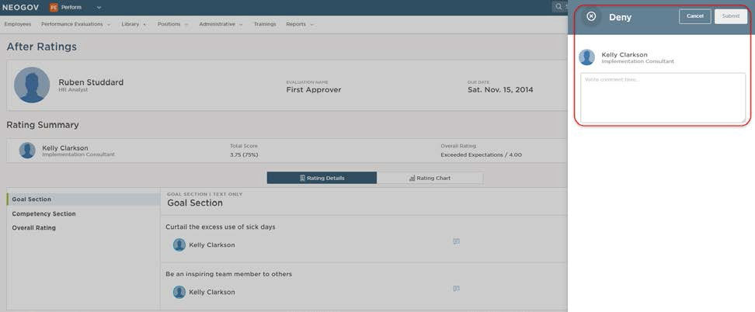
NOTE: When an evaluation is denied, and it is sent back to any weighted rater(s) for changes. Once the Rater(s) resubmit, the approval process is re-triggered again to the 1st Approver.

When an evaluation is approved, an email is immediately generated to the next approver in the sequence to record their approval and/or signature.

If only a signature is required, the option to approve/disapprove will not appear. Typically, employees are granted signature rights only.

Enter an electronic signature or draw in your own by clicking Draw Signature:

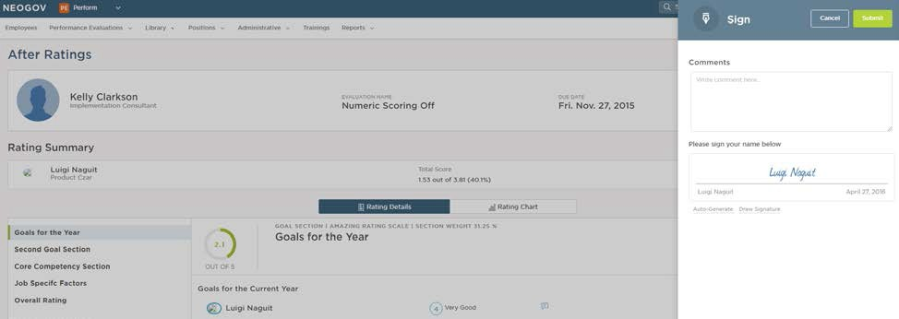

Enter any comments, and click Submit.

Once all approvals and signatures have been recorded, if there are no further approvers in the After Ratings section, the evaluation is considered Completed and the status will update accordingly.

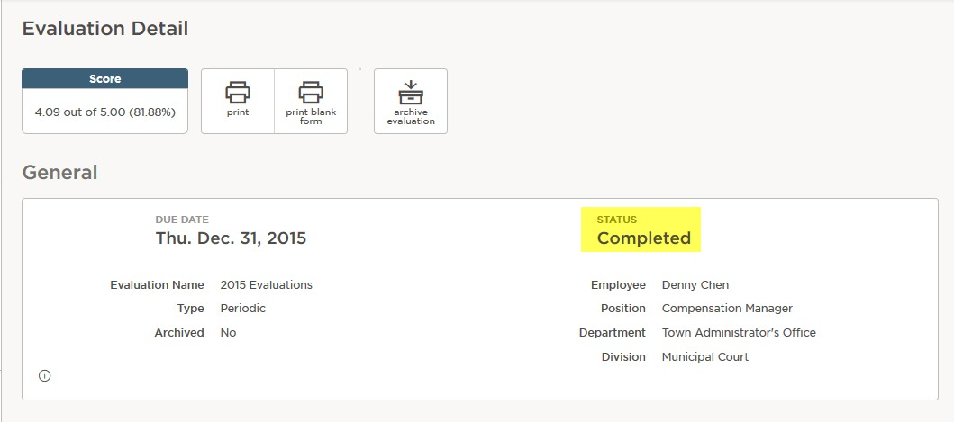

MODULE D – Other Tasks (optional)

In addition to Rating and Approval tasks, there are other tasks that can be created and assigned to an individual in the system.

Before Ratings tasks can be in the form of acknowledgements. If before-ratings tasks are configured in a Program or individual evaluation, a user might be required to acknowledge the evaluation before rating can begin.

The task will appear in the Dashboard as Current as soon as the evaluation is Activated.

To complete the before-rating (acknowledgment) task, be sure to filter on the Sign box and select the icon or task title below the Task column:

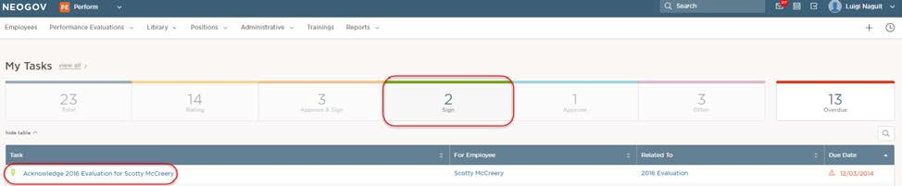

The individual can sign and enter any comments to acknowledge the evaluation.

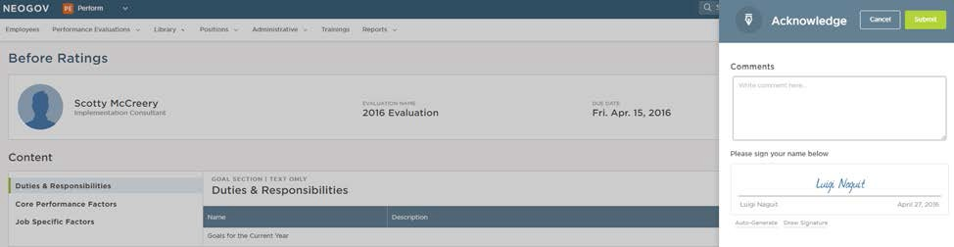

Once submitted the acknowledgment is recorded and the evaluation process continues. If no other before-ratings tasks are required, rating can begin.

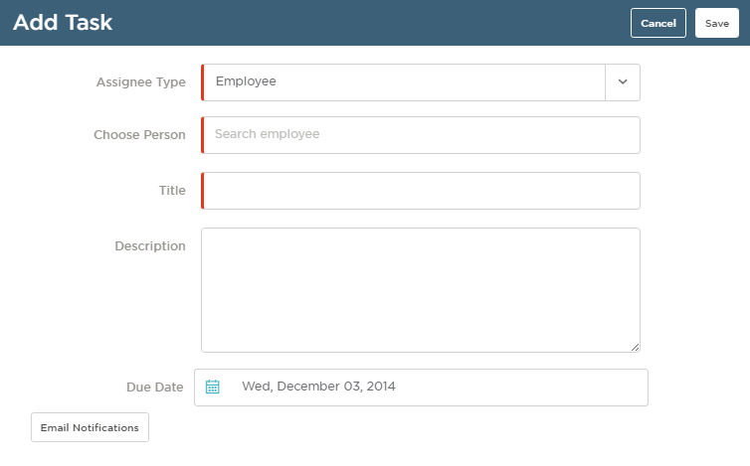

NOTE: tasks can be added to evaluations while in any status (Draft, Not Started, Rating, Approval, etc.). However, the tasks will only appear as Current on the Dashboard once the evaluation is activated.

To complete the task, be sure to filter on the Other box and then select the icon or task title under the Task column:

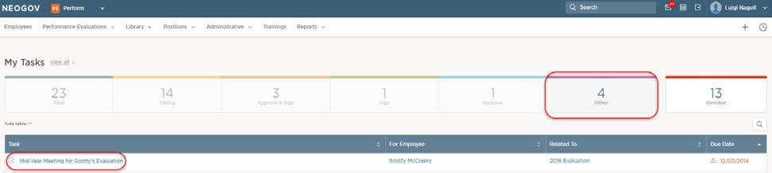

Enter any comments and ensure the Task Status is set to Completed. Click Save.

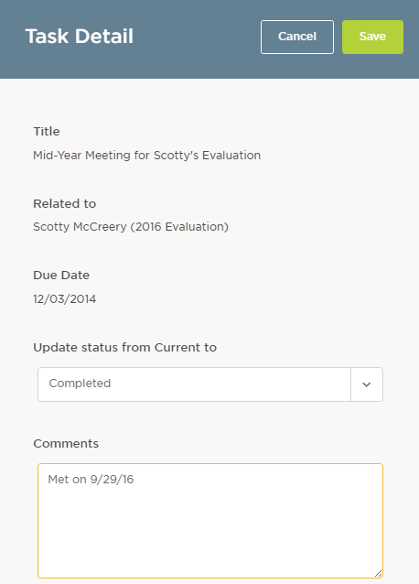

The task is immediately moved from the Dashboard to Completed tasks. The evaluation process continues.

MODULE E – Notes & Attachments (optional)

When recording job strengths and/or deficiencies please use attachments as needed. (emails, letter, memo, etc.)

NOTE: Notes and attachments can be added to evaluations while in any status (Draft, Not Started, Rating, Approval, etc.).

Notes and attachments can be added to an evaluation from within the Evaluation Detail
page (as configured by security).

To add a note or attachment, access the respective evaluation by clicking into the
Evaluation name, then scroll to the bottom of the Content section. Click the +Add Notes
& Attachments button:

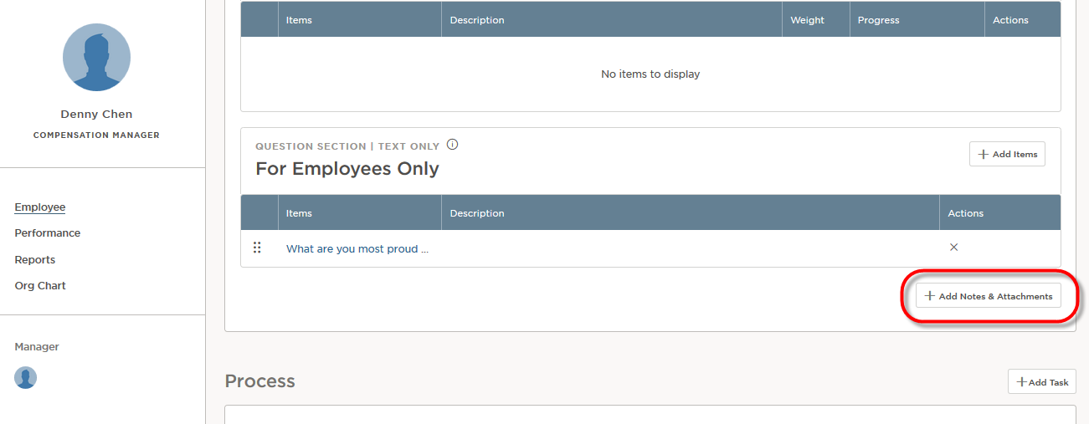
Type directly into the body of the Note, and use the RTE as needed to format any text.

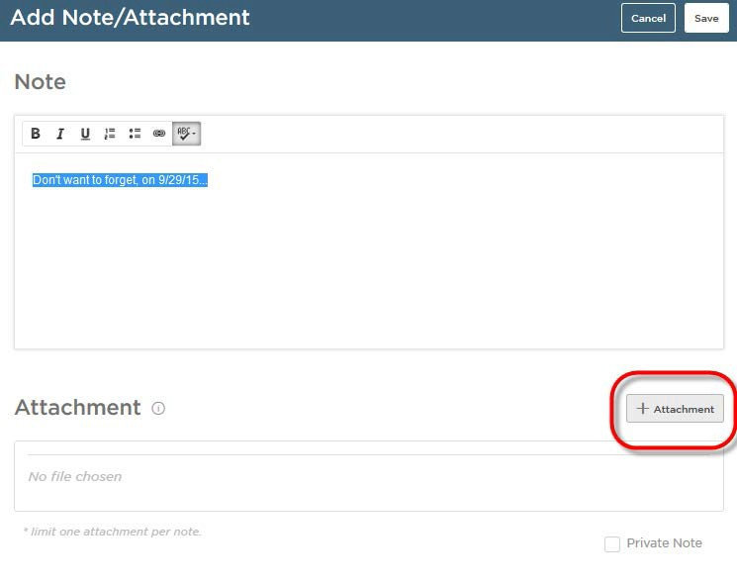

Click the +Attachment button to add a file as an attachment, and browse to select the file:

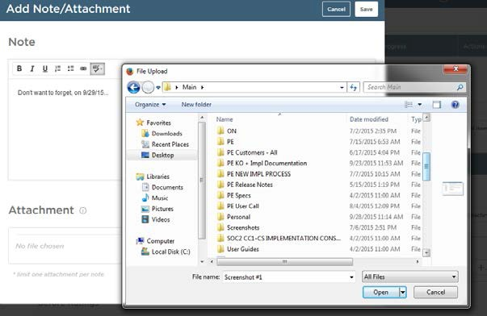

Select Private Note to hide the note from anyone else with access to the evaluation.

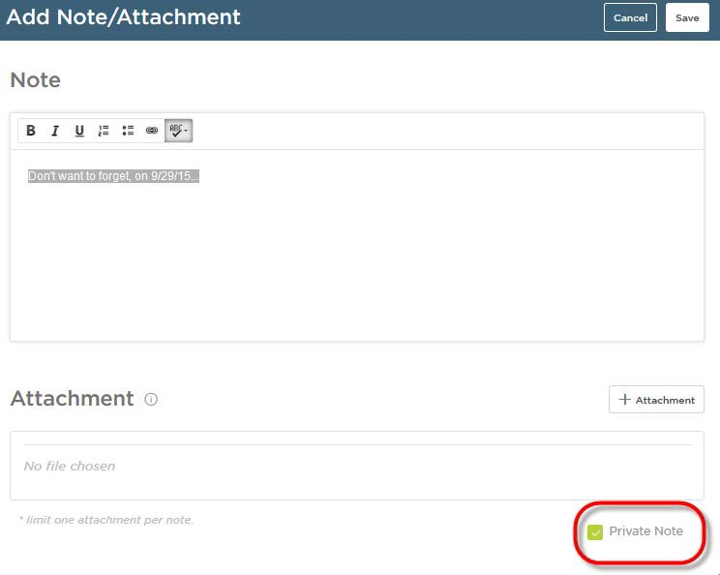

To launch a note or attachment for viewing, access the corresponding Evaluation Detail page, scroll down to the bottom of the Content section to see all notes and attachments then click into the respective note or attachment.

To read the note click into the text hyperlink; to launch the attachment click on the paperclip icon under the Actions column:

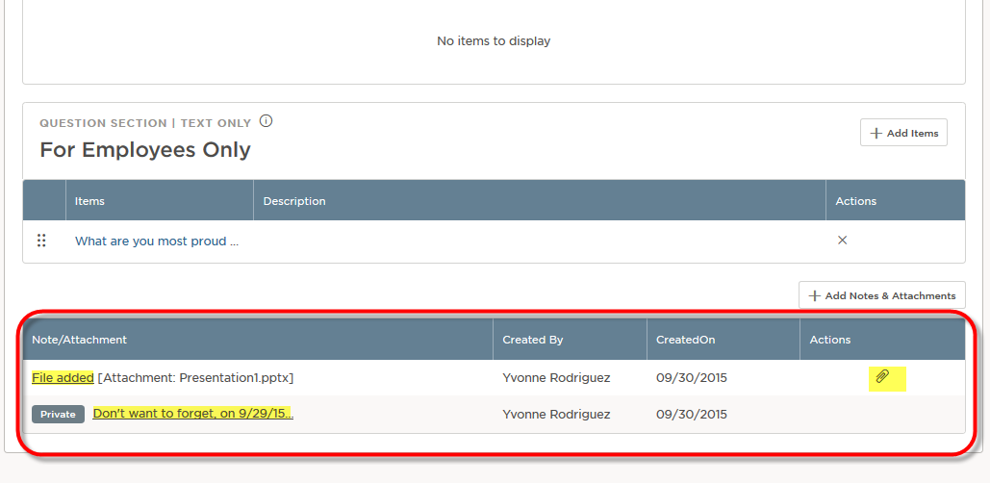

Repeat to add as many notes or attachments as necessary, throughout the evaluation process.

