Michelle A. Behne
mbehne@csusb.edu
Information Security & Emerging Technologies
Contact info: cia-support@csusb.edu
Updated: November 30, 2017
CIA DELEGATE GUIDE
Creating & Monitoring CIA Requests

Contents

Key Websites 2
OnBase Workflow (Production) 2
ISET Contact Info 2
ITS Training 2
New CIA Requests 2
Finding the Form in OnBase 3
Create a CIA Request 4
Monitoring Requests 5
Finding Custom Queries 5
Monitoring Forms 6
THINGS TO NOTE: 6
Interpreting Custom Query Results 7
Table: WF Status Translation 7
FAQs 8
CIA Request Process Flow 10
CIA Components – Descriptions, Requirements, & Training 11

TIP: use this document in its digital form so you can copy & paste the links when needed.

CIA Delegates Guide

Key Websites

OnBase Workflow (Production)
Below are links to 2 OnBase. One way is best for creating CIA Requests. The other is primarily for monitoring CIA Requests.
CREATE REQUESTS | MONITOR REQUESTS
Use any browser | MUST use Internet Explorer
http://bit.ly/2hiIjhR | https://workflow.csusb.edu
Fastest & easiest | More time consuming

TIP: to create a bookmark or favorite – login first before saving either link as a bookmark or favorite. That way when you click your bookmark or favorite you’ll go right to the login screen.

ISET Contact Info
Email: cia-support@csusb.edu
Phone: 77262
Web: https://www.csusb.edu/its/security/submit-computerized-information-access-cia-request

ITS Training
Email: ITSTrainingServices@csusb.edu Phone: x77425

TRAINING SIGN-UP | REVIEW TRAINING RECORDS
https://info001.csusb.edu/cms/reg/courseview.php | https://info001.csusb.edu/cms/reg/mytrain_index.php
Website to sign up for training | Database to review training records
TIP: Give these links to requesters so they can sign up for training & review what training they’ve taken.

New CIA Requests
CREATE REQUESTS
Use any browser
http://bit.ly/2hiIjhR
Fastest & easiest

Create a CIA Request
Use screenshot of the CIA Request form below and do the following:
STEP 1 - Fill out all the information on the Employee tab.
STEP 2 - Select the tab with the necessary components. (1)
STEP 2 - Click the ADD button (2) to open the drop down menu. Click ADD again if more than one component is needed.
STEP 3 - select one or more components needed access using the dropdown (3).
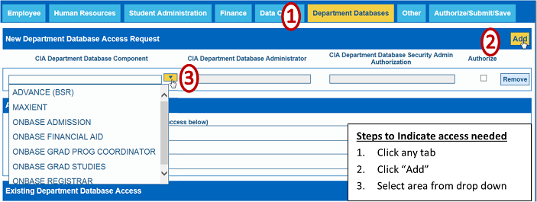
STEP 4 - When finished selecting all the access needed go to the AUTHORIZE/SUBMIT/SAVE tab to click the "SAVE" button. This submits the form.

NOTE: Blank forms are forms without a component which prevents CIA Requests from moving through the process.

Monitoring Requests
The best place to see the status of CIA Requests is by using “Custom Queries”. First login to OnBase Workflow using the URL https://workflow.csusb.edu.
MONITOR REQUESTS
MUST use Internet Explorer
https://workflow.csusb.edu

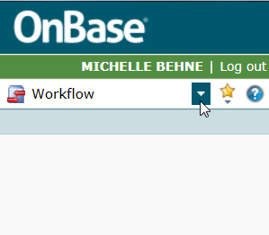
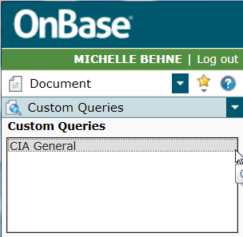
Finding Custom Queries
Navigate to Custom Queries using these steps.

- Click carat next to Workflow to reveal Document.

- Click Document to reveal Custom Queries.

- Click Custom Queries to show CIA General then click that.

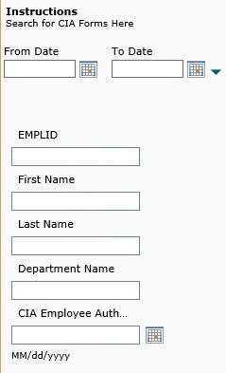
- The image to the right shows the search parameters fields.
Remember:
Only one search parameter is needed.
Wild card is the asterisk “*”.
Use * when doing partial word searches.

TIP: To avoid these steps in the future save this page as a “Favorite”. Click the star next to the document carat. You’ll be asked to name this “Favorite”. Use “Monitor CIA Requests”. Click save. Next time you login click the star & the “Monitor CIA Requests” will be listed as a Favorite.

Monitoring Forms
- Enter one or more parameters into the appropriate field.
- Click “Enter” or the binoculars in the bottom left of the page.

THINGS TO NOTE:
- OnBase’s search wildcard is “ * “ (asterisk)
- Use wildcard when searching partial words or partial name.
- Only one search parameter is needed.

Example: Someone’s last name is Brown-Welty. The search for last name must be “Brown*” or “Bro*”

Example: Searching someone’s first name: Mich* will pull names like Michelle, Michael and Michaela.

Interpreting Custom Query Results
Here’s a sample search. Notice the WF Status column (WF = Workflow). This is the information needed to determine the form’s status.
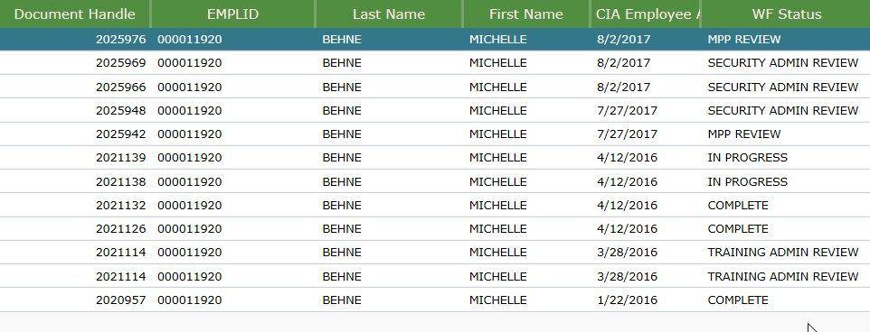

Pay attention to details like the date of the CIA Employee authorized to discern if there’s more than one submission.

Table: WF Status Translation
WF Status | Meaning | OnBase Queue
MPP REVIEW | Waits for MPP approval | MPP
SECURITY ADMIN REVIEW | Security Admin authorization required | Security Admin
TRAINING ADMIN REVIEW | Training has not been validated or training has not been completed. | Training Validation
IN PROGRESS | Ready for Implementation | Implementation
COMPLETE | No longer in Workflow – request is finished or fell out of workflow. | No Queue

FAQs

ACCESS REQUIREMENT
- What components have paperwork requirements? And what are those requirements?

CIA COMPONENT | PAPERWORK REQUIRED | DEPT. TO CONTACT
Absence Management – Timekeeper or Approver | Signature Authorization Form | Payroll
Master Pay Warrant Authorization (MPWA) | Signature Authorization Form & MPWA form | Payroll
ProCard | ProCard application | Purchasing
Requisitions | Approval form with signature of authorized signer for chart-string account | Purchasing

REQUEST MODIFICATION
- Am I allowed to modify a request after submission?
No. Email cia-support and “cc” the requester & the requester’s MPP. In the email include name, emplid, date of submission and what needs to be changed.
- Can CIA Delegates change the MPP after the form has been submitted?
No. Email cia-support and cc the new MPP. Include in the email: Requester’s name & emplid and date of CIA Request submission along with who will be the MPP Approver.
- Does a manager have to approve the entire CIA Request?
Managers have the ability and authority to add or remove components from a CIA Request. The “Add” and “Remove” buttons on the component’s line allow modification of CIA Requests.
- What if a request needs to be removed?
Email cia-support and “cc” the requester’s MPP. Include name, emplid, date of submission along with the request to remove from Workflow.

PROCESS REQUIREMENT
- When is a CIA Request not needed for changing access?
A person increasing their current access in a specific component will not need a CIA Request. For example, if the Student Records View access needs upgrading or slight modification. The only exception is when adding departments to those with MPWA or Absence Management Access. Here is when a new CIA Request is required.
- What if a new employee’s access needs to mirror someone no longer at the university?
Screen shots are made of the PeopleSoft access of exiting personnel. Email cia-support@csusb.edu to request details about retrieving PeopleSoft access screen shots.
- Why is a new CIA Request needed when people transfer?
It cannot be assumed a transferee's access for their new duties will match the access of their old position. Hence, standard security practice is to remove administrative PS access then require a new CIA request must be submitted. However, CIA Delegates can submit requests for incoming personnel before they arrive.

ONBASE FUNCTIONALITY
- Why does the screen go blank when submitting a CIA Request?
If you're using a browser other than Microsoft Internet Explorer, there will be a blank page upon submission. This is a known OnBase issue.
- Can Mac users create CIA forms since OnBase works only with Internet Explorer?
Yes - by using a virtual environment. Contact cia-support@csusb.edu for additional details.

CIA Request Process Flow
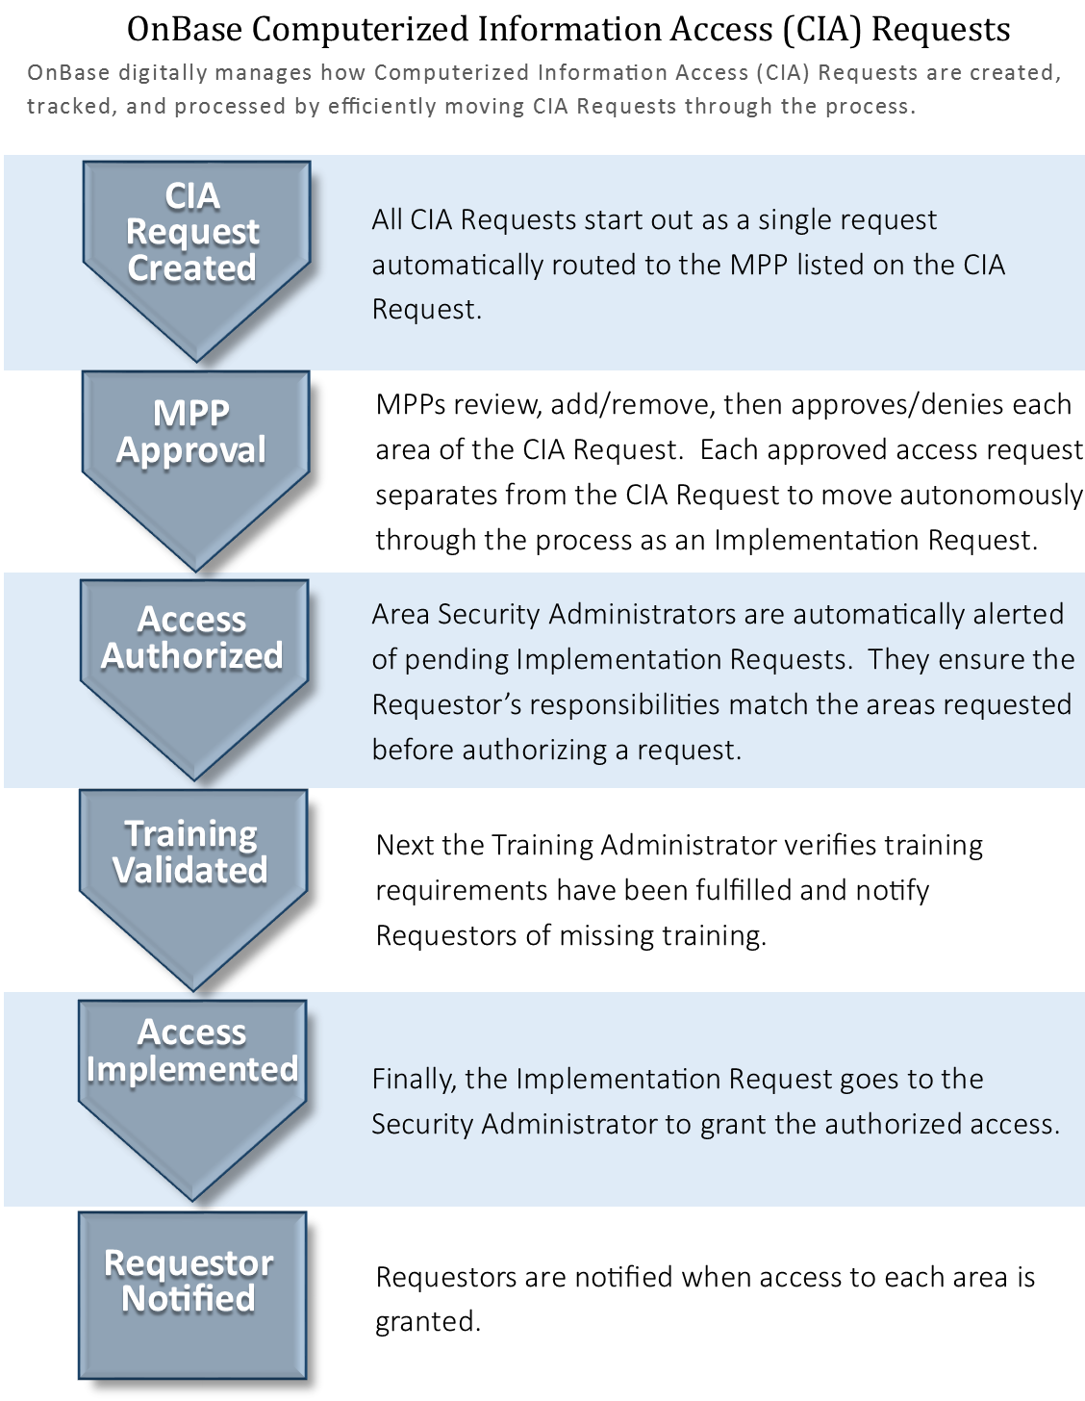

CIA Components – Descriptions, Requirements, & Training
The spreadsheet containing this information is available separately. Retrieve it from the ISET website listed in the header of this document or email cia-support@csusb.edu for a copy.

TIP: Use the CIA Components spreadsheet with descriptions, requirements and training in its digital form to enable easy search capabilities and manipulation of the information.

