 | COA/CFS Account Conversion Query HowTo Guide

Last Revised: 04/12/10
Final 04/12/10
REVISION CONTROL
Document Title: COA/CFS Account Conversion Query HowTo Guide Conversion
Author: Budget Office/CMS
File Reference: 0000.doc
Revision History
Revision Date | Revised By | Summary of Revisions | Section(s) Revised
4/12/10 | CMS/dc | Update using template – ADA compliance | All
Review / Approval History
Review Date | Reviewed By | Action (Reviewed, Recommended or Approved)
4/13/2010 | Budget/ ABeechko | Approved

Table of Contents Page
How to use the OLD_TO_NEW_ACCT queries 4

How to use the OLD_TO_NEW_ACCT queries
The following queries have been created to assist with the identification of the new Account numbers effective April 15, 2010. Image of Query Manager page
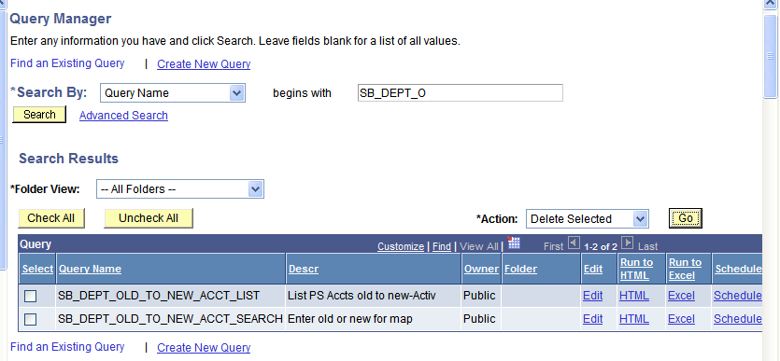
- Search for the Queries SB_DEPT_OLD_TO_NEW_ACCT_LIST and SB_DEPT_OLD_TO_NEW_ACCT_SEARCH
- Save them as Favorites
For a list of all old to new Accounts
- Run the SB_DEPT_OLD_TO_NEW_ACCT_LIST (Use Excel Link)
To find the new Account for a specific Old Account
- Run the SB_DEPT_OLD_TO_NEW_ACCT_SEARCH (use Excel Link)
Enter the old Account # and use % in the new Account number box. Search for a specific translation.
For Example : Old Account = 619091 New Account = % Select View Results button.
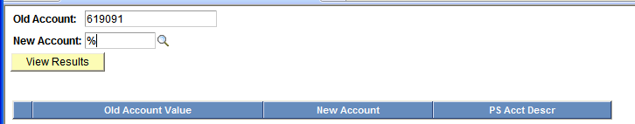
Use the % in the New Account Field. Never leave a parameter field blank when running queries, use %.
Results will be viewed in Excel.


