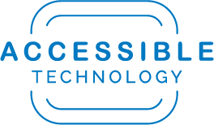

Accessibility for Drupal Content Editors

Table of Contents
Page Navigation & Structure 3
Hyperlinks: Always use Descriptive Link Text and Mask URLs 3
Headings: Use them in Order and Do Not Fake with Visual Emphasis Alone 3
Ordered Lists 4
Images 4
Alternative Text: Ensure Quality Alt Text for Images that Convey Meaning 4
Digital Content & Multimedia 5
Word, PDF, PowerPoint Documents 5
Videos Require Captions 5
Audio Files Require Transcripts 5
Help & Resources 6

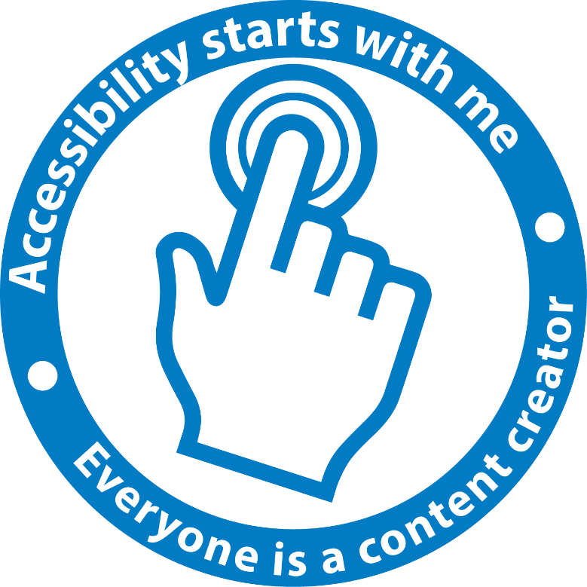

Page Navigation & Structure

Hyperlinks: Always use Descriptive Link Text and Mask URLs

Why?
Screen reader users and users of other assistive technologies frequently navigate webpages via an extracted list of links. When links are extracted for navigational purposes, there is no surrounding context to provide meaning. Use of non-descriptive link text such as “click here”, “read more”, etc. do not stand alone. The result is that users are not able to efficiently navigate a webpage.
Assistive technology users can also sort through their list of links alphabetically via first letter navigation. Thus, link text with the same word repeated at the beginning of every link, even if the link text is descriptive, makes the alphabetic first letter navigation method less useful.
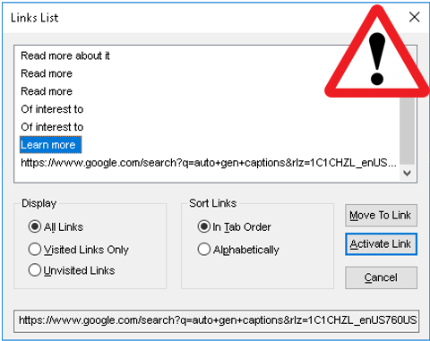

Best Practices
- Do not use unmasked URLs as links on your page
- Mask the full URL with descriptive text of where the link will take the user
- If you have repetitive language in your links on a page, place the repetition at the end of the link text.
- If your link will immediately trigger a download, be sure to include “download” in the link description

Headings: Use them in Order and Do Not Fake with Visual Emphasis Alone

Why?
Headings provide structure for the information on your page; however, they are often improperly used by content editors for style and emphasis without consideration to structure. As with links, assistive technology users can extract headings from a page to navigate to specific content areas. Headings signal the nesting level of information on a page. For example, a heading level 2 could be “Dog Breeds”, with specific breeds such as “Labrador” and “Golden Retriever” being heading level 3s.
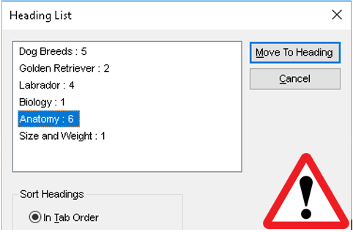

Best practices
- Do not skip heading levels. If you are using a heading level 4, there should be a level 3, 2, etc.
- Do not use headings out of order. The progression should be logical: 2, 3, 4, etc.
- Do not fake headings. In other words, do not employ emphasis with bold or large text alone. While these techniques may provide visual emphasis, there is no programmatic structure provided to assistive technology users.

Ordered Lists
When you are creating a list of any type, whether numbered, bulleted, or indented, be sure to use the tools in the Drupal toolbar.

Images

Alternative Text: Ensure Quality Alt Text for Images that Convey Meaning

Why?
Alternative text (alt text) is the primary method used to convey the meaning of images to non-sighted users via assistive technology. The quality of alt text is important. Alt text also provides a descriptive and meaningful placeholder for images on a page if they are not loaded, or if the user has elected to load the page with images turned off. There are typically two classifications of images on the web: decorative images and images that convey meaning or information.

Best Practices
- Be as concise and accurate as possible. A few words to a short sentence will typically suffice to describe the content and function of an image
- Do not include terms such as “graphic” or “image of” as these are redundant (screen reader identifies the object)
- If your image is decorative and it is also a link, you must provide alt-Text
- Decorative images or images that do not convey meaning of importance should have a null alt attribute (alt=”“)

Digital Content & Multimedia

Word, PDF, PowerPoint Documents
Principles for accessible documents are much the same as for the web. Here are the top issues to keep in mind when posting documents to your website:
- Use headings to provide structure for your documents
- Add alt-text to images that have meaning
- Mask URLs with descriptive text
- When inserting numbered or bulleted lists or a table of contents, use the tools provided. Do not create manually.
- PDF documents should be properly tagged
- PDF documents should be checked for reading order
- Ensure that document properties are correct such as title, language, author, etc.

Videos Require Captions

Why?
YouTube auto-generated captions are about 95% accurate, but it is that last 5% that is required to meet accessibility. It is recommended that you utilize YouTube’s auto generated captions to create initial captions and timings, but that these are further edited for accuracy.
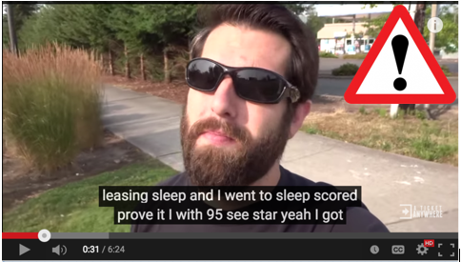

Best Practices
- YouTube auto generated captions are not sufficient-- manually edit then for accuracy
- Don’t forget to check for punctuation, capitalization, and timing captions are on the screen simultaneously with corresponding audio)
- Avoid creating videos that present information visually but have only music for audio. Without meaningful audio, blind individuals will not be able to access the information being presented

Audio Files Require Transcripts
If you are positing audio only files (such as a podcast of a lecture) on the web, you must provide a text transcript of the audio, preferably in html or .txt. This will allow individuals who are hard of hearing or deaf to access your content.

Help & Resources
You can reach out to the accessibility team with questions or comments at any time by emailing accessibility@csusb.edu or by calling extension 75079 and selecting option 3. In the meantime we recommend that you also check out the following resources:
- VIDEO: Manually Edit YouTube Auto-Gen Captions
  - [https://www.csusb.edu/accessible-technology/accessibility-training]
- Check the accessibility of your Webpage with the WAVE Toolbar
  - [http://wave.webaim.org/]
- Sign up for accessibility training on the Accessible Technology Initiative website
  - [https://www.csusb.edu/accessible-technology/accessibility-training]

