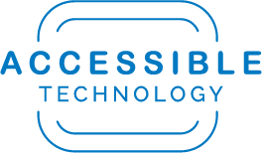

Accessibility Strategies

for Drupal Content Editors

Table of Contents
Page Navigation & Structure 3
Hyperlinks: Always use Descriptive Link Text and Mask URLs 3
Headings: Use them in Order and Do Not Fake with Visual Emphasis Alone 4
Ordered Lists 4
Images 4
Alternative Text: Ensure Quality Alt Text for Images that Convey Meaning 4
Digital Content & Multimedia 5
Word, PDF, PowerPoint Documents 5
Videos Require Captions 5
Audio Files Require Transcripts 6
Help & Resources 6

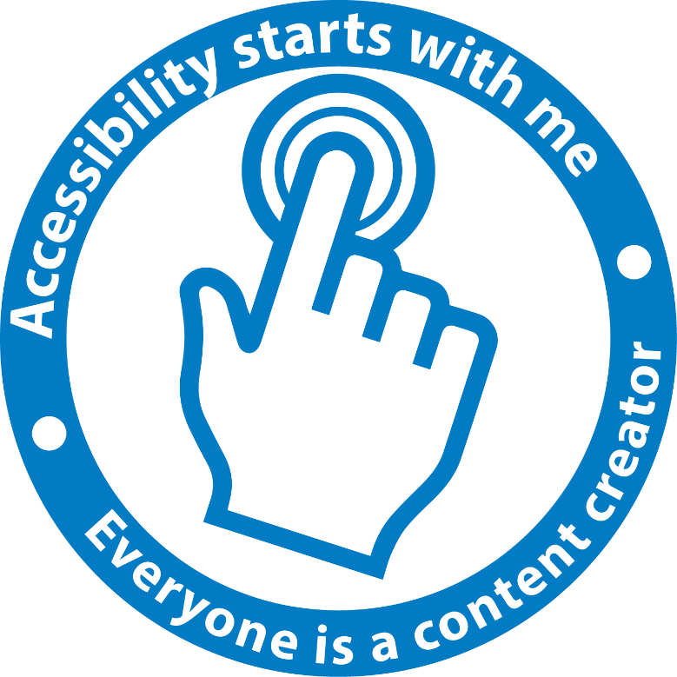

Page Navigation & Structure

Hyperlinks: Always use Descriptive Link Text and Mask URLs
It’s not enough to simply mask exposed URLs with text, you need to ensure that the text used to describe a link is descriptive and can stand alone without additional context.

Why?
Screen reader users, and users of other assistive technologies, frequently navigate webpages via a list of extracted links. This navigation method makes it easy to jump to specific content or areas of interest on a webpage without having to painstakingly navigate through extensive repeated navigational menus and multiple pages. However, when links are extracted for navigational purposes, the surrounding text is not included to provide meaning. If links are exposed (simply the full URL) or are masked by non-descriptive text such as “click here”, “read more”, “of interest to”, etc., the user cannot discern where clicking this link will take them. Non-descriptive links are useless to screen reader users and force them to navigate a webpage in a slow and ineffective way just to find very basic information.
In addition, screen reader users can also sort through their list of links alphabetically via first letter navigation. Thus, link text with the same word repeated at the beginning of every link, even if the link text is descriptive, makes the alphabetic first letter navigation method less useful.
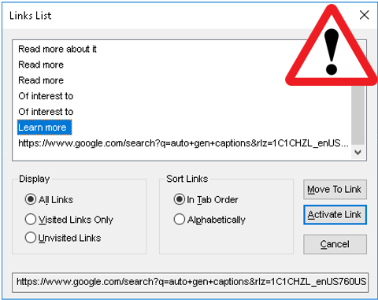

Best Practices
- Do not use unmasked URLs as links on your page
- Mask the full URL with descriptive text so that the link alone makes sense
- If you have repetitive language in multiple links, place the repetitive language at the end of the link text
- If your link will immediately trigger a download, or an action other than going to another webpage, be sure to include “download” or the resulting action in the link text to alert non sighted users of what to expect.

Headings: Use them in Order and Do Not Fake with Visual Emphasis Alone

Why?
Headings provide structure and hierarchy for the information on your webpage. However, headings are often improperly used by content editors simply for their visual style and emphasis without considering the hierarchy created by the heading level. As with links, assistive technology users can extract headings from a webpage to navigate to specific content areas. Headings signal to the user the hierarchal classification of information on a webpage. For example, a heading level 2 could be “Dog Breeds”, with specific breeds such as “Labrador” and “Golden Retriever” each being heading level 3s. As is illustrated in the screenshot below, the headings (indicated by the number) on this webpage are illogical and out of order, they do not provide a logical breakdown of information to the user. If the user were to navigate via a heading level 2 in the list below, they would not get to the most important content as they should, they would be buried in the weeds of the information and could miss the overarching classification.
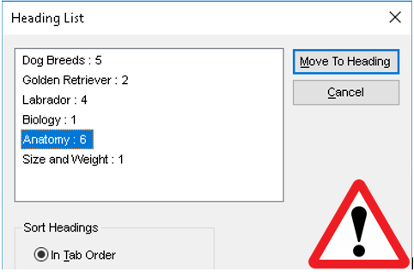

Best practices
- Do not skip heading levels. If you are using a heading level 4, there should be at least one heading level 3, 2, etc.
- Do not use headings out of order. The progression should be logical for nested information: 3 under 2 etc.
- Do not fake headings. Do not use bold, large text, underline, or other visual methods alone. While these techniques may provide visual emphasis, there is no programmatic structure provided to assistive technology users. If headings are visual only, there will be “no headings found” for users of screen readers or other assistive technologies.
Would you like to see good heading structure in action? If you’re reading this document in Word, click on the “View” tab on the ribbon, and then check the box “Navigation Pane” to expose the headings list.

Ordered Lists
When you mean to designate information as a list, whether numbered, bulleted, or indented, be sure to use the tools in the Drupal toolbar. Manually placing a symbol in front of a line of text, such as a dash or asterisk, or manually numbering information, while it appears to the visual user as a list, is not identified by screen readers and other assistive technology as a list. If properly designated as a list using the tools, users of assistive technology will be alerted of a “list with 7 items, item one” if the list is number. If the list isn’t created using the tools there is no audio emphasis of the information to the screen reader user.

Images

Alternative Text: Ensure Quality Alt Text for Images that Convey Meaning
Images can be categorized into three main types; decorative, images that convey meaning, and complex images. Decorative images do not require alt text. Images that convey meaning should have concise alt text of what is being conveyed. Do not include “image of” in alt text as this is already read aloud by assistive technology. You can use concise language regarding this composition of the image such as to denote a portrait or headshot for example. Complex images are those that contain a lot of information, perhaps images of text such an image of a flyer, and the description would be too much for a short alt text description. In the case of text description of text images, use a figure caption under the image to describe it.

Why?
Alternative text (alt text) is the primary method used to convey the meaning of images to non-sighted users via assistive technology. The descriptive quality of alt text is important, in the same way that a description of something should be as concise as possible. In addition, alt text provides a descriptive and meaningful placeholder for images on a page if they are not loaded, or if the user has elected to load the page with images turned off.

Best Practices
- Be as concise and accurate as possible. A few words to a short sentence will typically suffice to describe the content and function of an image
- Do not include terms such as “graphic” or “image of” as these are redundant (screen readers will identify the object)
- If your image is decorative and it is also a link, in this case you must provide alt-text
- Decorative images or images that do not convey meaning of importance should have a null alt attribute (alt=”“)
- For complex images that require a lot of description, use a figure caption to describe the image.

Digital Content & Multimedia

Word, PDF, PowerPoint Documents
Principles for accessible documents are much the same as for the web. If you are uploading documents to the web you should ensure that your documents are accessible. Here are the top issues to keep in mind when posting documents to your website:
- Use headings to provide structure for your documents
- Add alt-text to images that have meaning
- Mask URLs with descriptive text
- When inserting numbered or bulleted lists or a table of contents, use the tools provided. Do not create manually.
- PDF documents should be properly tagged
- PDF documents should be checked for reading order
- Ensure that document properties are correct such as title, language, author, etc.
Accessibility has a created a variety of guides to help with creating digital content. Visit the Accessible Technology website for training and tools on accessibility best practices.

Videos Require Captions

Why?
YouTube auto-generated captions are about 95% accurate, but it is that last 5% of correction that is required to meet accessibility standards. It is recommended that you utilize YouTube’s auto generated captions to create the initial captions and timings for YouTube videos that you own, but that you follow instructions to further edit them for accuracy.
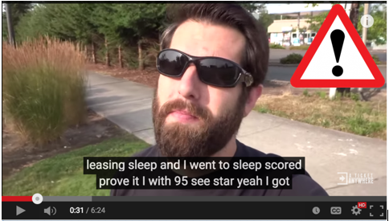

Best Practices
- YouTube auto generated captions are not sufficient and must be manually edited for accuracy
  - Don’t forget to check for punctuation, capitalization, speaker, and timing (captions are on the screen simultaneously with corresponding audio)
- Avoid creating videos that present information visually but have only music for audio. Without meaningful audio, blind individuals will not be able to access the information being presented.
  - Audio description can be used in addition to captions to describe visual information on the screen.
Accessibility has created a short video guide for manually editing YouTube captions.

Audio Files Require Transcripts
If you are positing audio only files (such as a podcast of a lecture) on the web, you must provide a text transcript of the audio, preferably in html or .txt. This will allow individuals who are hard of hearing or deaf to access your content.

Ongoing Monitoring of CSUSB Website Accessibility
Each month, Accessible Technology sends divisions, colleges, and other departmental entities an email which contains the latest automated accessibility scan results from the CSU automated website evaluation tool, currently Compliance Sheriff. The purpose of this email is to ensure continual improvement of CSUSB website accessibility, and to ensure that individuals who contribute content or design websites are aware of their impact on website accessibility.
If you are responsible for ensuring that your website is accessible, or if you would like access to Compliance Sheriff to check the accessibility of your website, contact Accessible Technology to have a Compliance Sheriff account created.

Help & Resources
You can reach out to the accessibility team with questions or comments at any time by emailing accessibility@csusb.edu or by calling extension 75079. In the meantime we recommend that you also check out the following resources:
- VIDEO: Manually Edit YouTube Auto-Gen Captions
  - [https://www.csusb.edu/accessible-technology/accessibility-training]
- Check the accessibility of your Webpage with the WAVE Toolbar
  - [http://wave.webaim.org/]
- Sign up for accessibility training on the Accessible Technology Initiative website
  - [https://www.csusb.edu/accessible-technology/accessibility-training]

