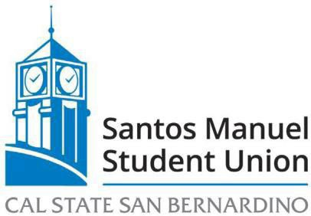

California State University, San Bernardino Santos Manuel Student Union Board of Directors Finance and Contracts Committee Meeting
April 4, 2023

MINUTES

MEMBERS PRESENT: Jasmine Curtis, Maria Najera-Neri, Dulce Gonzalez, Esteban Hernandez, Jose Hernandez, Jesse Felix

STAFF PRESENT: Carlos Gonzales, Anthony Roberson, Lee Stovall, Christine Grott, Sasha Baltazar, Navneet Singh, Vilayat Del Rossi, Jared Fisk, Debahni Escobar, Sonia Martinez, Roryana Bowman, Rosemary Zometa, Angelica Agudo, Monica Baeza, Matthew Jenkins, Juan Serrato, Trent Morgan, Mark Oswood, Jenny Puccinelli, Mike Palacios, Tamara Holder, Sean Kinally, Alexandra Thambi

Call to Order: The meeting was called to order at 10:33am.

Roll Call: A verbal roll call of members was conducted.

Approval of Minutes from February 2, 2023
M/S Curtis/Gonzalez to approve the minutes from February 2, 2023
Motion approved by consensus.

Open Forum (3 minutes per speaker)
There were no speakers for Open Forum.

Adoption of Agenda
M/S Gonzalez/E. Hernandez to adopt the agenda.
Motion approved by consensus.

NEW BUSINESS
FC 11/23 First Reading of Annual Budget (Discussion, Najera-Neri)
M/S Curtis/Gonzalez to open FC 11/23 First Reading of Annual Budget.
Discussion ensued regarding changes to the Annual budget including an increase in the Admin line for travel to conferences and utilities costs. An increase in the Maintenance budget for supplies, summer students, increase in set up costs. This budget is ready for review by the Board of Directors.

M/S Neri/Gonzalez to amend FC 11/23 to an action item.
Motion approved by consensus.

Motion to approve FC 11/23 as amended by consensus.

Announcements -There were no announcements.

Adjournment- M/S Gonzales/E. Hernandez to adjourn at 12:12pm

Respectfully reviewed and submitted by:

_________________________________ ___________________________

Jose Hernandez, Committee Chair Date

