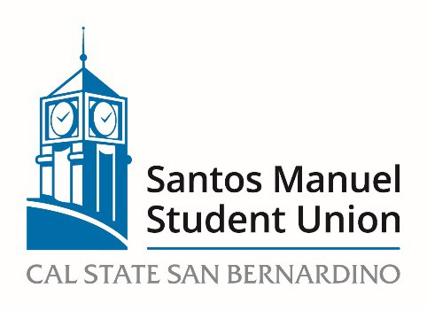

California State University, San Bernardino

Santos Manuel Student Union Board of Directors

Personnel Committee

April 20, 2023

MINUTES

MEMBERS PRESENT: Angelica Agudo, Jesse Felix, Jennifer Puccinelli, Rodolfo Hernandez

Call to Order : The meeting was called to order at 9:10am

Roll Call: A verbal roll call of members was conducted.

Open Forum: There were no speakers for the open forum.

Approval of Minutes from February 2, 2023
M/S Felix/R. Hernandez to approve the minutes of February 2, 2023.
Motion passed by consensus.

Adoption of Agenda
M/S Felix/R. Hernandez to adopt the agenda.
Motion passed by consensus.

NEW BUSINESS:
PC 06/23 Review and Approval of SMSU Board of Directors Applications for 2023-2024 (Action, Puccinelli)
M/S Felix/R. Hernandez to open PC 06/23 Review and Approval of SMSU Board of Directors Applications for 2023-2024
As of this meeting a new applicant has applied, Daniel Arana. His application will be accepted with the others. The Alumni Association has agreed to accept Alicia Dean as the Alumni Representative for the BOD.

M/S Felix/R. Hernandez to suspend Roberts Rules for 10 minutes while the applicants are being discussed. (9:15am)
Motion passed by consensus.

M/S Agudo/R. Hernandez to resume Robert Rules for the remainder of the meeting (9:25am)
Motion passed by consensus.

With the exception of those students who are part of the ASI Board, all applicants presented today will be moved forward to the Annual Meeting on May 11, 2023, for interviews and elections. Students who have applied and are current employees of the SMSU have agreed to terminate their employment with the SMSU should they be elected to the Board of Directors.
VOTE: 2 In Favor 0 Opposed 1 Abstention
Motion passed.

Announcements – There were no announcements.

Adjournment – M/S R. Hernandez/Felix to adjourn the meeting at 9:44am.

Reviewed and respectfully submitted by:

_________________________________ ________________________
Angelica Agudo, Committee Chair Date

