Financial Affairs Collaboration Team (FACT)
July 1, 2015
Minutes

Present:
Aguirre, Alejandre, Anderson, Calderon, Chester, Contreras, DeLeon, Escamilla, Farre, Fuller, Guzman, Hansen, Henderson, Kuenz, Lewis, Lindsey, Prado, Smith, Valencia, Watkins

Absent:
Brown, Iannolo, Maculsay

Guest
Tatiana Karmanova – Uses for Campus Partnership Funds (CSU Fund 444)
Dean Karmanova shared with the group that Campus Partnership Funds’ (CSU Fund 444) purpose is “to fund the development of new or enhance existing self-support programs” (see Appendix A). Based on research, interpretation, and audit findings of CSU Fund 444 the recommended justification for usage is in the bold text of APPENDIX A. Requisitions must also state the same text. Text options for various purchases were provided in APPENDIX C. In order to comply, purchases must benefit students supported by CEL (can be both short and long-term). It is the responsibility of the Colleges to maintain documentation when using Fund 444, but an e-copy of the document(s) should be forwarded to CEL Office (to Miya or Deirdre).

General
- The role of pre-encumbrances (divisions/college view)
Ms. Chester asked the group how pre-encumbrances are being used or if they are referenced on reports. It was concluded that pre-encumbrances are a good reminder of commitments/obligations and are preferred to continue to be used, especially at year-end.

Accounting
- Deadline for scholarship disbursements (continued from June)
Ms. Anderson explained to the group how a delay in awarding scholarships affects year-end numbers and students’ financial aid. An earlier deadline, such as end of May, is preferred to start the award process with the Financial Aid Office. The group was asked to provide feedback to Ms. Anderson on individual deadline dates based on award ceremonies or other scholarship related events within the colleges.
- New contra revenue accounts
A new account was created to map credit/debit transactions to monitoring student fee revenues (“Waiver Contra Revenue”). This has been implemented in the student financial system, effective this fiscal year. Mr. Farre will share the account numbers. Ms. Chester will share the email which contains the accounts (see APPENDIX D).
- Consolidation of misc. revenue accounts
Ms. Lindsey reminded the group about the Miscellaneous Revenue Account Change email, effective July 1, 2015. See APPENDIX E.

Auxiliary Financial Services

Budget
- Proposed changes to budget transfer process
Ms. Chester encouraged the group to budget expenses in advance as much as possible to reduce budget transfer requests and to reduce workload in managing requests which contain errors. The proposed process requested that department AA/S’s review the requests to catch the errors, and there was some resistance. Ms. Chester shared that she will work with the colleges to accommodate them as much as possible.
- 15/16 budget update
Ms. Chester provided information about the final budget memo, which is expected between the 2nd or 3rd week of July. There are new funds coming to the campus (most are already earmarked) and a decision will be made if a budget call will go out once the final allocation is received. The baseline for FY 14/15 and any base adjustments will be the minimum baseline for FY 15/16. The baseline load process will be the same as FY 14/15 (template for salaries and O&E). Ms. Escamilla will send the journal with breakdown by chartfield strings.

Support Services
- Standardizing furniture
Ms. Hansen distributed the first draft of the CSUSB Furniture Policy (see APPENDIX F). Once leadership vets the policy a committee will be formed. Ms. Hansen asked the group to consider potential committee members.

The group congratulated Ms. Valencia on her new position and Ms. Chester on her division Leadership Award.
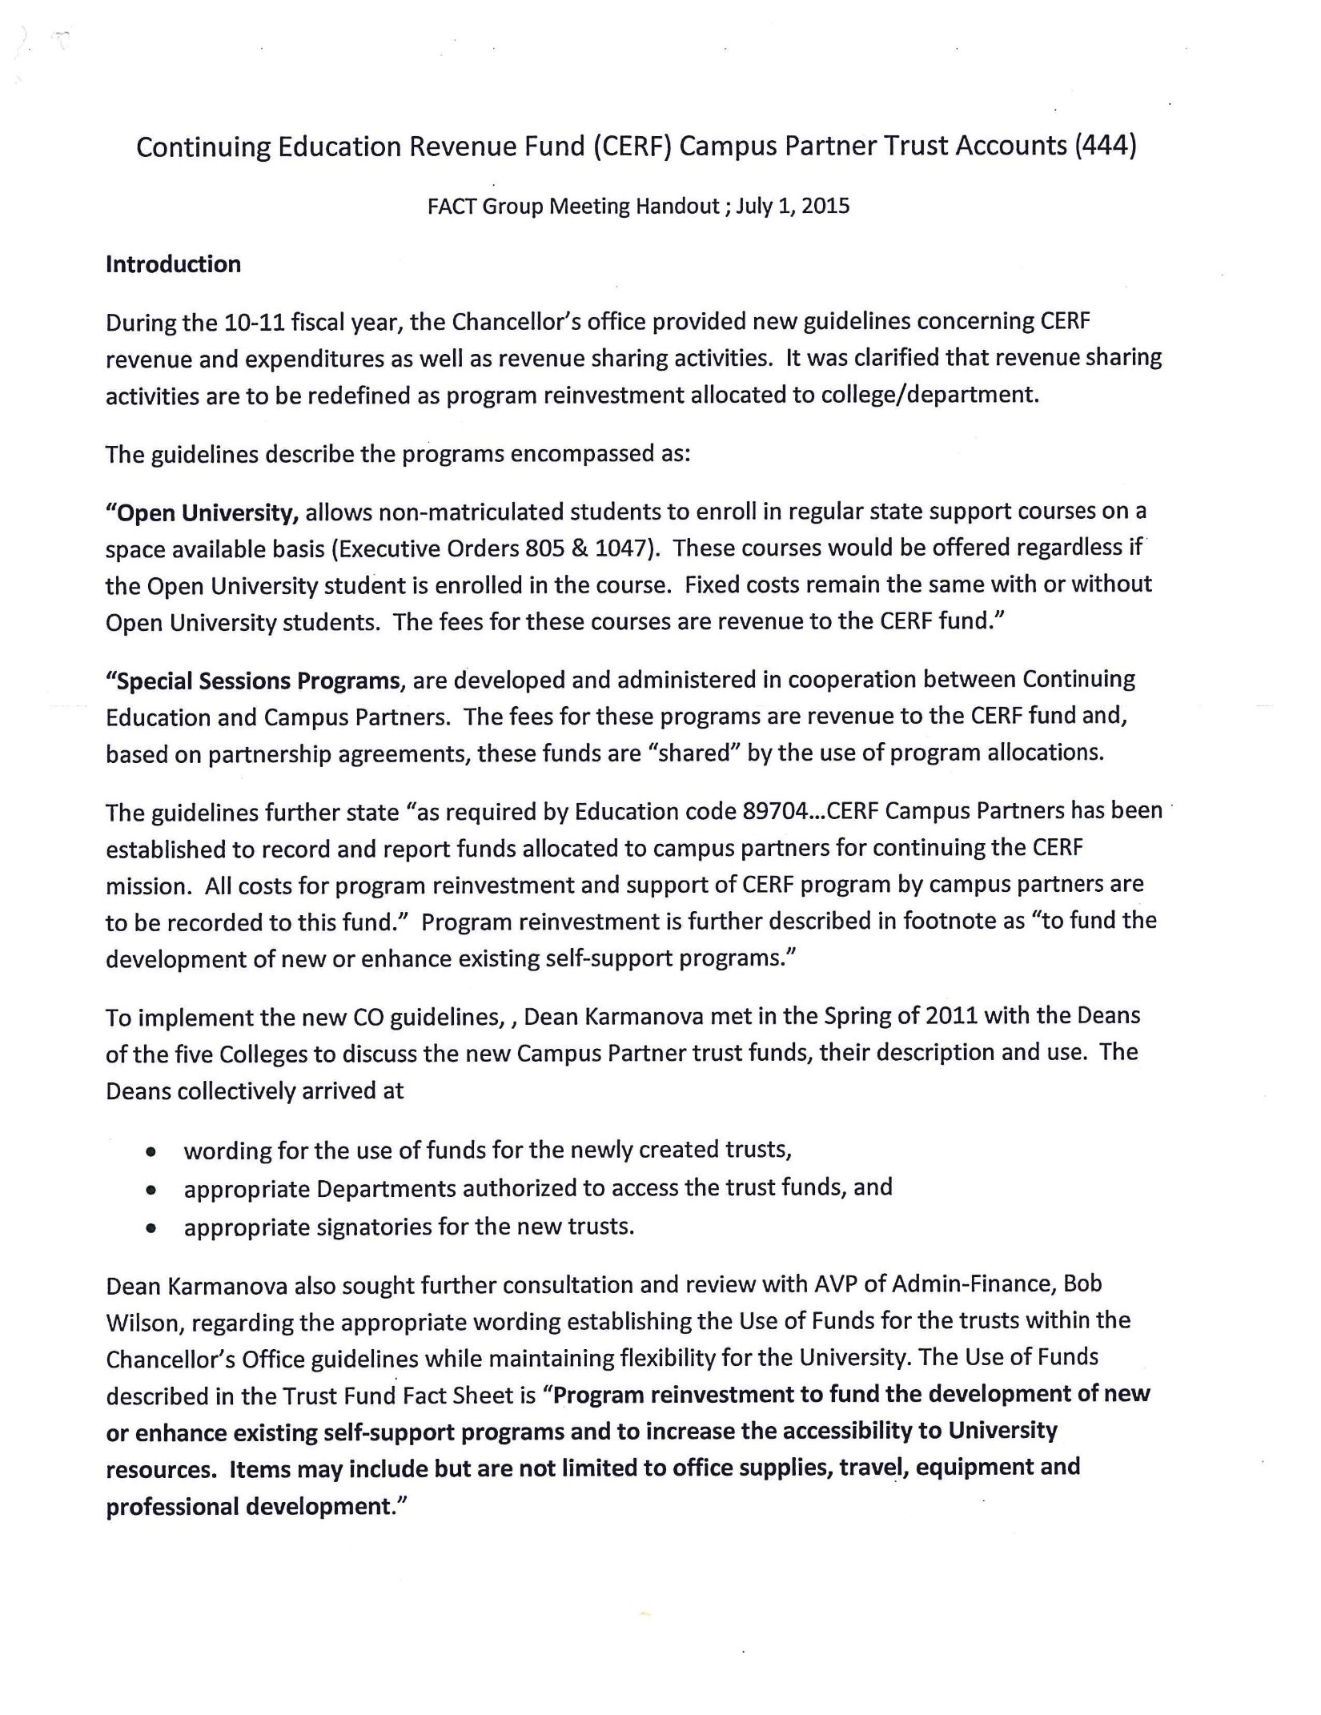
APPENDIX A
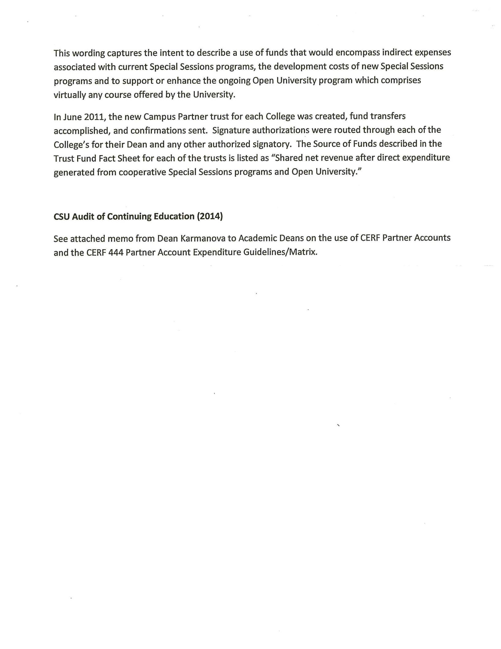
APPENDIX A
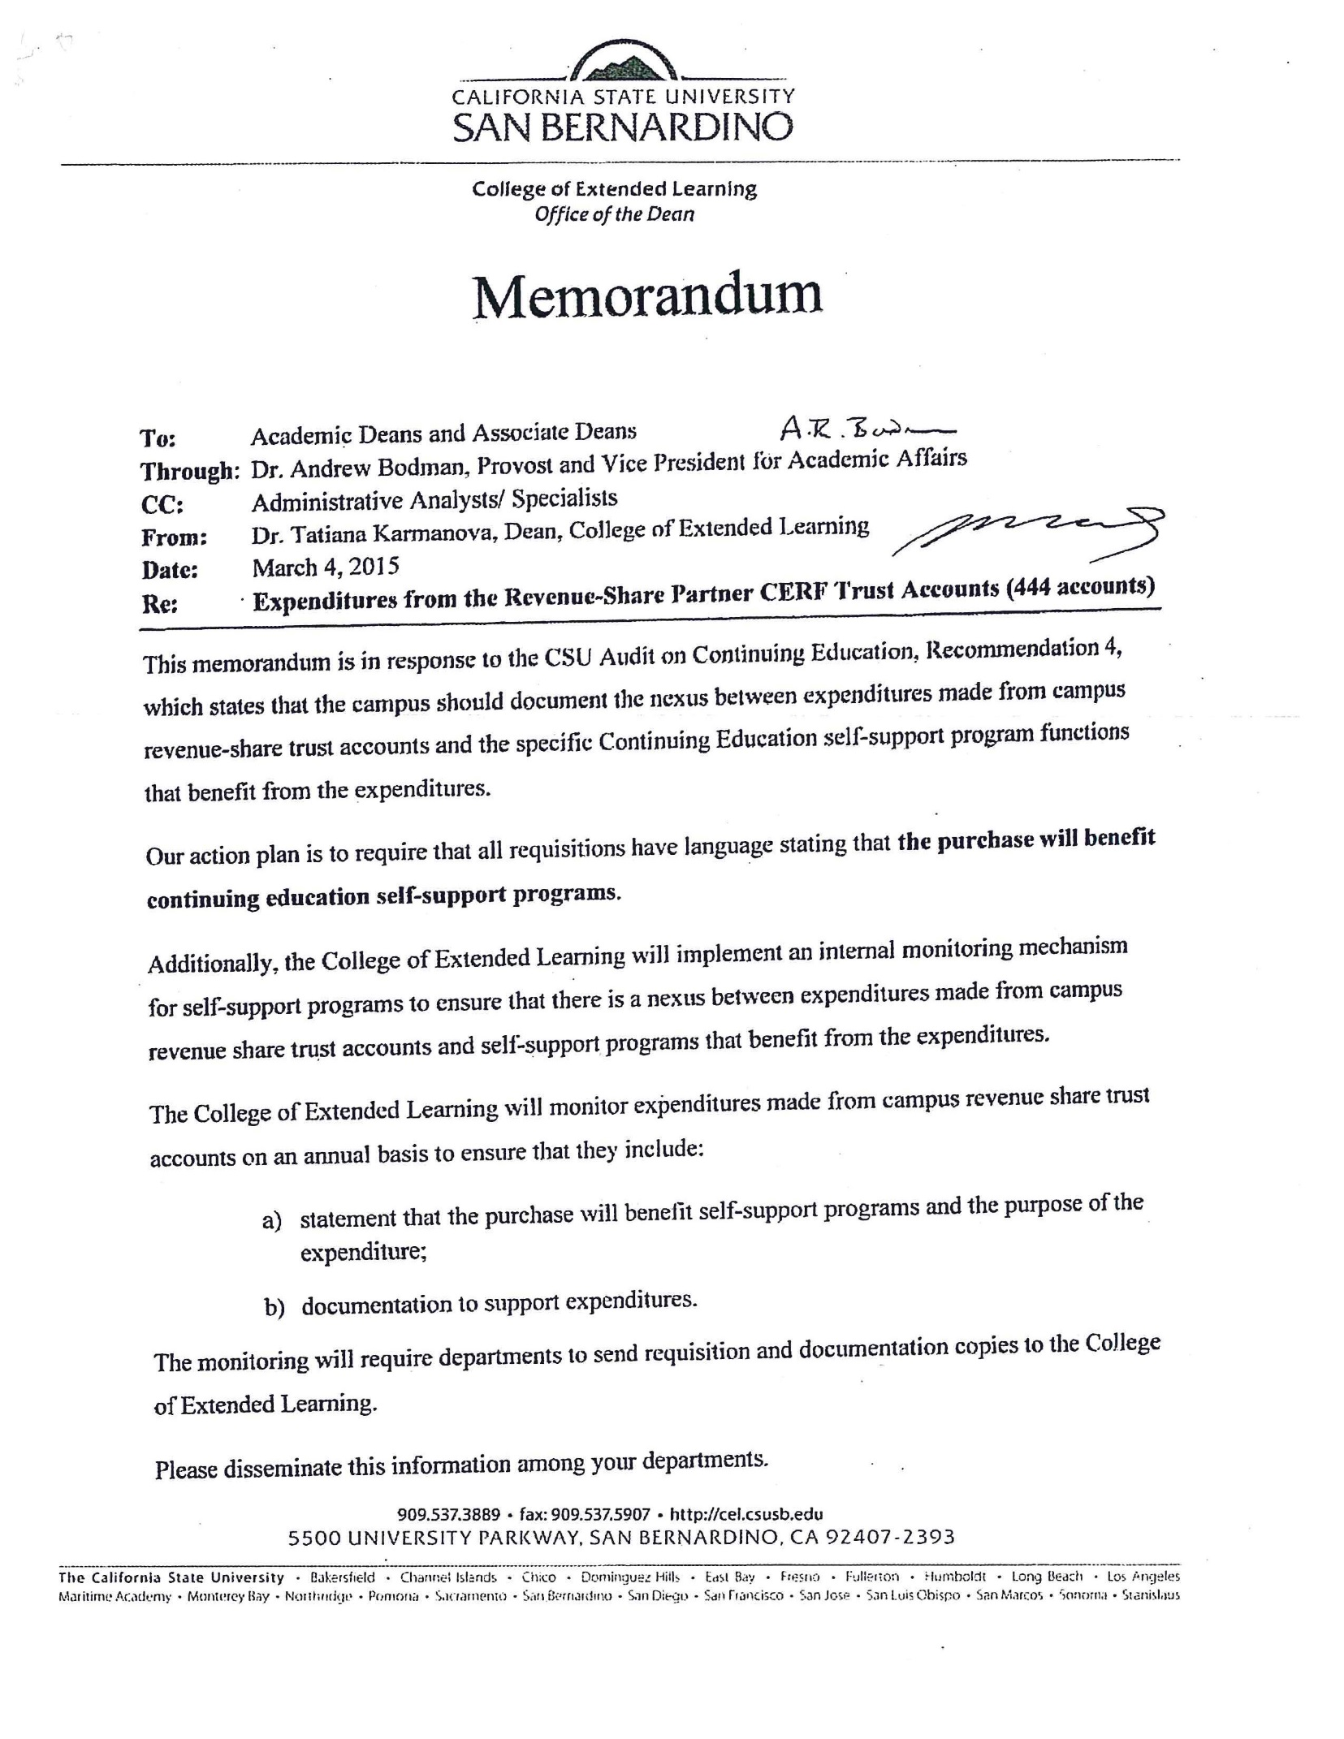
APPENDIX B
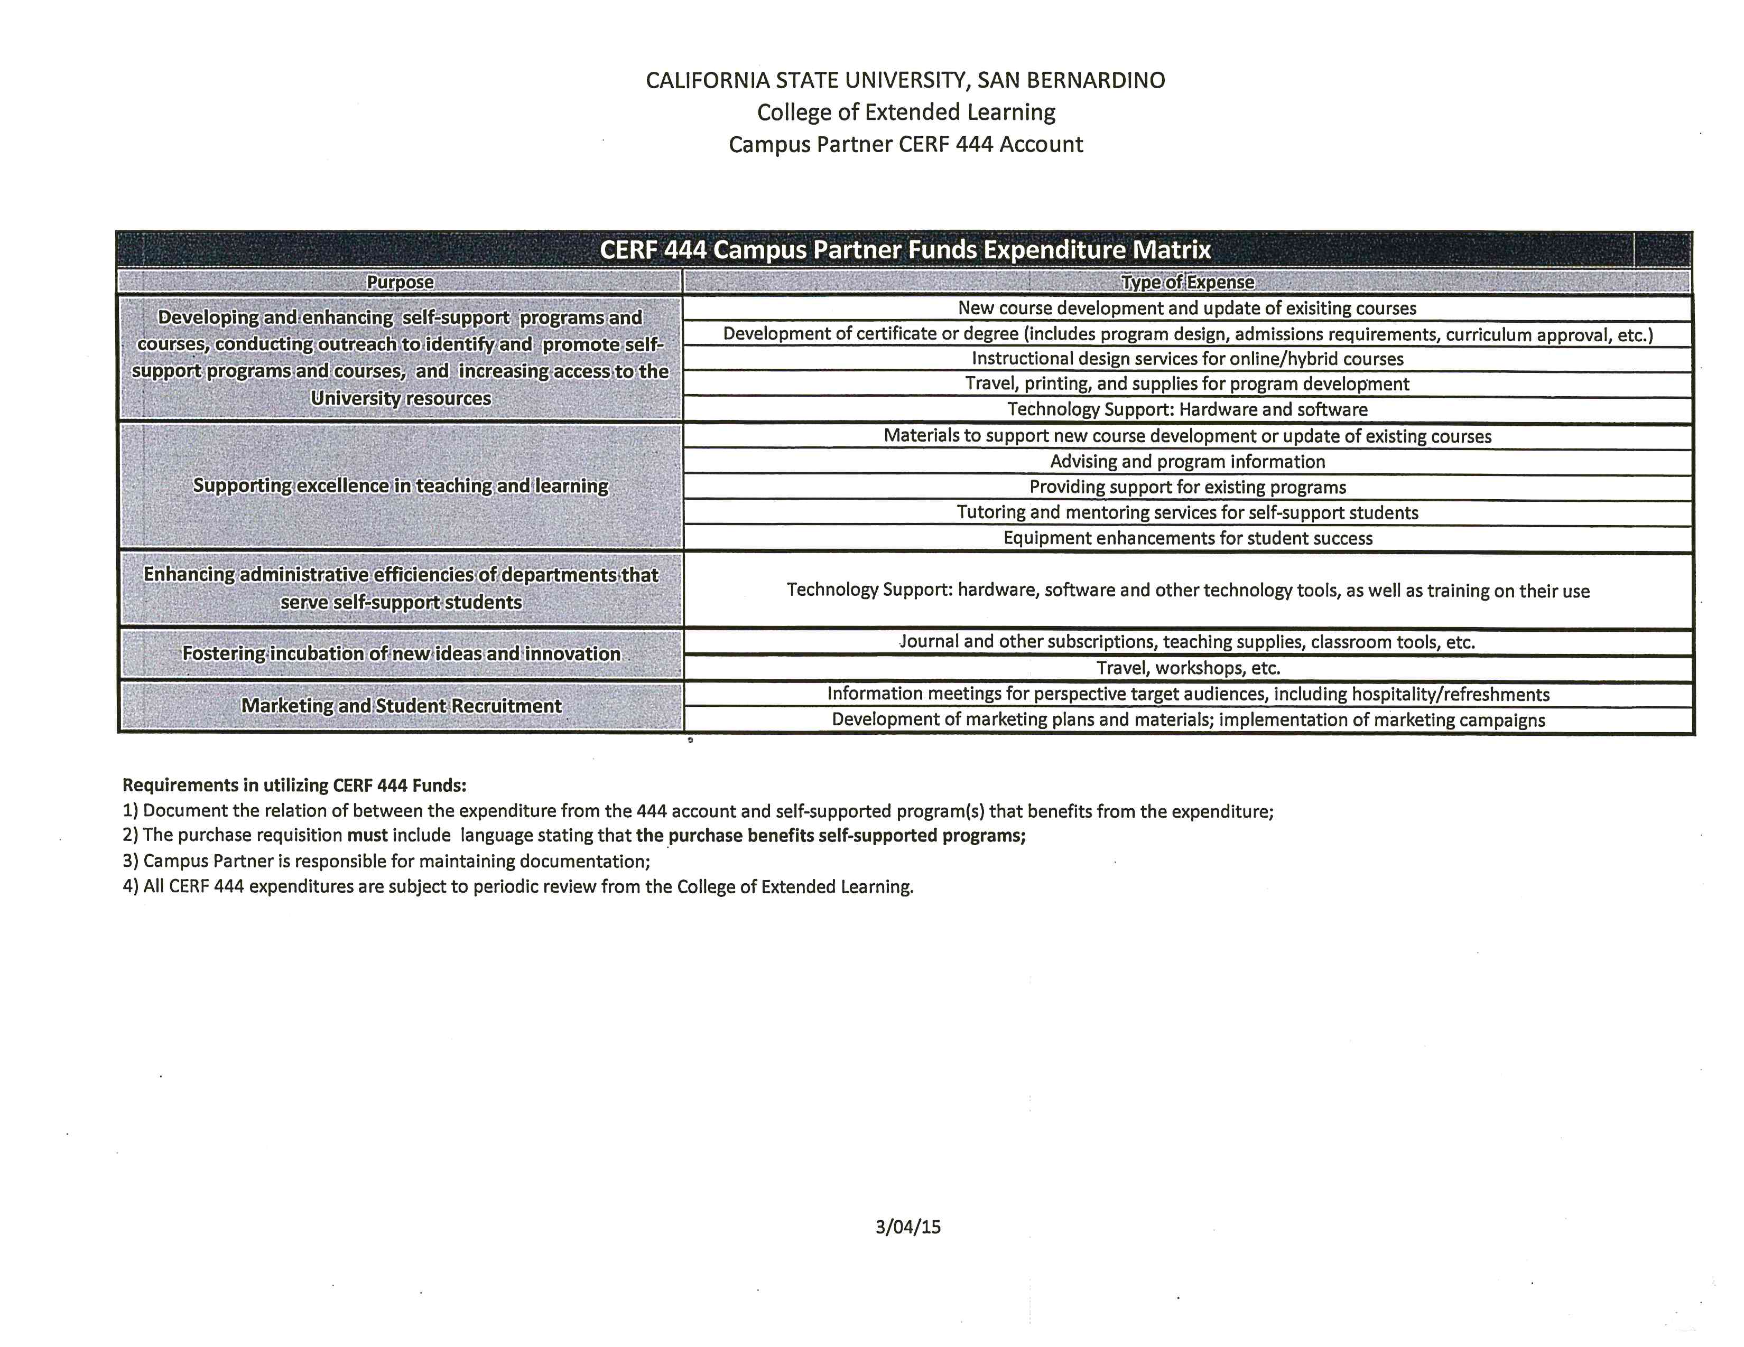
APPENDIX C

APPENDIX D
New Contra Revenue Accounts
Account # | Account Desc | Obj Code | Obj Code Desc
501920 | TuitionFee-SUF WaiverContraRev | 501001 | Tuition Fee
501921 | NonResTuitionFeeWaiverCntraRev | 501002 | Non-Resident Tuition Fee
501922 | StuHealthSvcFee-WaiverCntraRev | 501005 | Student Health Services Fee
501923 | ASI Fee-Waiver Contra Revenue | 501101 | Associated Student Body Fee
501924 | IRA StudentFee-WaiverContraRev | 501102 | Instructionally Related Activity Fee
501925 | Cat3 CourseFee-WaiverContraRev | 501110 | Category 3 Course Fees (Use only in CSU Fund 485)
501926 | Cat2 Fee-Waiver Contra Revenue | 501111 | Category 2 Fees (Use only in CSU Fund 485)
501927 | Cat4 Fee-Waiver Contra Revenue | 501112 | Category 4 Fees (Use only in CSU Fund 485)
501928 | ProfPrgFee-GBPF WaiverCntraRev | 501201 | Professional Program Fee
502817 | CEL-S/SDegreePrgWaiverCntraRev | 502101 | Continuing Education - S/S Degree Programs
502818 | CEL-Open Univ Contra Revenue | 502104 | Continuing Education - Open University
502819 | CEL-CertificatePrgCntraRevenue | 502203 | Continuing Education - Certificate Program
502820 | CEL-RegNonCredit ContraRevenue | 502301 | Continuing Education - Regular Non-Credit
502821 | CEL-CEUCreditPrg ContraRevenue | 502303 | Continuing Education - CEU Credits
504764 | Housing Rent-Waiver Contra Rev | 504001 | Housing Rent
504765 | Housing-Other Waiver ContraRev | 504002 | Housing Revenue-Others
504766 | CampusUnionFee-WaiverContraRev | 504008 | Campus Union Fee

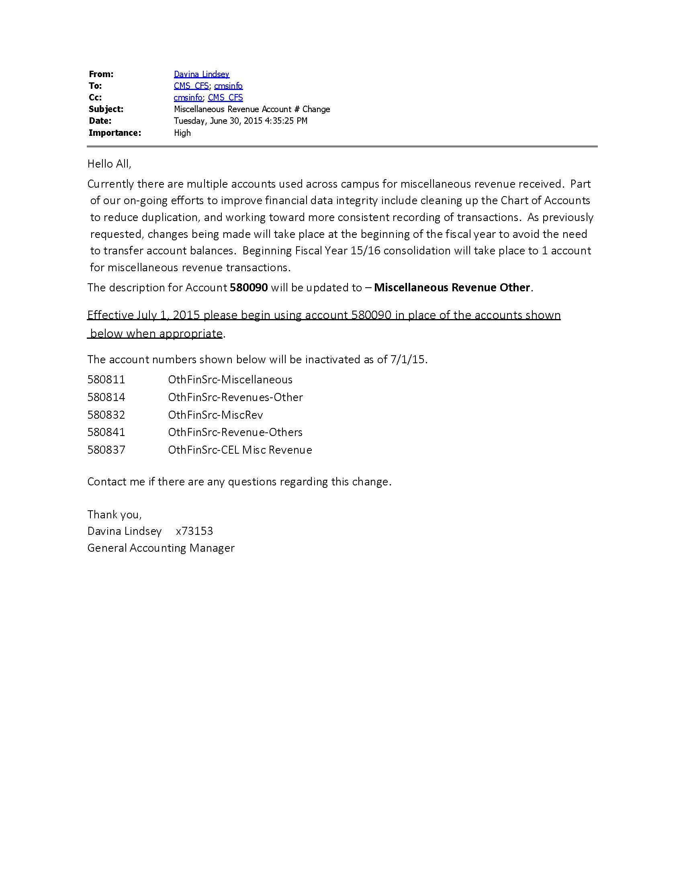
APPENDIX E
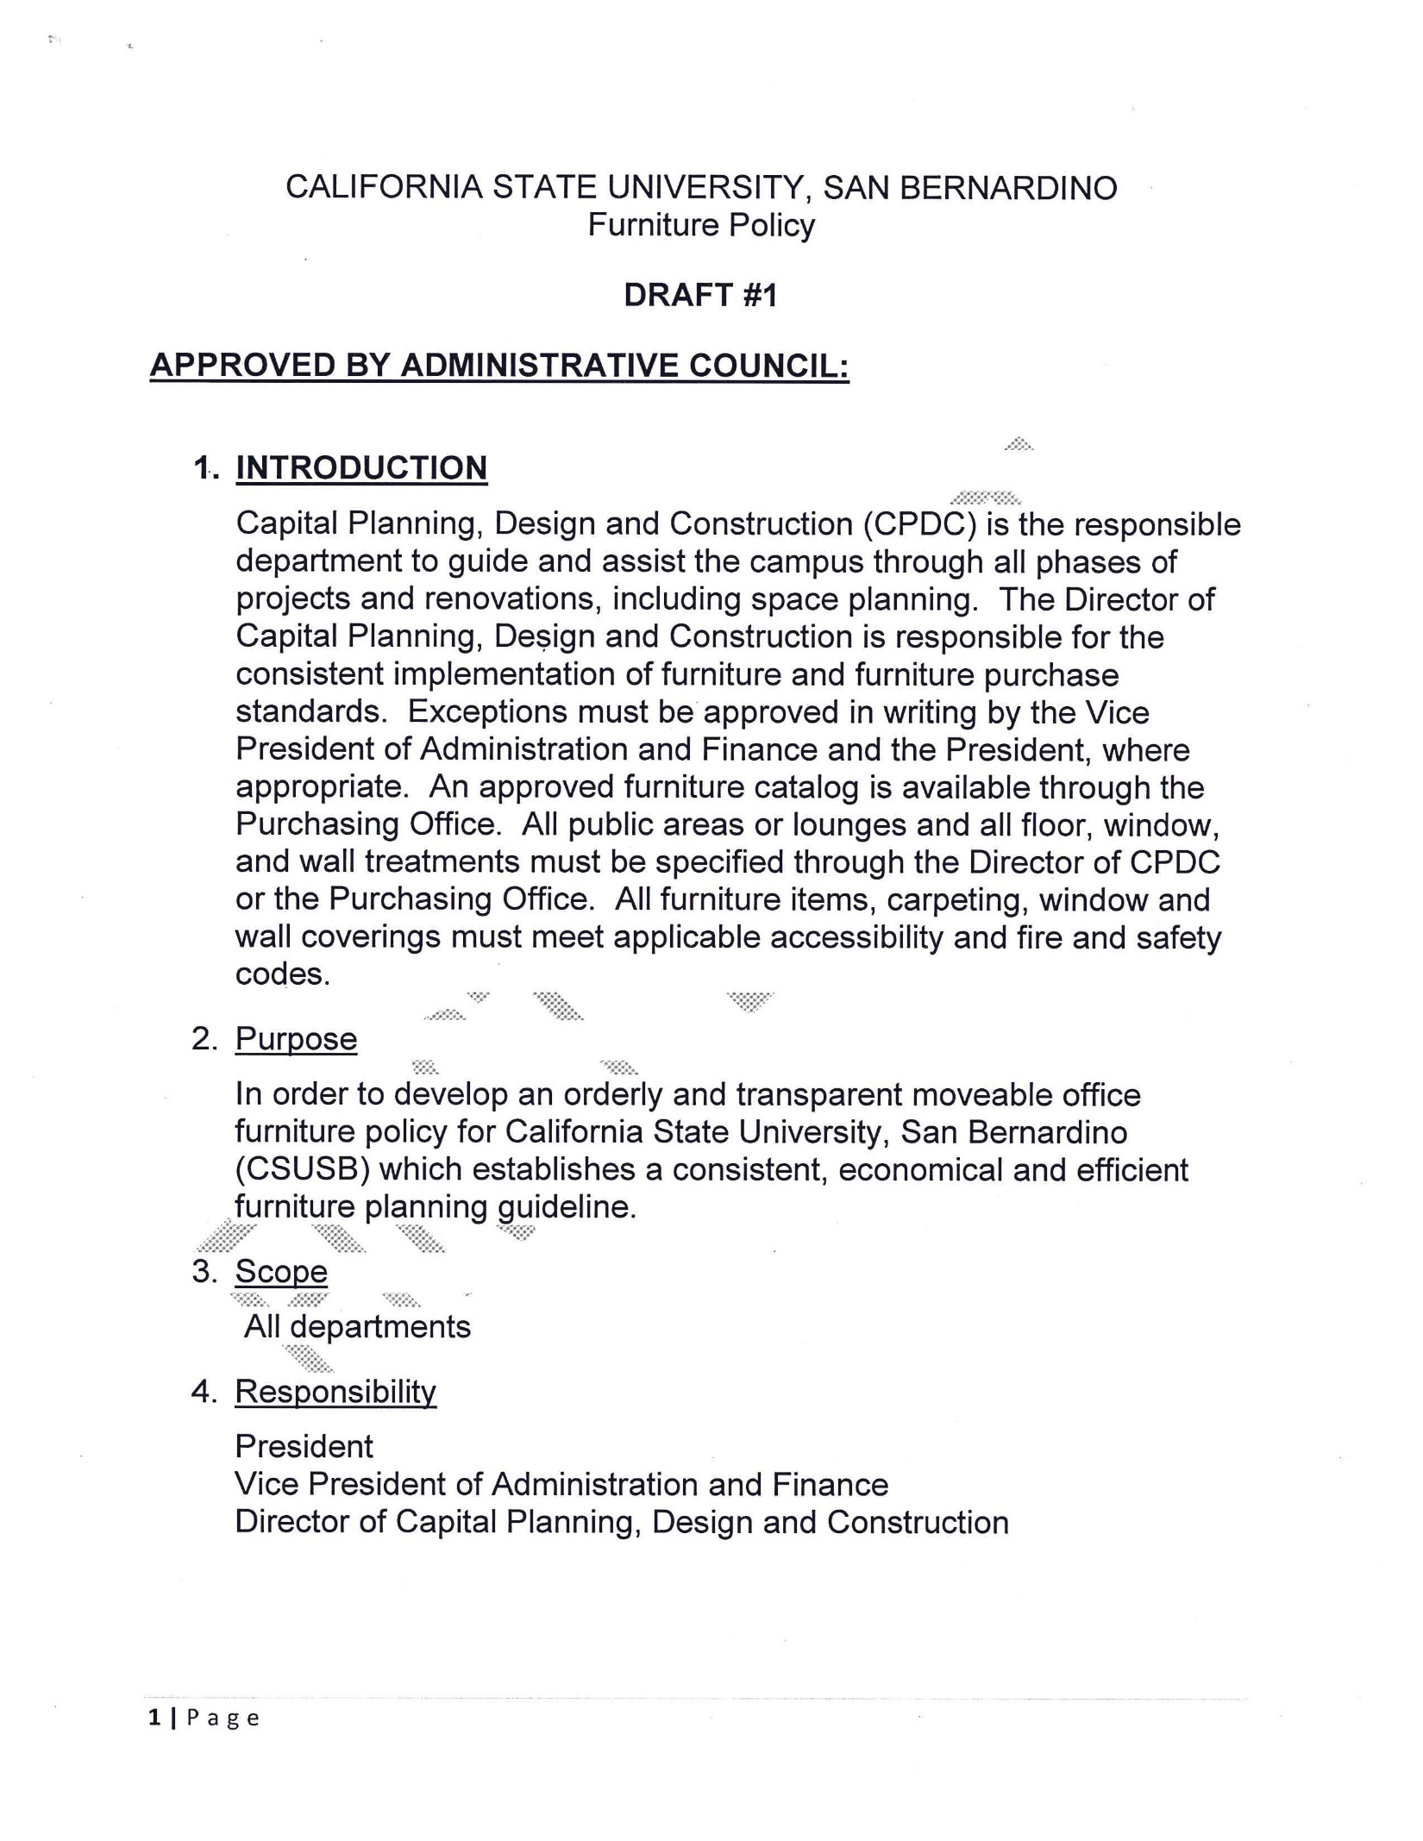
APPENDIX F
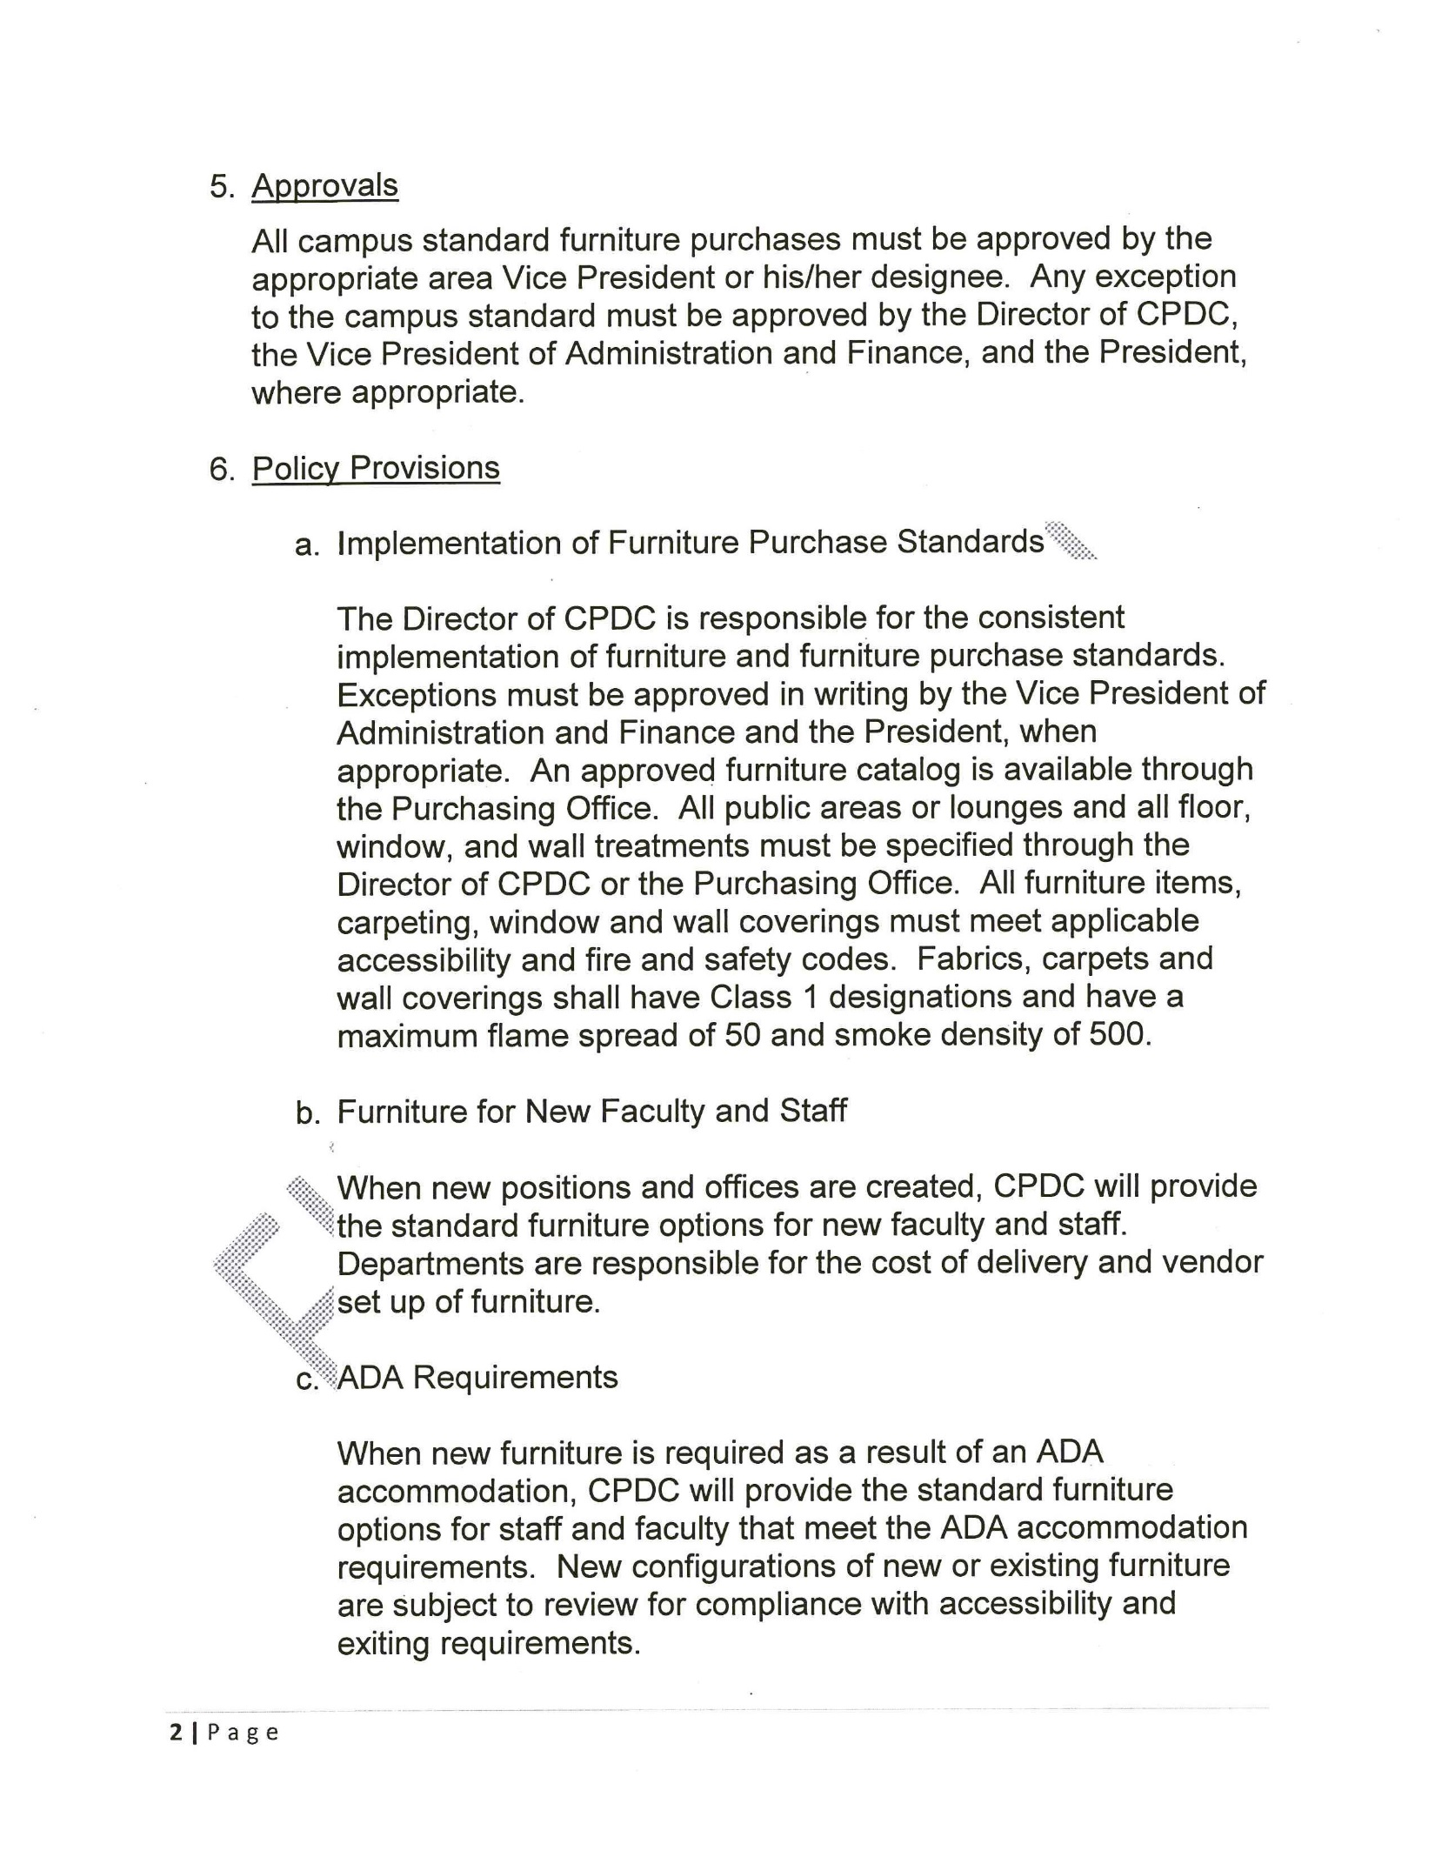
APPENDIX F
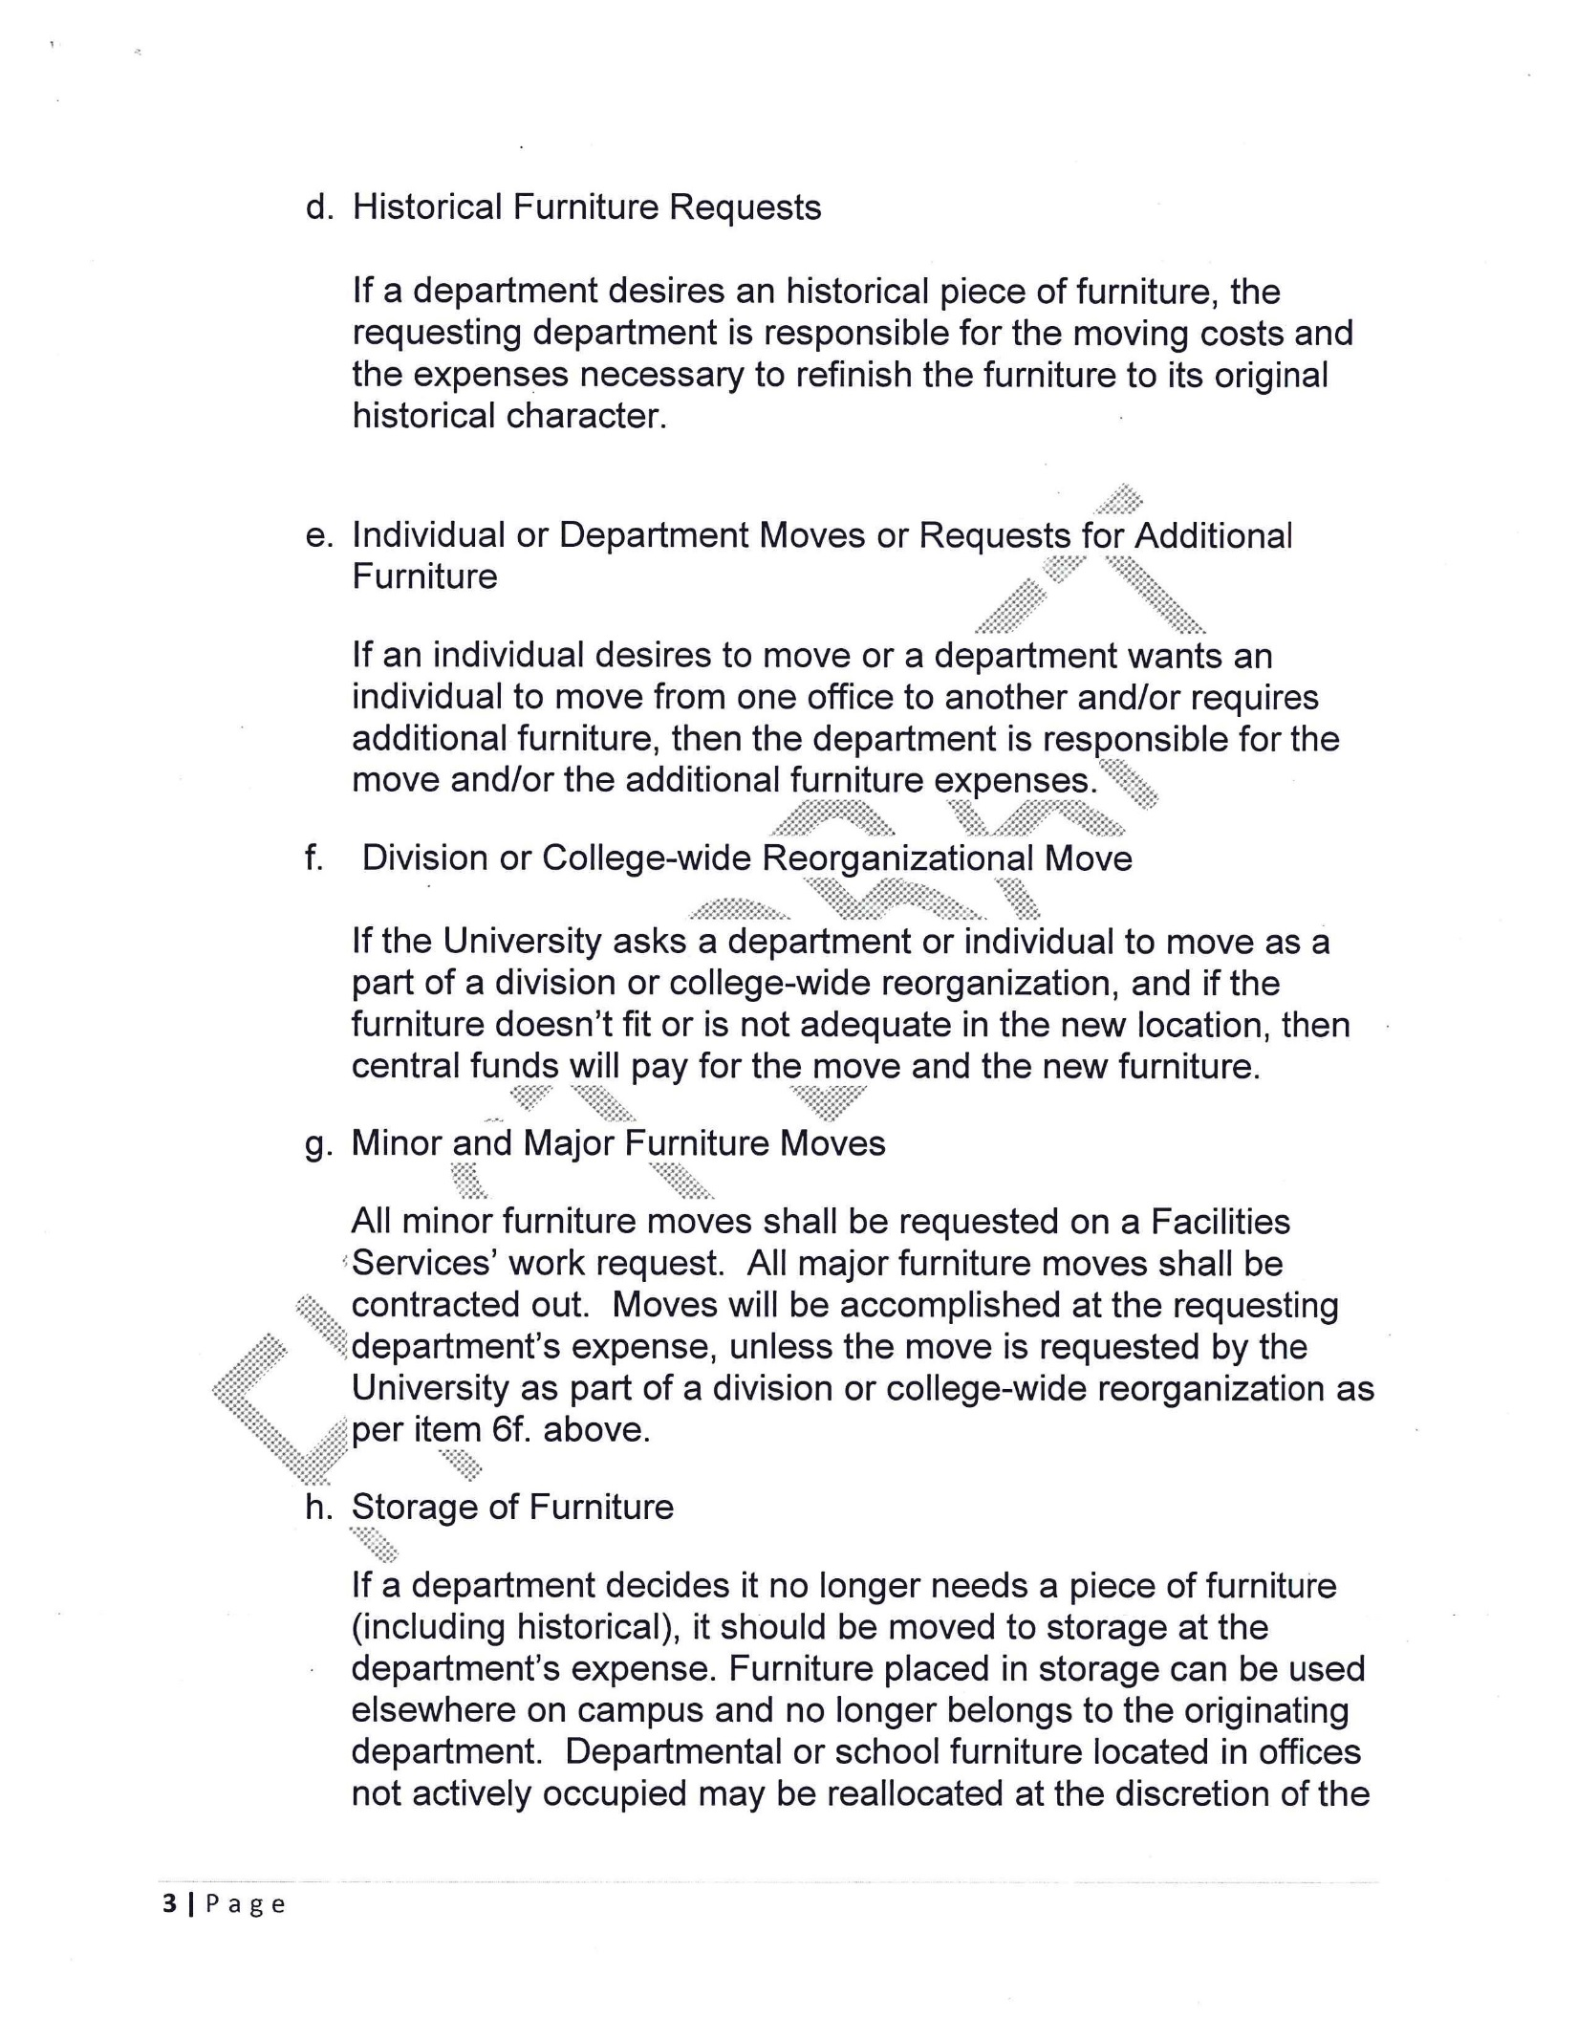
APPENDIX F
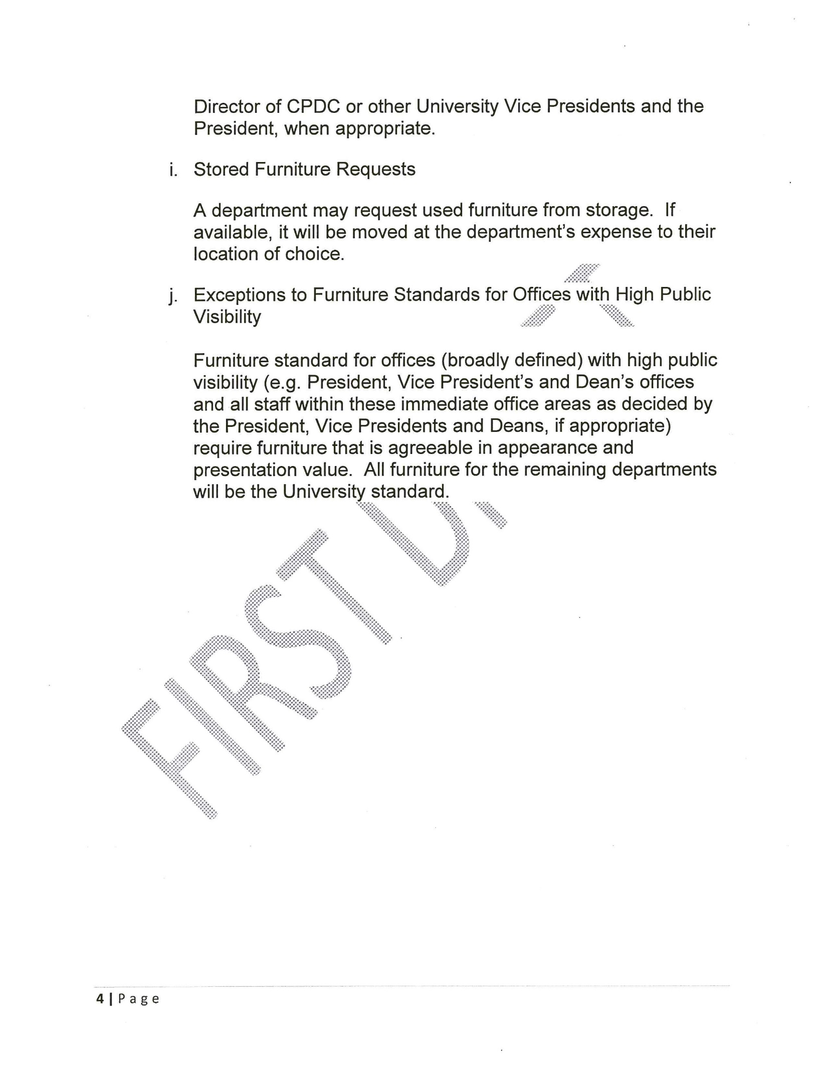
APPENDIX F
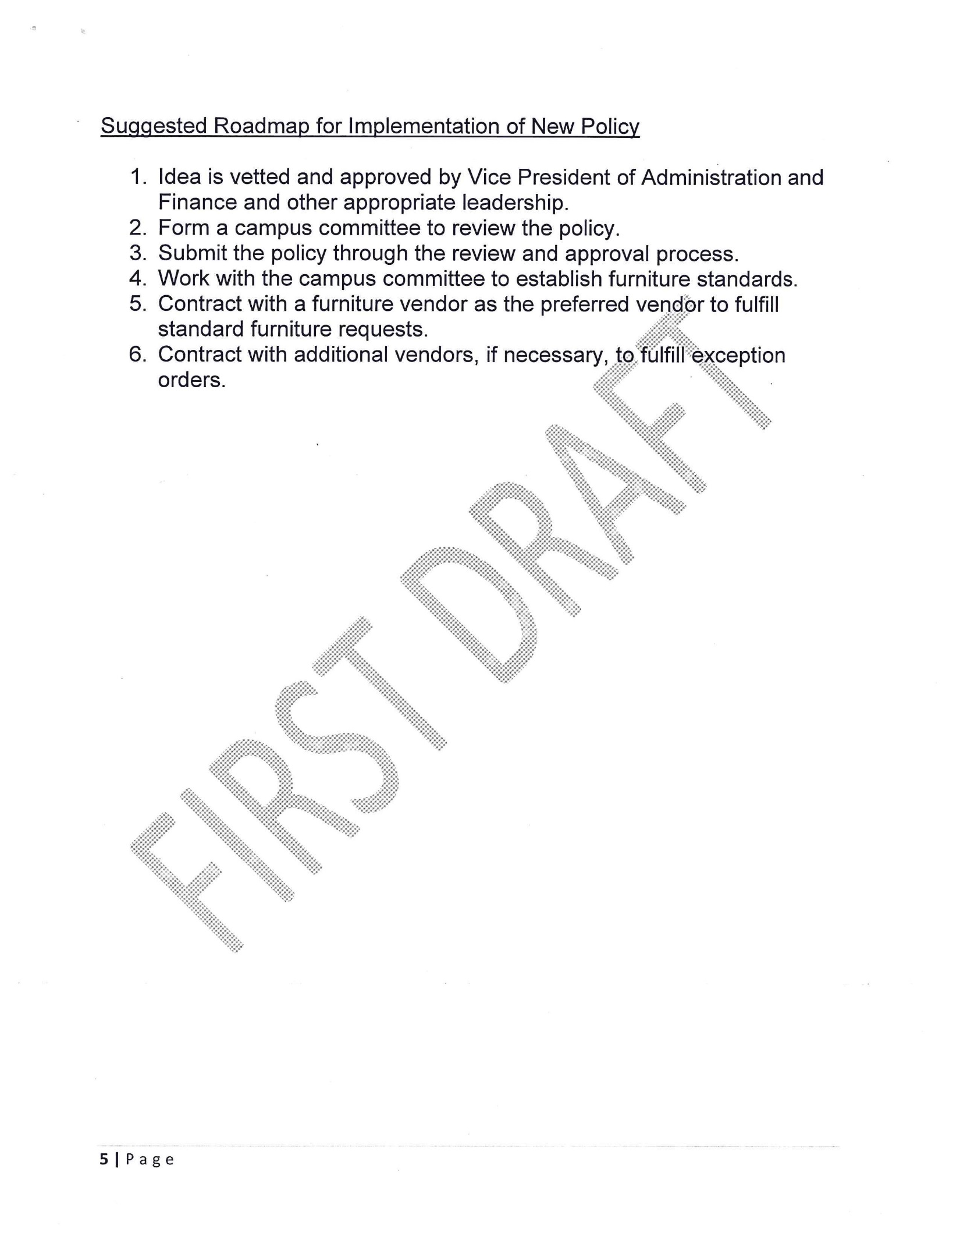
APPENDIX F

