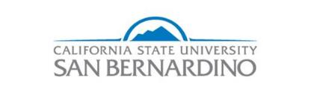

**Graduation Initiative  
Accountability Metrics Framework**

**February 24, 2017**

EXECUTIVE SUMMARY

* Activities have taken place in pedagogy, addressing bottleneck courses, intrusive advising, increasing unit load towards graduation, and keeping students engaged.
* Some Graduation Initiative monies have been allocated especially in advising and increased sections.
* The Division of ITS and the Office of Institutional Research have created a robust capacity for data analytics.
* CSUSB is putting together a steering committee that will bring together subcommittees from pedagogy, policies and procedures, data analytics, enrollment management, and student engagement. These groups will delve into discussions and recalibrate activities for timely graduation for our students.

STRATEGIES, ACTIVITIES, AND METRICS

In the September 2016 campus plan, CSUSB proposed five categories of short-term strategies to increase graduation rates. Several new strategies are added in this report. Those in blue are the corresponding activities that occurred since Summer 2016, followed by metrics, if applicable. Some steps have been made in the allocation the Graduation Initiative budget to departments and programs (Appendix A). The categories are:

1. **Enhanced Instruction**

* ✓Through the TRC and as part of the Q2S transformation, support faculty in studying and implementing equity-minded, evidence-based teaching practices to increase student success.
* ✓Support faculty to develop and assess linked courses that foster interdisciplinary inquiry and problem-solving as part of the new General Education program.

CSUSB Teaching Resource Center (TRC) operates on the philosophy that the unit of change is the faculty member, thus influencing a large number of courses. While members participate in activities with particular courses in mind, we have learned that if the changes in design and instruction are based on a solid understanding of learning and teaching principles, those changes bleed over into teaching in all areas. With that in mind, TRC has provided professional development around the following areas:

* (with the Q2S office) Principles of program design (4-day institute followed by monthly 2-hour sessions; each institute was offered three times)
* Hybrid/Online teaching (3-day institute followed by monthly 2-hour sessions and individual mentoring)
* Diversity, equity, and inclusion (3-day institute followed by monthly 2-hour sessions) for Natural Sciences faculty
* Faculty learning community for Natural Sciences faculty around evidence-based teaching practices for the sciences
* New(er) faculty learning community (2 cohorts; monthly 2-hour sessions) around disciplinary ways of thinking and practicing
* Professional Learning Community around facilitation (monthly meetings) to support faculty and staff who are facilitating meetings in support of student success
* Teaching Academy workshops around academic integrity, innovative teaching strategies, and integrative learning

All institutes, learning communities, and workshops incorporate the study of research on how people learn, and planning for evidence-based teaching practices (EBTPs) and high impact practices (HIPs) in the context of our diverse student body. Some examples of EBTPs and HIPs that faculty are incorporating: active learning in a variety of modes; an emphasis on explicit clarification of disciplinary ways of thinking; multiple representations and a variety of approaches to problems; internship programs that directly support student learning by making clear connections between theory and practice (praxis); think-aloud protocol to model ways of approaching a problem; problem-based learning; team-based learning.

Additionally, the TRC has begun a “Tech Fellow” program in which faculty who are well-versed in various technologies work on technology-related projects and are available for drop-in visits from other faculty to support technology-enhanced instruction.

In the past year, approximately 130 faculty (almost 1/3 of the tenure-track faculty, and a small number of adjunct faculty) were involved in these TRC activities with the goal of enhancing instruction for increased student success.

In 2017, we plan to continue with most of the Professional/Faculty Learning Communities mentioned here, as well as add a community for design of General Education courses and one for Problem-based Learning.

1. **More Aggressive Approach to Bottleneck Courses**

* ✓Provide the colleges the support to use their funds effectively and efficiently to ensure that students have the course sections necessary to graduate on time.
* Offer more summer and night courses that are bottleneck courses to decrease time to graduation.
* ✓Offer supplemental instruction for bottleneck courses.

The Office of Undergraduate Studies expanded the number of bottleneck and high-risk courses; accompanying sessions of the research-based model of supplemental instruction (SI) was offered. Using institutional data and collaboratively designed data dashboards, several approaches are currently being used to address student success in bottleneck courses.

1. Each term, starting on the first day of course registration, department chairs and department enrollment managers are informed regarding bottleneck courses as of that day. Upon receipt of the information, department leaders open additional seats in courses to accommodate the demand generated by students who need open additional seats to accommodate student demand.
2. The "Course Bottleneck-DFWI rate" dashboard is also used to identify courses with high DFWI rates. Using the available data, academic departments have also taken an approach to improve student success in "high-risk" courses by working collaboratively with the Office of Undergraduate Studies to deliver SI each quarter. SI is a research-based, nationally proven method for helping students succeed in challenging courses by providing peer-led, subject-matter instruction, support, and guidance to strengthen critical college skills.
3. Effective Fall 2016, the SI program in Undergraduate Studies fully adopted and implemented the nationally recognized SI model for academic support developed by Dr. Deanna Martin at the University of Missouri, Kansas City in 1973. Under this model, SI sessions are led by student leaders who attend all corresponding content course lectures, prepare for and hold 50-minute SI sessions twice a week, and work closely with the course instructor/faculty and a Supplemental Instruction Mentor throughout the quarter. SI Leaders are undergraduate (sometimes graduate) students who have previously been successful in the corresponding content course or an equivalent course in the subject area. SI Leaders are trained on designing and conducting SI sessions, small group learning dynamics, general and discipline specific learning strategies, effective test taking skills, etc.
4. In addition to monitoring the success of SI and non-SI participants enrolled in high-risk courses served by the Office of Undergraduate Studies on a data dashboard, a recent study of the current Undergraduate Studies SI program at CSUSB in Fall 2016 used matched sample analysis of SI versus non-SI participants. The results suggests that SI participants consistently performed better than their non-SI peers enrolled in the same courses (CSUSB Institutional Research, 2017). Additional findings for CSUSB SI participants showed that students who were female, Pell recipients, full-time, and students who were repeating their course attended more SI sessions than their peers enrolled in the same course. No statistically significant difference was found on SI participation across ethnic groups.
5. Based on the findings, the program will continue to expand using funds from multiple sources and will incorporate additional high-risk courses in Spring and Fall 2017 from the Colleges of Arts and Letters, Natural Sciences, and Social and Behavioral Sciences. Supplemental Instruction will also be available to support students enrolled in high-risk courses during summer session.
6. Developmental Mathematics courses also serve as a barrier to timely graduation. The faculty in the math department have been working diligently to improve student teaching and learning in their courses through course redesign, faculty development, and the use of texts which make the information more accessible. Simultaneously, the math department and the Learning Center are also piloting "preview workshops" for developmental math courses. Preview workshops will provide students enrolled in developmental math courses with a refresher on the mathematical concepts that will be explored in their class with a goal of presenting the content in a manner that builds on their background knowledge and prepares them to attend classes ready to explore, discuss, and engage with course content.

The Office of Undergraduate Studies also offers tutoring for many courses in various disciplines (e.g., biology, chemistry, physics, mathematics, accounting, finance, etc.), including bottleneck courses. The Writing Center conducts more than 10,000 one-to-one student writing conferences and facilitates workshops with faculty members in a variety of campus classrooms. While many students come to work on papers for composition courses, a large number seek support for a wide variety of courses across the university. Writing consultants work with students at all stages of the composing process. Several consultants work specifically with multilingual students to help them negotiate linguistic and cultural differences in written composition; these tutors also conduct informal English conversation groups for multilingual speakers.

CSUSB has five different dashboards measuring course bottlenecks. The dashboard on “course is full” error is popular during registration period because it is updated daily and enrollment managers can utilize it to open more sections as needed (Appendix B). Another dashboard shows DFWI rates and is more pertinent to planning for additional courses in subsequent terms or years (Appendix C). CSUSB has another dashboard that describes enrollment of juniors and seniors in lower-division and upper-division GE courses (Appendix D).

1. **Through Intrusive Advising**

* Provide students with necessary courses in requisite term(s), work with faculty and department chairs to address course difficulties, and refer students to ancillary services such as supplemental instruction, tutoring, health clinic, or counseling center, if relevant.
* ✓Provide super seniors with an exit strategies.
* ✓Effectively implement the data and tools offered by the EAB in order to intervene in a timely manner to keep students on track for completing their academic requirements.
* Develop an aggressive campaign to help all current students graduate before conversion to semesters in Fall 2020.
* Develop individual advising plans, through the use of UDirect and DARS, for all students who enter on the quarter system, but will graduate on the semester system.
* Review every student degree audit who filed a graduation check and reach out to them to make sure they are enrolled in appropriate courses.
* ✓Contact students that have not registered for courses and offer assistance.
* ✓Identify individuals who are registered for 12 units and offer assistance in finding an additional class.
* Review policies on transferring majors.
* Identify Associate for Degree Transfer students from community colleges and provide them with information and advising for completing degree with at most 90 quarter units (60 semester units) per SB 1440.
* Provide follow-up support to Associate for Degree Transfer students to facilitate timely graduation.
* Collaborate with community colleges to increase Associate for Degree Transfer students.

The Office of Undergraduate Studies and advising within the colleges have increased efforts in intrusive advising to decrease time to degree:

1. All advisors provide students with resources and assist with finding requisite courses. Advisors oftentimes also assist students with finding classes by working directly with departments to find additional seats. In addition, advisors inherently refer students to ancillary services as warranted. We also have a number of relationships with departments to provide both tutoring and supplemental instruction as needed.
2. CSUSB has marked 180+ quarter units as super seniors. Undergraduate Studies must approve all changes of majors, add of major, and/or add of minor for all seniors (135+ earned units) as a way to decrease the number of super seniors. To provide each super senior with an exit strategy, a registration hold is placed and only removed once the student has an advising appointment during which an academic exit plan is completed. Subsequent holds are placed as necessary to ensure appropriate academic progress. The responsibility is shared between Advising and Academic Services and the colleges.

3. EAB is used to intervene in a timely manner to keep students on track for completing their academic requirements. To effectively implement it, trainings and workshops are offered regularly. EAB is used to identify students who would benefit from an individual advising appointment in which guidance is based on the students’ proclivity to be successful with their program of study. Additionally, EAB is used to analyze and group students for outreach and intrusive advising. These specific cohorts of students are considered at risk or in need of assistance during pivotal points in their academic progress to help ensure timely graduation.

4. To develop an aggressive campaign to help all current students graduate before conversion to semesters in Fall 2020, the Q2S Advising subcommittee is developing both communications and advising resources to impart the information and importance of graduating prior to conversion. Tools, such as email campaigns, advising handbooks, and FAQ, are in development.

5. We are in the pilot phase to develop individual advising plans for all students who enter on the quarter system, but will graduate on the semester system, through the use of UDirect and DARS. UDirect is rolling out the system in College of Business and Public Administration to beta test the product and determine how it aligns with the college’s roadmaps and the newly implemented DARS product. The next step is to collect accurate and up-to-date roadmaps from every program university-wide so that Udirect can be fully implemented. The timeline is closely tied with Q2S and is related to the academic programs newly developed semester curriculum.

6. To review every student degree audit who filed a graduation check and reach out to them to make sure they are enrolled in appropriate courses, graduation checks are vetted by the registrar’s office transfer graduation counselors (TGC) at the time of filing. The TGCs evaluate the degree audit to ensure the student is making satisfactory academic progress to graduate in the requested term. CSUSB is hiring four Graduation Retention Counselors to target this group of students.

7. To contact students who have not registered for courses, we ran campaigns in each of the undergraduate colleges in the Fall of 2016 to offer assistance. CSUSB is hiring four Graduation Retention Counselors to target this group of students.

8. We are not actively targeting students who are registered for 12 units other than through individual advising and helping them to understand the need to have 15 units to finish in four years. Advising and Academic Services and Graduation retention counselors will roll out a campaign to target these students. CSUSB will also revisit our priority registration system.

9. To review policies on transferring majors, we are currently in the process of working with the Graduation Initiative taskforce to evaluate and rewrite policy that seems to be detrimental to timely graduation. At this point changing a major merely requires a student to file the required paperwork and pay a small fee. The Graduation Initiative taskforce will address issues and attempt to limit excessive units. CSUSB is working with community colleges to increase the number of Associate for Degree Transfers for students who plan to transfer to CSUSB and are more likely to complete their degree in two years.

In response to reports showing 4.5-year graduation rates for freshmen and 2.5-year graduation rates for transfer, the Office of Undergraduate Studies in collaboration with the offices of advising in each of the colleges has engaged in an aggressive analysis of students who were first-time freshmen in Fall 2013 and transfers from the 2015 cohort (Appendix E). Activities in support of the analysis included in-person meetings between advisors and students, phone calls to students, reviews of PAWS reports, development of graduation plans that were in alignment with degree roadmaps, and a pre-Graduation party for eligible-to-graduate students.

Upon initial review of the freshmen Fall 2013 data, 425 students were “on track” (based on unit accumulation) to graduate; after a subsequent review, approximately 170 students were actually eligible to graduate by Summer 2017.

Reviews of Fall 2015 transfer student data showed 600 students in the cohort were seniors (based on units) in their second year. However, in the absence of a mechanism that would allow advisors to systematically review PAWs reports in an efficient manner, eligible 2013 freshmen and 2015 transfers were invited to attend a “Pre-Graduation Party” to encourage them to graduate by Spring 2017.

Advisors also met with students who were “on track” to assist and ensure that they file for graduation checks, were able to enroll in the courses they need each quarter (included courses which are a part of major required sequences) and received support with planning for their post-graduation success (career services and graduate school). All activities with students were documented in EAB.

The majority of students on the list had sufficient units to obtain “senior level” status but the credits they accumulated were not all degree applicable. Students stated that in previous years, they were unable to enroll in needed courses because there were not available seats at time. They also expressed an interest in additional support for challenging courses. Advisors used the meetings with this group of students to get them into the sections they needed and on track to graduate as early as possible (including Summer and Fall 2017)

In response to the needs that surfaced with the Fall 2013 freshmen and Fall 2015 transfer cohorts, advisors across the campus are diligently supporting the cohorts and working proactively with subsequent cohorts earlier in their academic career. This will ensure that they are enrolled in degree applicable units and connected with requisite supports earlier than the start of their fourth year.

While intrusive advising is an ongoing activity, one strategic way for focused efforts is to measure success by each cohort of students. In our dashboard, Advising and Academic Services can monitor the progress of cohorts each year until a graduation check is filed and they officially graduate (Appendix F).

1. **Increase Unit Load towards Graduation**

* Scale up the 4-year pledge program to develop students’ academic commitment.
* Create a 2-year pledge program for transfer students.
* Provide the beginnings of a Transfer Student Center where transfer students can receive support.
* Scale up career preparation for all freshman and transfer students.

Along with Intrusive Advising and continuous communication with students, the Office of Undergraduate Studies has implemented strategic activities to increase unit load towards graduation:

1. Through expanding programs, such as the 4-year pledge, we are actively encouraging students to take 15 units to be able to finish in 4 years.

2. Due to the success of our current 4-year pledge, we are purposely revising the program and expanding it to capture as many students as possible to offer them program plans that will allow them to successfully complete their degree within a 4-year time period.

3. We have already created a draft policy of the 2-year pledge for transfer students and are also in the process of expanding and aligning it with the current tenants of the 4-year pledge.

4. There is none to report on the Transfer Student Center.

Our campus maintains information on freshmen and new transfers unit load progress each year towards graduation (Appendix G) and graduation rates by department (Appendix H and I). It is predicted that, if our campus truly implements effective and intentional strategies collectively, then the percentages of students who return every Fall to CSUSB and progress in their class status (i.e., freshmen, sophomores, juniors, seniors) would also increase.

1. **Engage Students into Campus Life**

* Provide more campus employment, keep students engaged on campus, and decreasing time to degree for students going from 2nd to 3rd year which is the highest dropout period.
* Scale up high impact practices activities such as internships, on-campus employment, service learning, study abroad, living learning community options in the residential community, and supplemental instruction for math and English.
* ✓Increase funding for the food pantry since 65% to 81% of 320 food-insecure students who visited The Den in the last six months were first generation, Pell recipients, and underrepresented minority.
* ✓Celebrate by having an early graduation party specifically for Juniors with 90-134.9 quarter units where advisors sit down with students, plan a course path towards graduation, and file a grad check.
* ✓Create community traditions that connect students to the university and create a welcoming environment.
* ✓Enhance awareness of identity, community, culture and diversity.
* ✓Expand case management capacity.

The CSUSB Division of Student Affairs have implemented the following activities:

1. The Division partnered with the City of San Bernardino and the Associated Students, Inc. (ASI) to provide paid internships for CSUSB students. Specifically, ASI has set aside $50,000 to fund 50 internships in San Bernardino non-profit organizations. The Career Services team works with students to prepare them for interviews and also created a Professional Clothing Closet with free business attire for students preparing for interviews and the successful beginning of new internships.
2. The Department of Housing and Residential Life developed new living learning community options in the residential community to connect residents to faculty, staff and campus resources: Black Residential Scholars and Green House (sustainability-centric). In addition, a new-to-CSUSB Faculty-In-Residence (FIR) program was developed with three faculty members and their families. The faculty are from the sciences and arts, and live among students. Each faculty member has programming funds and a meal plan to engage with students living in the same community.
3. Offices under the Division of Student Affairs created three new community traditions that connect students to the university and enhance a welcoming environment: 1) The ASK ME! Campaign occurs the first week of the Fall and Winter quarters. In various locations on campus, CSUSB faculty, staff and student volunteers staff tables with snacks, campus maps and CSUSB resources (e.g. on-campus employment openings; student events and activities for the first few weeks of classes; parking pass information; athletic event schedules, etc.) and are available to answer student questions. 2) New Student Convocation occurs two days before classes begin and is a mandatory event for all first-year students who are enrolled in the Four-Year Pledge Program. Participation is also strongly encouraged for all first-year and transfer students. The event includes welcome remarks from campus leaders and is hosted by Associated Students. Following the event, students leave to attend a festive club and organization fair, receive their unique "class year" CSUSB T-shirt and meet Cody, the CSUSB mascot. 3) Parent and Family Orientation is in place to enhance the transition experience for families and their students. Given that many of our students' families have not attended college, a family and parent orientation informs our students' greatest supporters on important aspects of student success: time management, financial literacy, the language of CSUSB, campus resources, etc.
4. The Office of Student Engagement created and opened the LatinX Student Success Center and First Peoples' Center in February 2017, the Pan African Student Success Center in September 2016 and the DREAMers Resource and Success Center in January 2016. These centers will enhance awareness of identity, community, culture and diversity, and elevate connections to campus life and student identity.
5. The Division hired a bilingual case management specialist to support the CARE team. This specialist oversees referrals for housing and food insecurity, addiction, domestic and intimate partner violence, PTSD, ADHD and other student well-being issues that can impact timely graduation.

The 2016-2017 annual Faculty/Staff Campaign will include the pledging of financial support for The DEN. The co-chairs for the Campaign are Diane Podolske (Office of Community Engagement) and Laurie Smith (School of Social Work.) More importantly, longtime San Bernardino business leaders and philanthropists Chuck and Shelby Obershaw gave a $1 million endowment to CSUSB in support of students in need and to support entrepreneurship. A portion of the annual endowment interest will be allocated for The DEN.

The Office of Student Engagement has identified leaders of nearly 180 student groups and intentionally focused on enhancing leadership capacity through club training, individual coaching/advising sessions, fraternity & sorority leadership programming, Title IX training, diversity education, and training around responsibilities of alcohol and other drugs. Engaging this population of nearly 3,000 students provides opportunities for reflection, service, leadership learning, and building relationships that assist in retention and graduation.

Services to Students with Disabilities has identified at-risk students and is developing innovative accommodation plans that better meet their needs. Services to Students with Disabilities’ WorkAbility IV Program is expanding its career services to address Briel and Wehman’s nine challenges students with disabilities face in terms of career development by providing tailored activities to strengthen faculty, staff and student relationships. The Career Center began delivering a tailored program to assist undeclared students in identifying a major and future career plan. The Veterans Success Center provides small group tutoring for veterans and other military-affiliated students in high DFWI courses.

A Scholarship Coordinator has been hired. This full-time professional will support students and families in securing additional dollars to offset the cost of attending CSUSB.

Our campus recognized that the Fall 2013 first-time freshmen and Fall 2015 transfer cohorts were those who would graduate the soonest (in Spring, Summer, or Fall 2017). The accompanying graphs indicate that if our campus did nothing new, we would expect the Fall 2013 cohort of freshmen to achieve a 4-year graduation rate of 11%; 14% if we implemented intentional and effective strategies. We anticipate that the Fall 2015 cohort of transfers would achieve close to a 40% 2-year graduation rate as with the Fall 2014 cohort, which suggests that future transfer cohorts will most likely surpass projections (Appendix J).

SUMMARY

Our campus had five months to rethink our contributions to the Graduation Initiative in addition to the quarter-to-semester conversion process. In response to this metric report, which highlights the abundance of activities and some disconnection to the Graduation Initiative goals, we acknowledge that our campus requires collective conversations with faculty, staff, and students. These conversations will further examine contributions and collaboration by departments and offices, resulting in a cohesive Graduation Initiative plan. Currently, we are putting together a steering committee that will bring together subcommittees from pedagogy, policies and procedures, data analytics, enrollment management, and student engagement. These groups will delve into discussions and recalibrate activities for timely graduation for our students. Institutional effectiveness recommends that we focus our efforts on:

1. Cohorts of students.
2. Special population of students, such as male students, Pell recipients, those with high failure grades in courses, undeclared majors, sophomores, juniors, those taking 12 units and maintaining a high GPA, those changing majors a second time, super seniors with 150% units over, seniors needing grad checks, or those relying on food pantry with a caveat that the graduation initiative was not designed for boutique programs.
3. Activities that increase yearly unit progress towards the degree.

APPENDIX A. Graduation Initiative Budget



Appendix B. Course is Full Error Dashboard

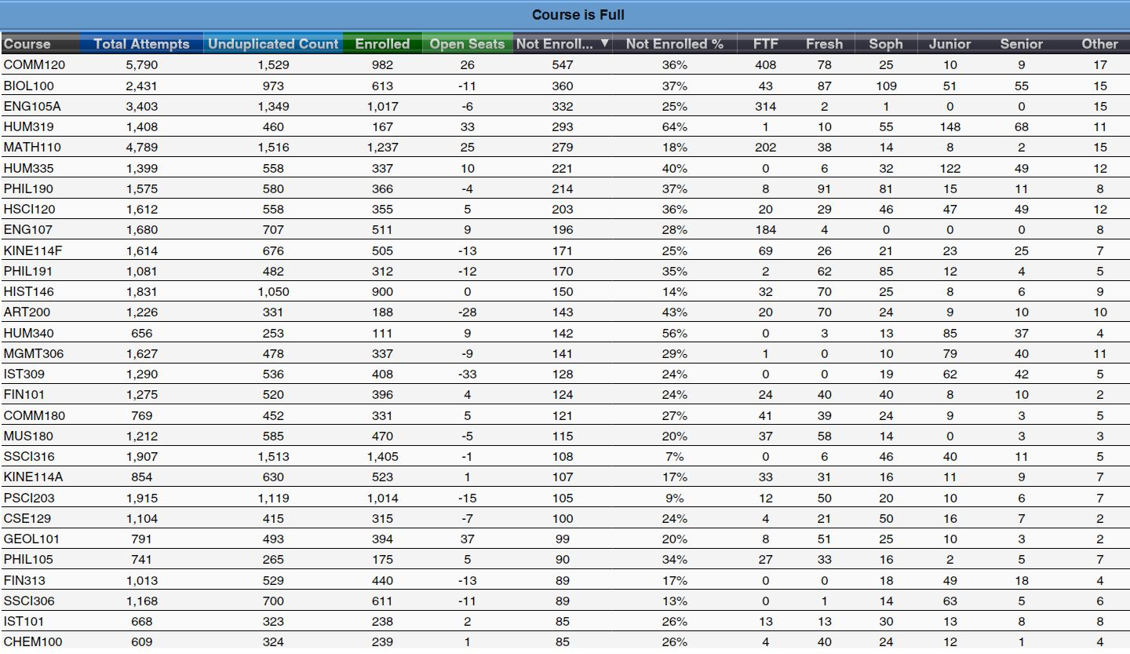

Appendix C. DFWI Rates Dashboard

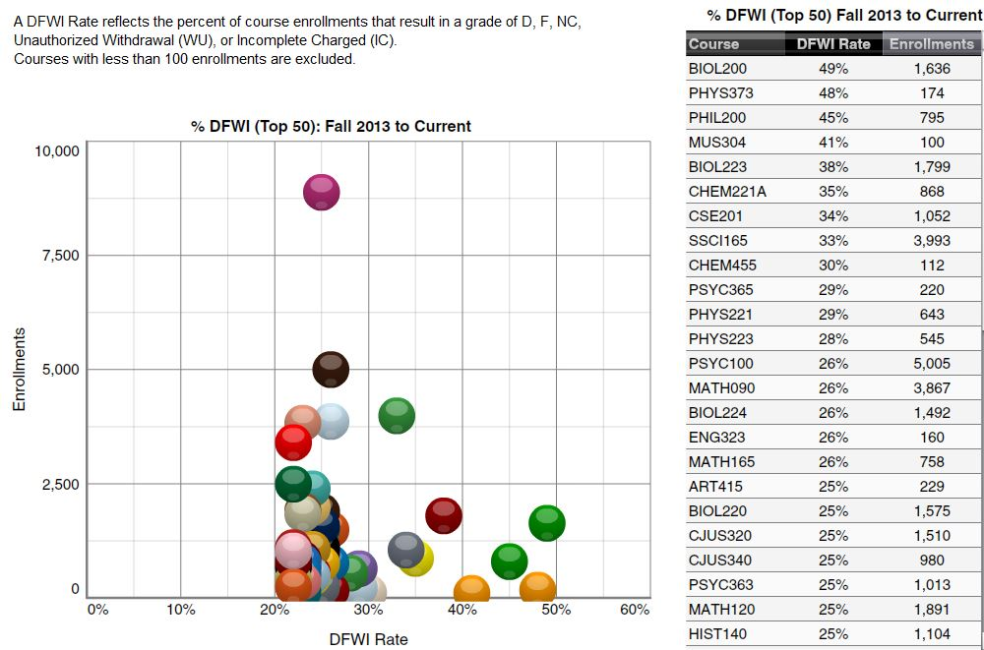

Appendix D. General Education (GE) Course Availability between Fall 2015 and Fall 2016

Seat Availability

• Seats in lower division (LD) GE courses increased by 2% (470 seats)

• Seats in Upper Division (UD) GE courses increased by 9% (905 seats)

• Combined, seats in all GE courses increased by 5% (1,375 seats)

Students not being able to enroll (based on PeopleSoft records of student enrollment attempts)

• Percentage of students who were not able to enroll in LD GE courses decreased from 24% to 20%

• Percentage of students who were not able to enroll in UD GE courses increased from 15% to 19%

• Percentage of students who were not able to enroll in all GE courses decreased from 21% to 20%

• 5,180 students attempted, but could not enroll in LD GE courses in Fall 2016. Of the 5,180, 14% (428 juniors and 302 seniors) were UD students. B2-4 GE requirements had the highest proportion of UD students taking LD courses.

* B2-Life Science (i.e., BIOL100 and HSCI120) – 563 students could not enroll in Fall 2016. Of the 563, 36% (98 juniors and 104 seniors) were UD students. The section seat limits of BIOL100 and HSCI120 were 250 in larger sections and 110 to 140 in smaller sections.
* B3-Physical Science (e.g., ASTR103, CHEM100, and GEOG103) – 397 students could not enroll in Fall 2016. Of the 397, 20% (53 juniors and 26 seniors) were UD students. The section seat limit of ASTR103 was 48, GEOG103 was 60 and CHEM100 and GEOL101 was about 120.
* B4-Special Topics in Science and Technology (e.g., BIOL217, CSE122, and GEOL210) – 257 students could not enroll in Fall 2016. Of the 257, 21% (40 juniors and 15 seniors) were UD students. The section seat limits of BIOL217, CHEM105, CSE122, CSE129 and GEOL210 were mostly between 120 and 130.

Appendix E. 4- and 4.5 Year for Freshmen and 2- and 2.5 Year for Transfer Graduation Rates

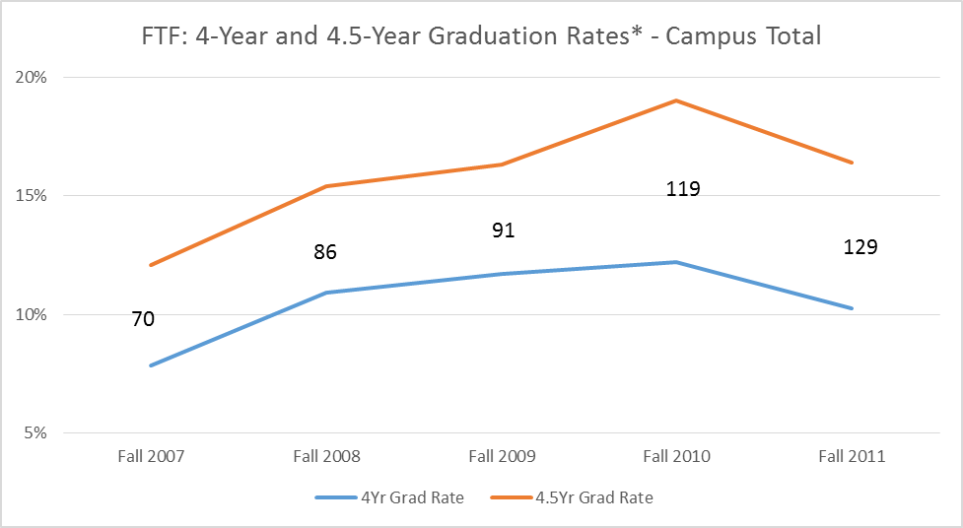

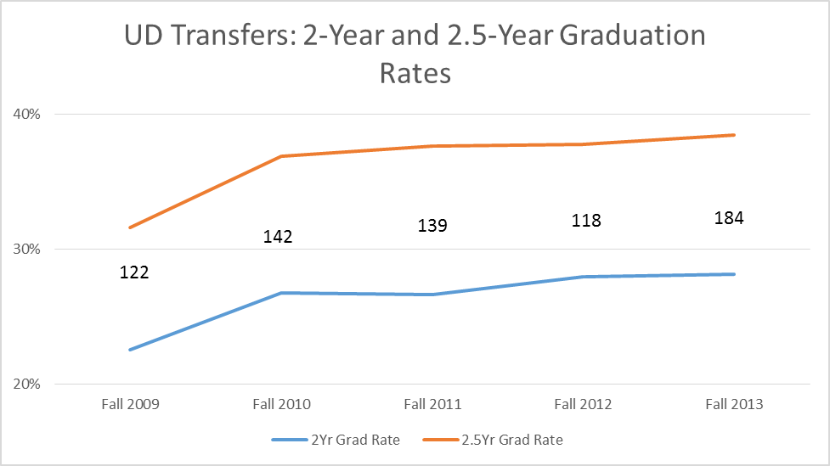

*4.5-Year graduation rates are based on the number of students who graduated before the end of their 5th Fall quarter. Numbers are counts of students. Shortening graduation by one term (from 4.5- to 4-year) will increase graduation rate by about 5%. Shortening graduation by one term (from 2.5- to 2-year) will increase graduation rate by about 10%. Appendix F. Grad Check by Cohorts

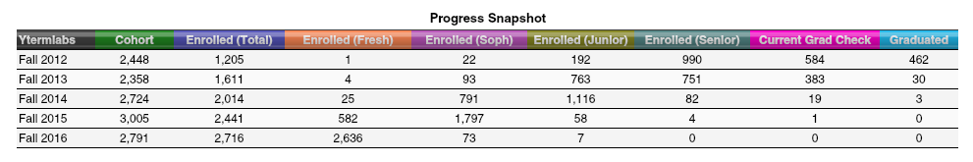

Appendix G. Unit Load Progress towards Graduation by Cohort

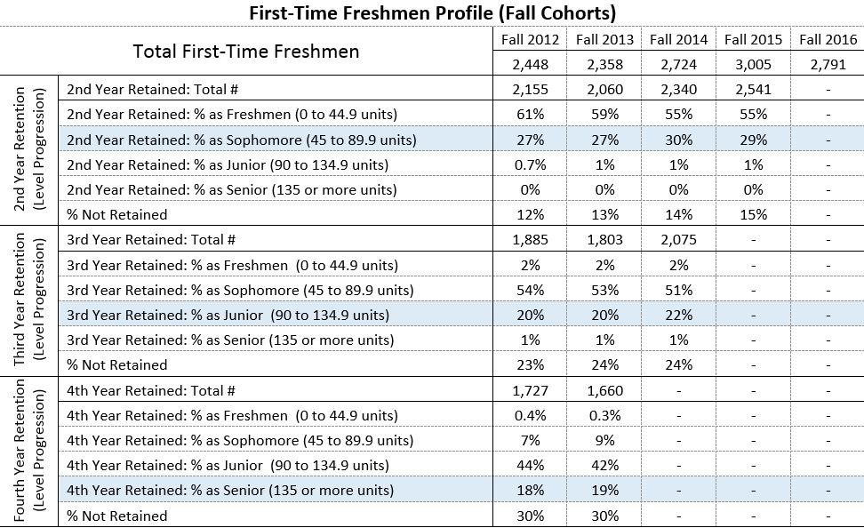



Appendix H. First-Time Freshmen 4- and 6-Year Graduation Rates by Department



Appendix I. Upper Division Transfer 2- and 4-Year Graduation Rates by Department



Appendix J. Projection for Freshmen 4-Year Graduation Rate and Transfers 2-Year Graduation Rate

