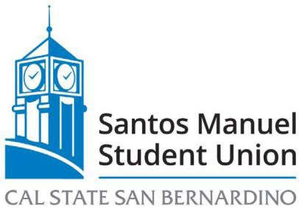

SANTOS MANUEL STUDENT UNION BOARD OF DIRECTORS
EXECUTIVE COMMITTEE MEETING
August 26, 2022 – 11:30am
Zoom: https://csusb.zoom.us/j/83160849358
or
in person: SMSUN Conference Room #3317

AGENDA

- Call to Order
- Roll Call
- Approval of Minutes from August 10, 2022 Executive Committee Meeting
- Adoption of Agenda

OLD BUSINESS
SMSU 01/23 Selection of RecWell Committee Members and Chair (Action, Del Rossi)
NEW BUSINESS
SMSU 08/23 SRWC Chemical Tanks & Biocide Pumps Replacement Proposal not to exceed $4,500 from Account #660061-FFD01-B0525 (Action, Gutierrez)
SMSU 09/23 SRWC Golf Cart Proposal not to exceed $29,851 from Account #660061-FFD01-B0525 (Action, Ureste)
SMSU 10/23 Approval of lateral reclassification for Monica Baeza from Program Board Coordinator to Scheduling Coordinator

Announcements
Adjournment

