Financial Affairs Collaboration Team (FACT)
August 5, 2015
Minutes

Present:
Aguirre, Alejandre, Calderon, Chester, Contreras, Fuller, Guzman, Hansen, Henderson, Kelley, Kuenz, Lindsey, Prado, Salge, Smith, Valencia, Watkins

Absent:
Anderson, Contreras, DeLeon, Escamilla, Farre, Henderson, Iannolo, Lewis, Maculsay

Announcement
Michelle Salge, AA/S for Undergraduate Studies, was introduced and welcomed to the group.

Guest
Alex Cassadas (Human Resources) – Background Check Policy
Mr. Cassadas presented to the group information regarding the new background check policy. See Appendix A.

Mr. Cassadas shared that students are required to apply for on campus positions through Career Launch.

Mr. Cassadas also mentioned that if a current employee is looking for another job on campus and is subjected to a background check and does not pass it can have adverse effects on current position.

The group was encouraged to share this information with their departments. There will be informational sessions about this new policy held on August 11th and 13th.

General
- Updated CSU Student Fee Policy (EO 1102) – New fee category and other useful information. Available at: www.calstate.edu/eo/EO-1102.html
The group was encouraged to visit the website to review the new policy.
- Concur Travel Approvers
Ms. Kuenz shared the new and forthcoming Concur travel implementation. Ms. Kuenz is requesting that the group update the Reports To/Travel Approver spreadsheet available in udocs.csusb.edu by August 31. Ms. Kuenz explained the purpose of correct travel approver information and will send the group a follow-up email with further instructions regarding this request.

Accounting
- Trust Funds annual review
Ms. Lindsey shared that trust funds without activity in 12 months may be closed. Remaining funds can be transferred to the central campus fund. This process will be implemented and those affected will be notified.
- Online forms – required information and why it’s needed
Ms. Lindsey reminded the group about requests for chargebacks and transfer of expenses which include email fields for requestor and person or department being charged. Often these requests are received with the same email address in both fields. The group was reminded that the person or department associated with the chartfield needs to be notified and to ensure that upon submission these fields are correctly entered.
- ADDED ITEM NOT DISCUSSED – Miscellaneous Revenue Account # Change
Reminder for miscellaneous revenue transactions. See Appendix B.

Auxiliary Financial Services

Budget
- 14/15 Rollover
Posted at division level. Division analysts will distribute to depts.
- 15/16 Baseline
Posted yesterday and at the department level; Colleges were posted at the Dean’s level.
- Budget Transfers – New Email: budgettransfers@csusb.edu
Ms. Chester requested that the group refer to the email regarding accepting budget transfers as the upload site will no longer be used (see Appendix C). The same template can be emailed at budgettransfers@csusb.edu, but the Budget Office is only accepting transfers from division/college analysts. If there is someone designated to submit transfers other than the division/college analyst please notify the Budget Office. Intra-department transfers are being accepted up until August 31st and will be available again in January. Inter-department transfers will be accepted year round.
- 15/16 Compensation Increases
Units have been paid out, except for units 3 & 6 which are pending. MPP/Confidentials are expected to pay out in August.
- Recruitment for Principal Cost Allocation and Policy Analyst (AA/S III)
The new Principal Cost Allocation and Policy Analyst position has posted.

Support Services
- Transition from OfficeMax to Staples
Ms. Hansen shared that the contract with OfficeMax has ended after 10 years and Staples won the bid. OfficeMax business with CSUSB is ending as of October 6th. The campus will be receiving information via campus email about the important deadlines, training, and webinars.
- Furniture Committee
Representative have been secured for the Furniture Committee and will be meeting within the next couple of weeks. Ms. Hansen will speak with Monir about having 1-2 representatives from Administration and Finance.

Open items
Inquiry about Unit 11 increases for employees who will not be active until Fall. Those increases were not posted. Ms. Chester will look into it and apply campus wide for Unit 11.

Inquiry about SSI Funds for FY 15/16. The SSIAC made a recommendation and presented to SSIEC; we are waiting for the approval/changes. The Budget Office is using Chancellor’s Office targets not actuals for SSI. There may be a call for proposals in January for upcoming FY.

Next meeting: October 7, 2015 at 9:00am
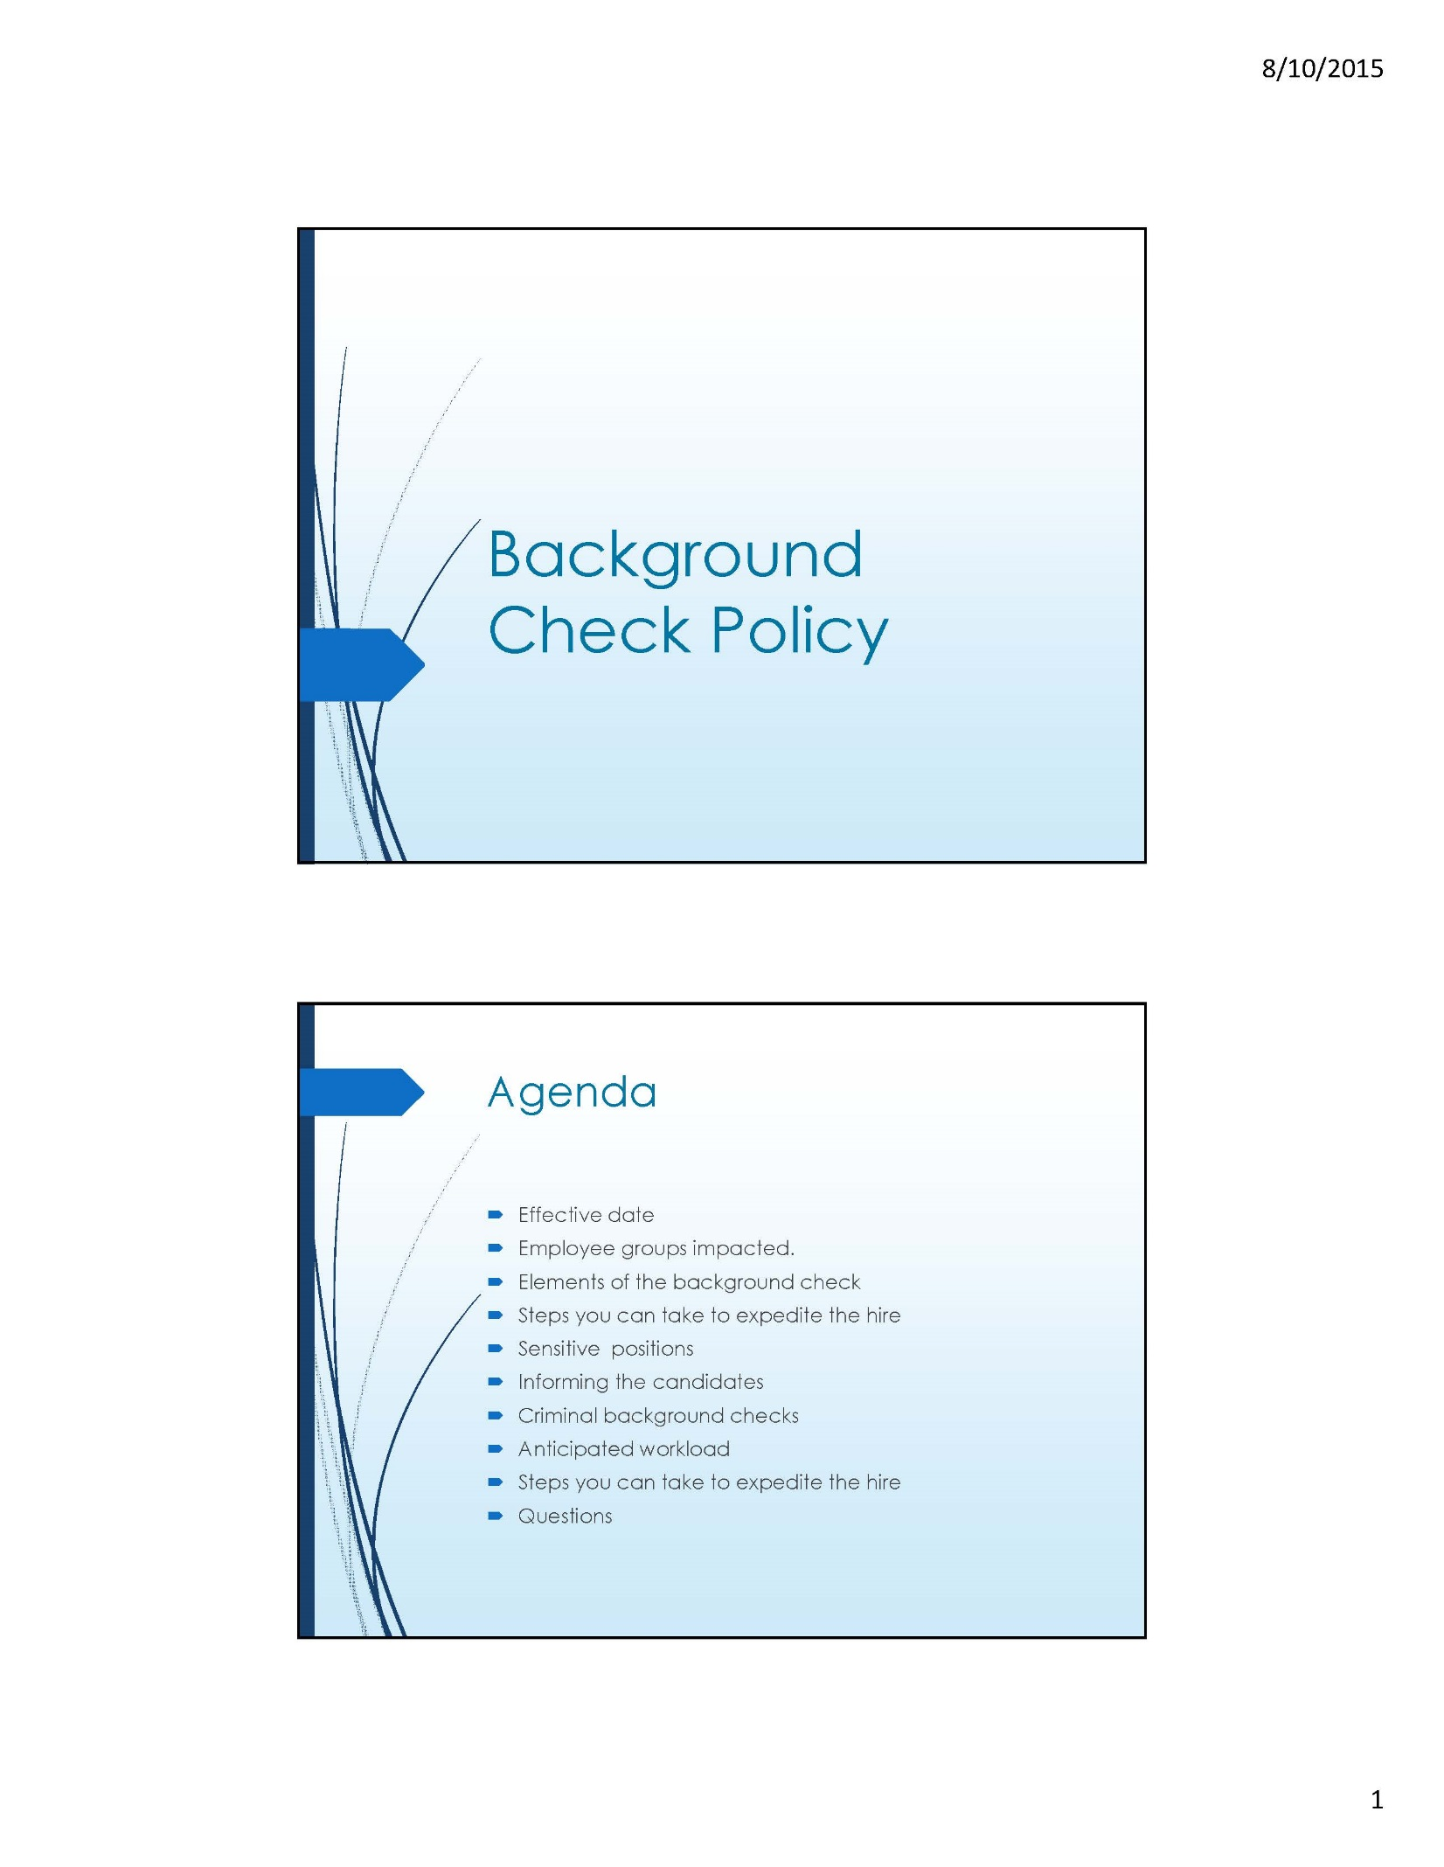
APPENDIX A
APPENDIX A
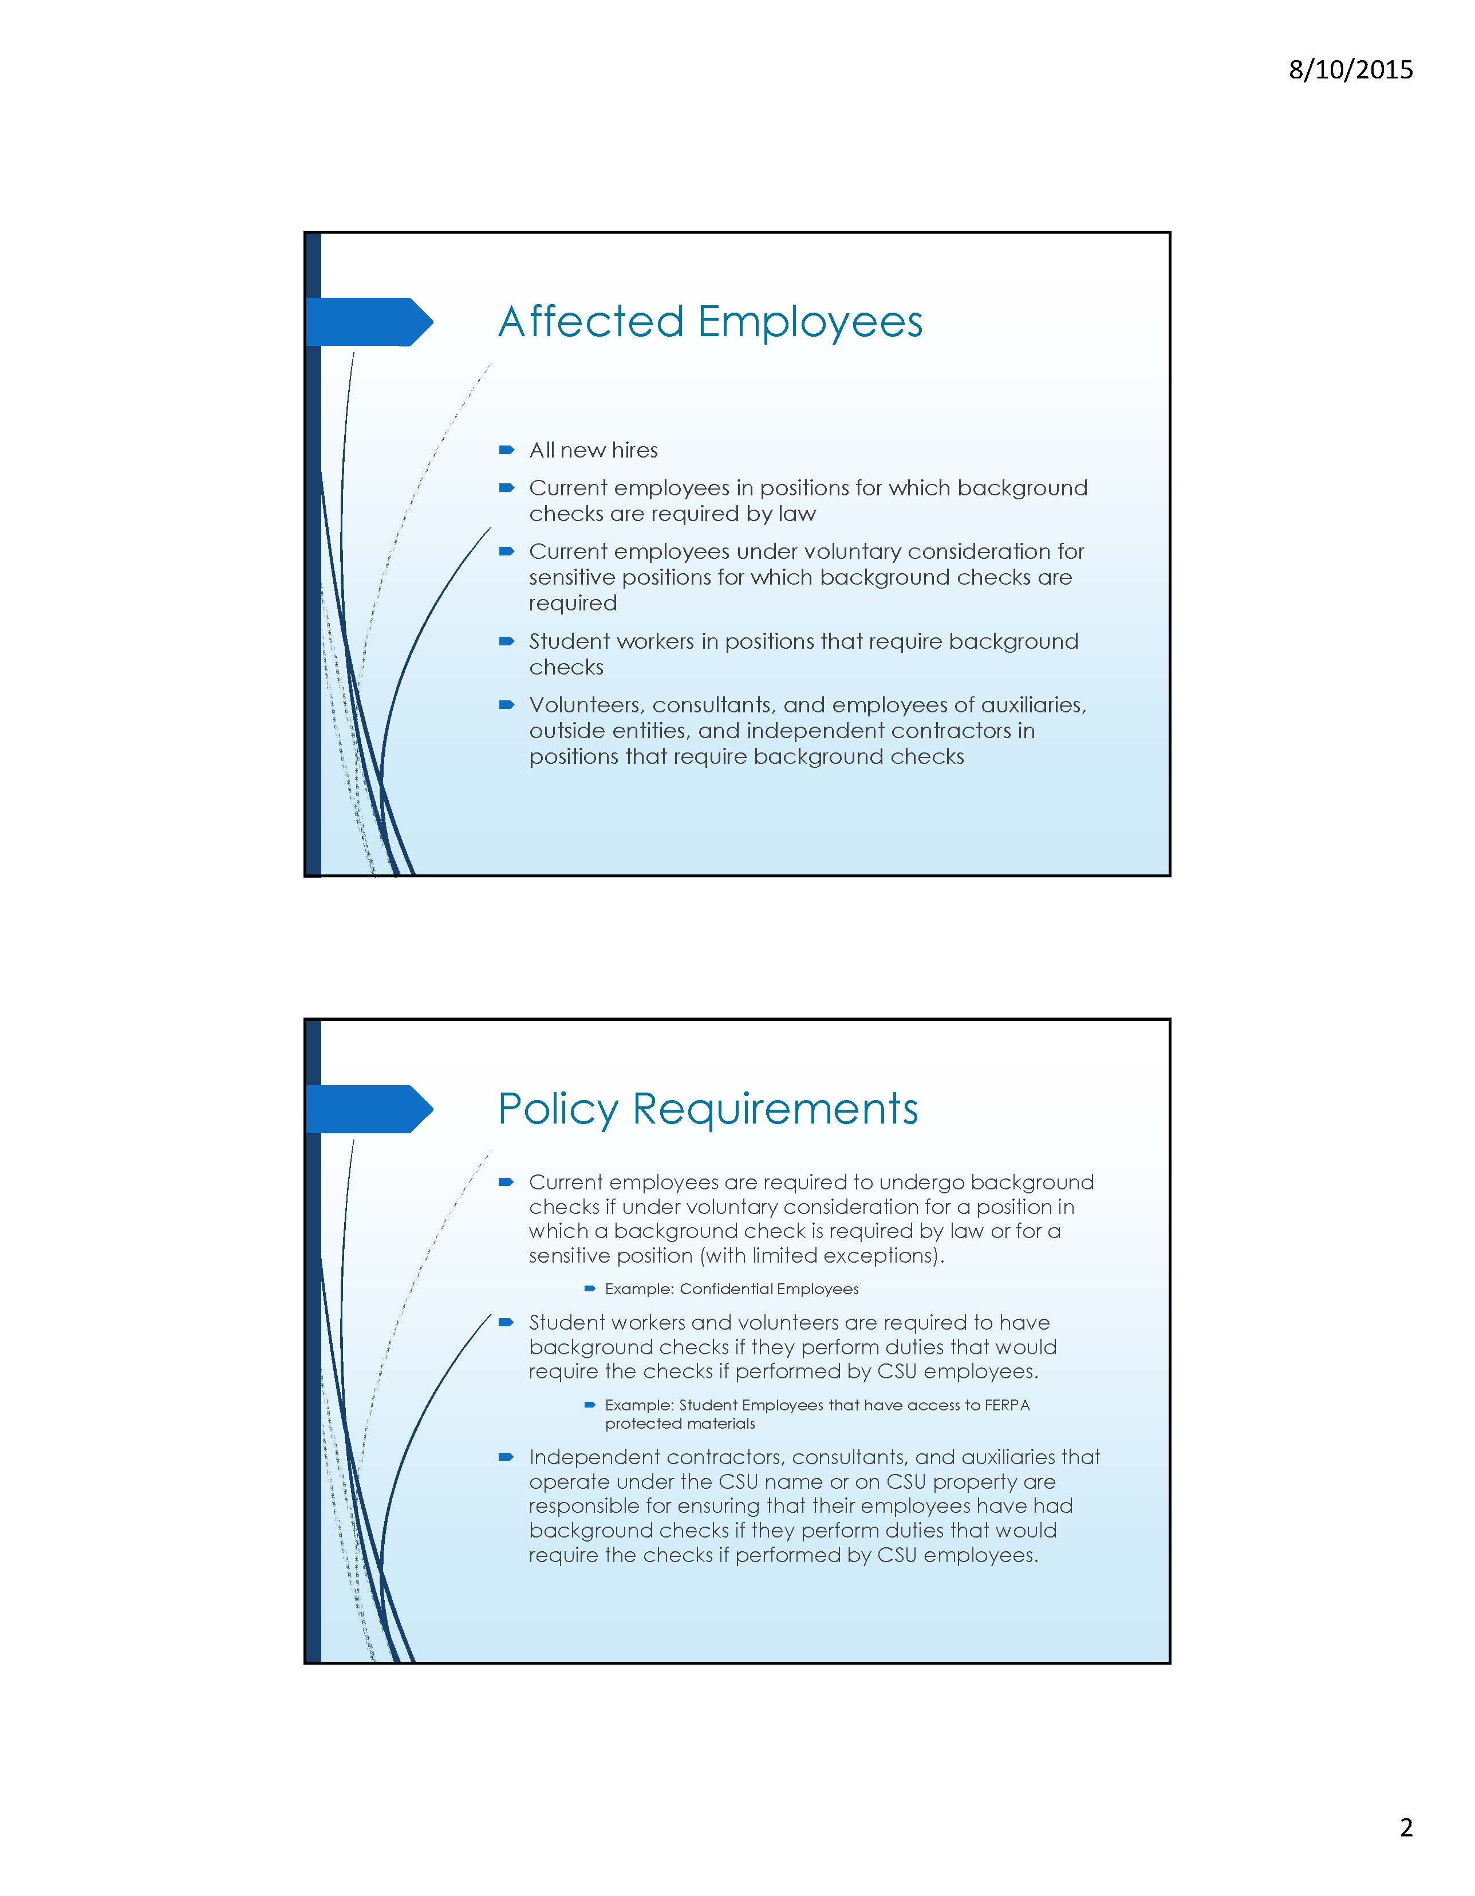
APPENDIX A
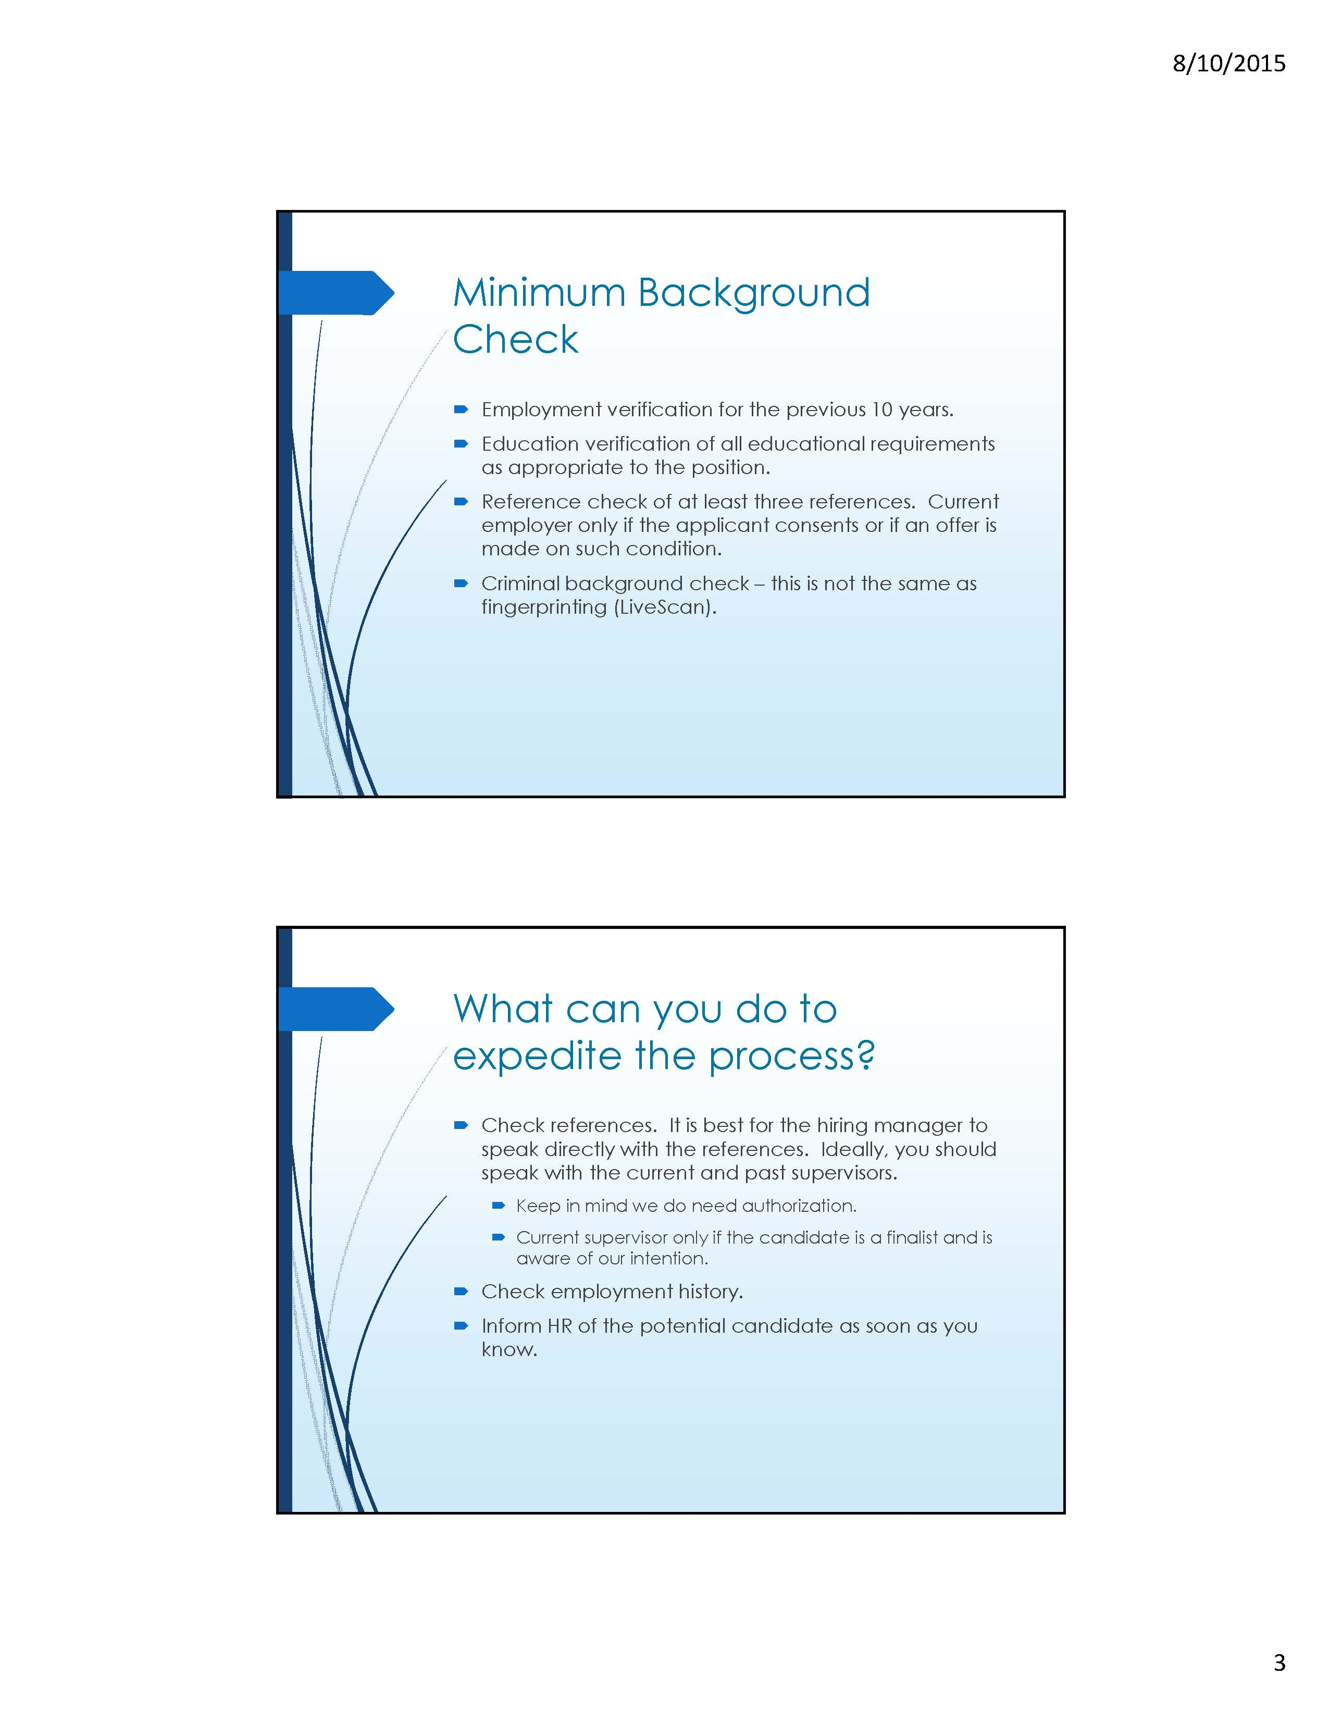
APPENDIX A
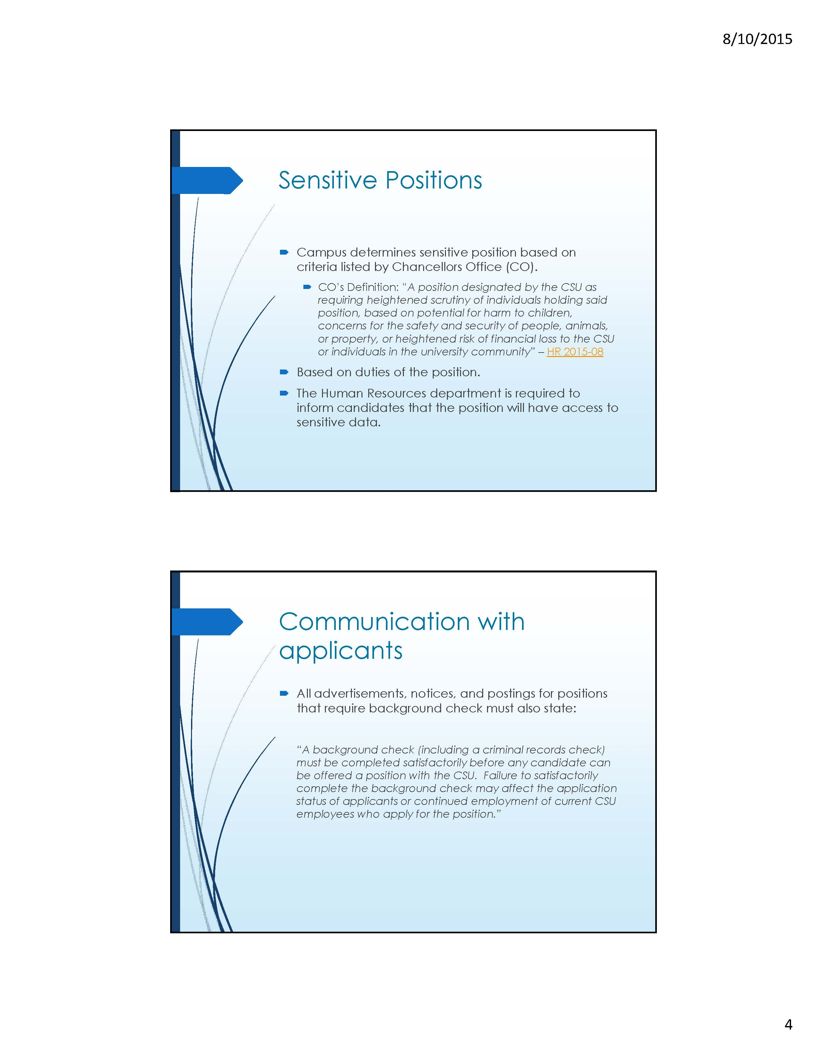
APPENDIX A
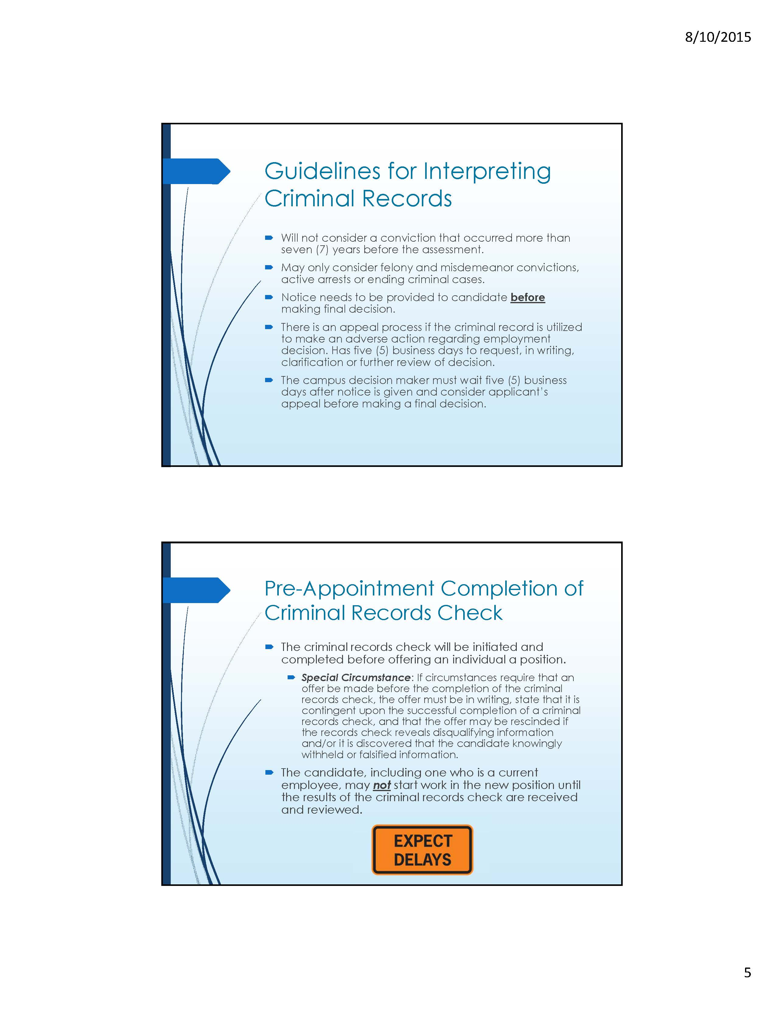
APPENDIX A
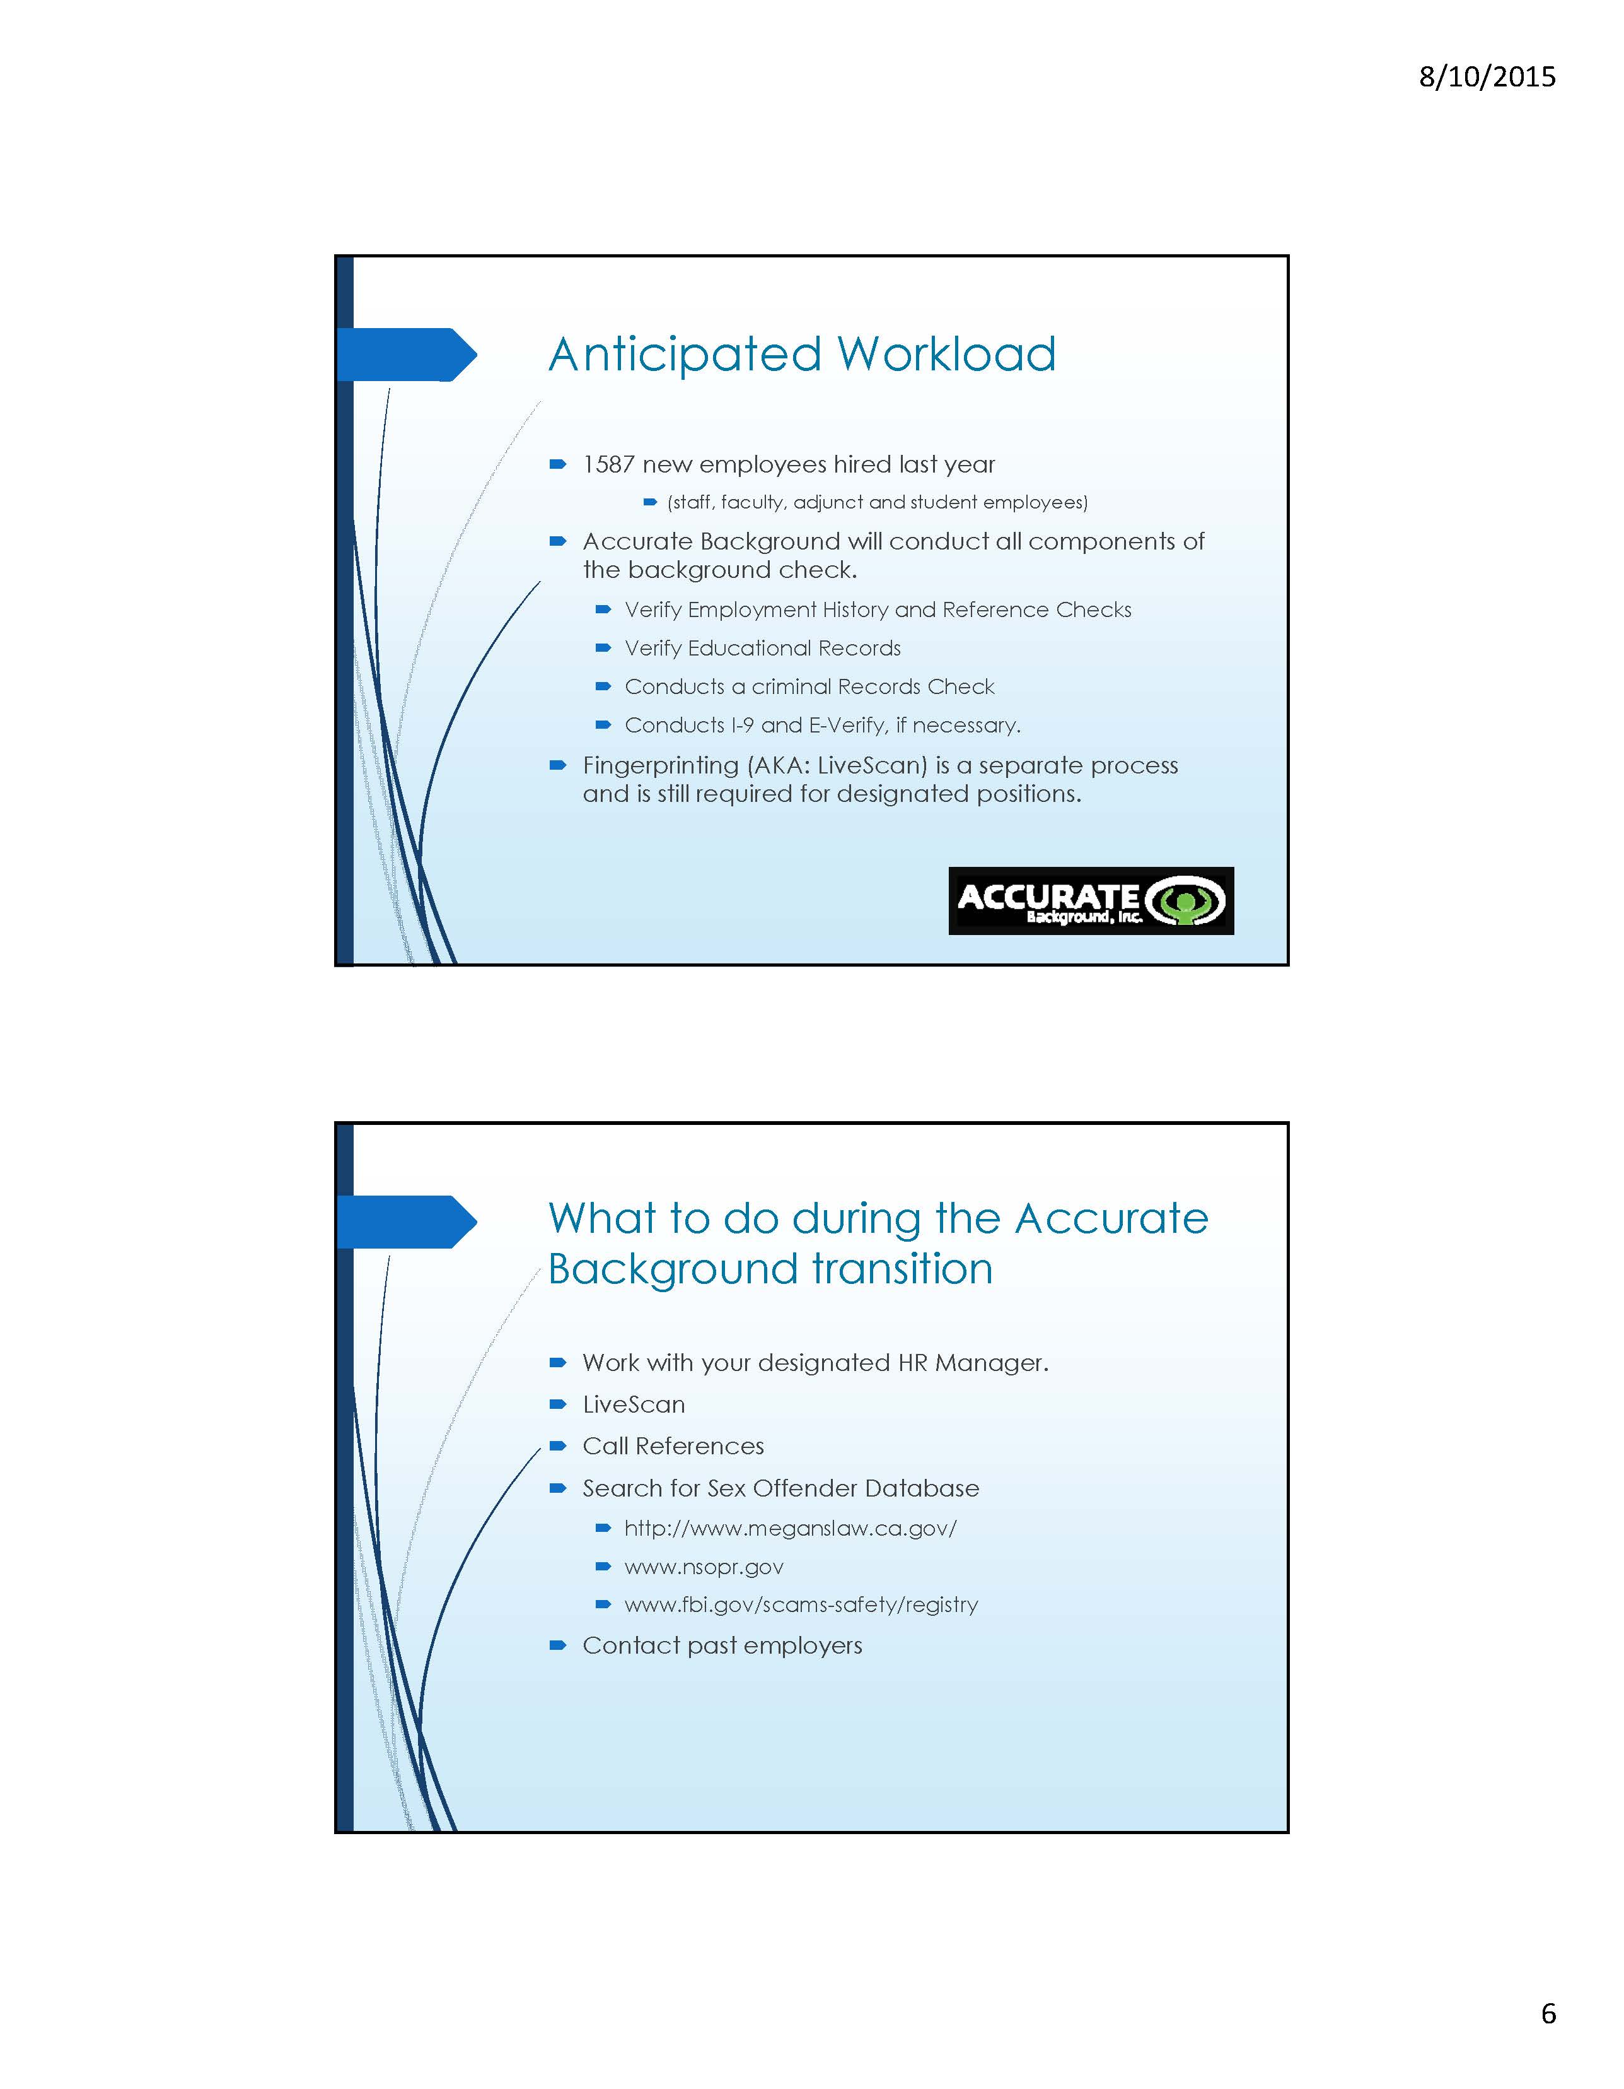
APPENDIX A
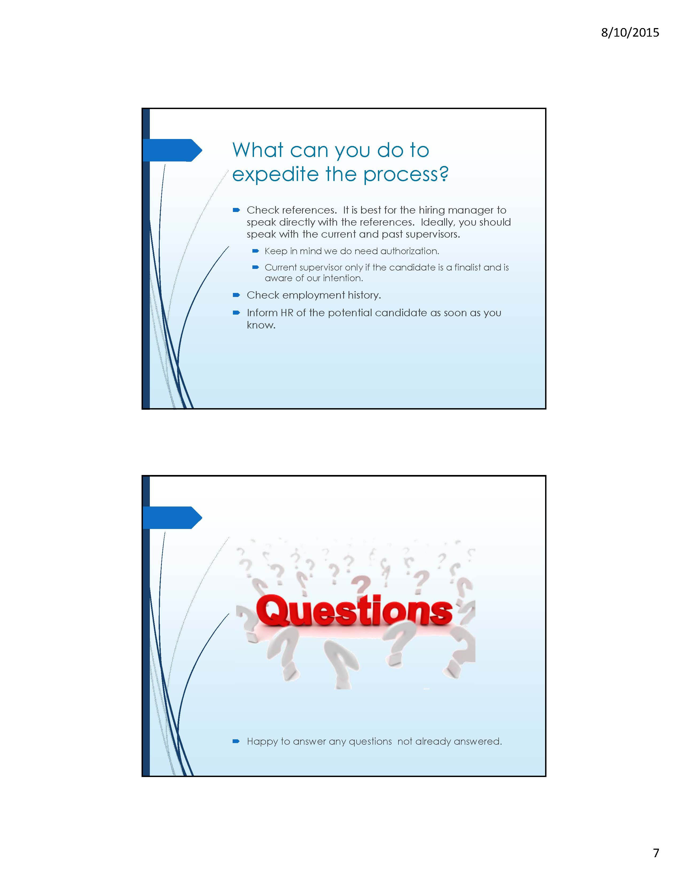
APPENDIX A
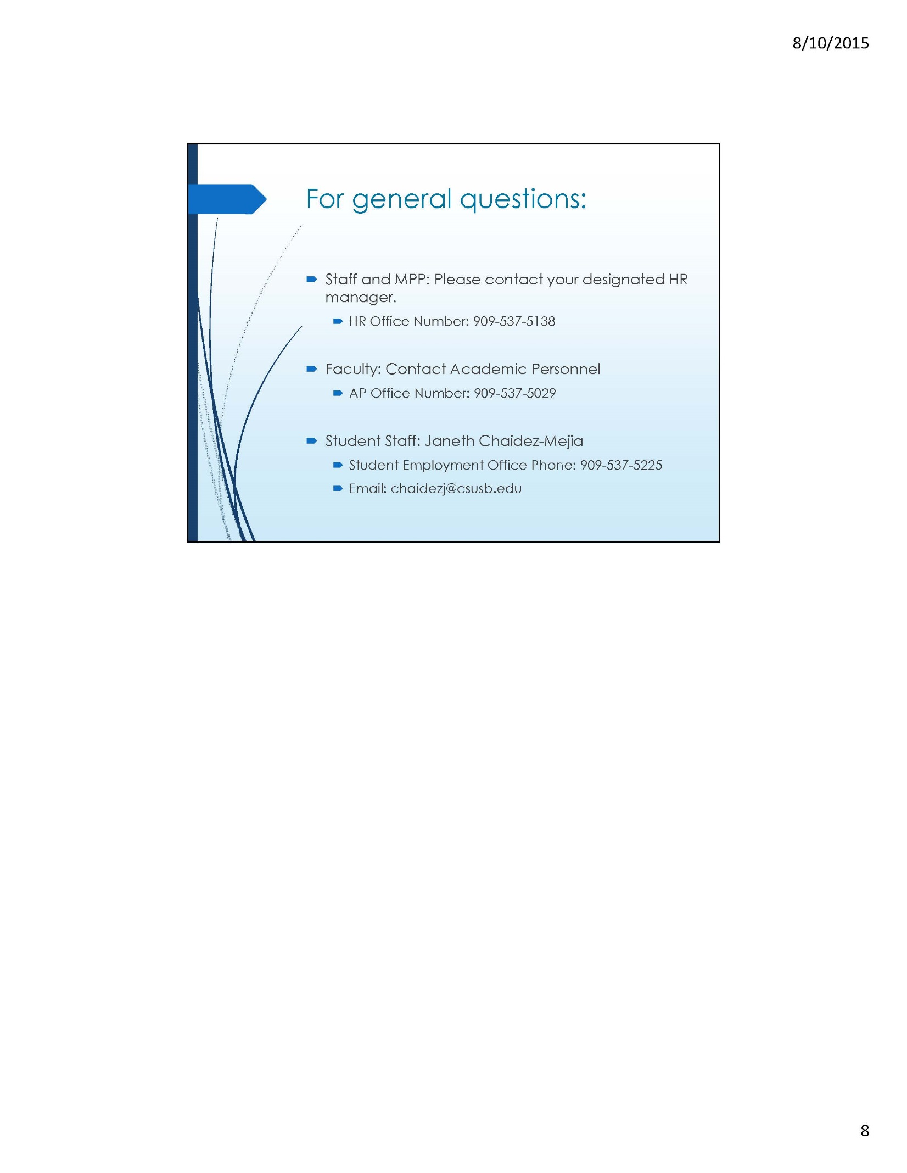
APPENDIX A
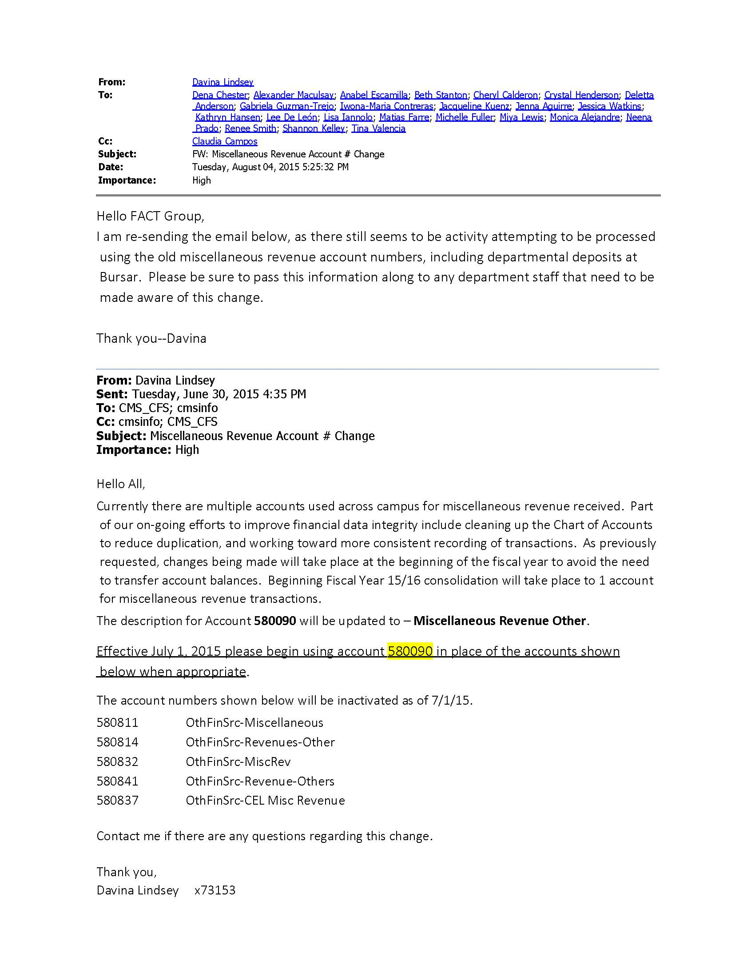
APPENDIX B
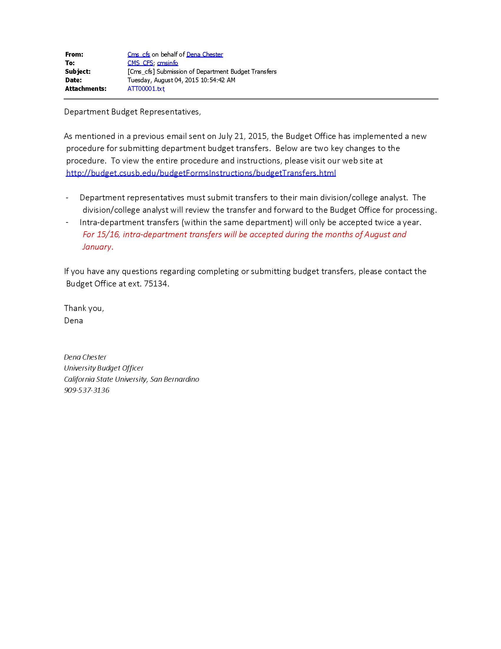
APPENDIX C

