Payment Lookup in Peoplesoft (CFS)

- CFS (Common Financial Systems) Navigation:
Navigator > Accounts Payable > Review Accounts Payable Info > Vouchers > Voucher

- Type in the correct Business Unit, followed by the Voucher ID, Invoice Number, Supplier Name, or PO ID. Click Search.
Use % (percent sign) as a wildcard to search and match on one or more characters. The % can be used at the beginning of a keyword, at the end of a keyword, or in between a keyword.
Examples:
- Document% — returns search results with words beginning with document, such as documents, documentary, documentation.
- %ment — returns search results with words ending in ment, such as department, management.
Note: if looking up a payment for SBASI, SBFDN, or SBSUN business unit, change the supplier SetID to SBFDN.

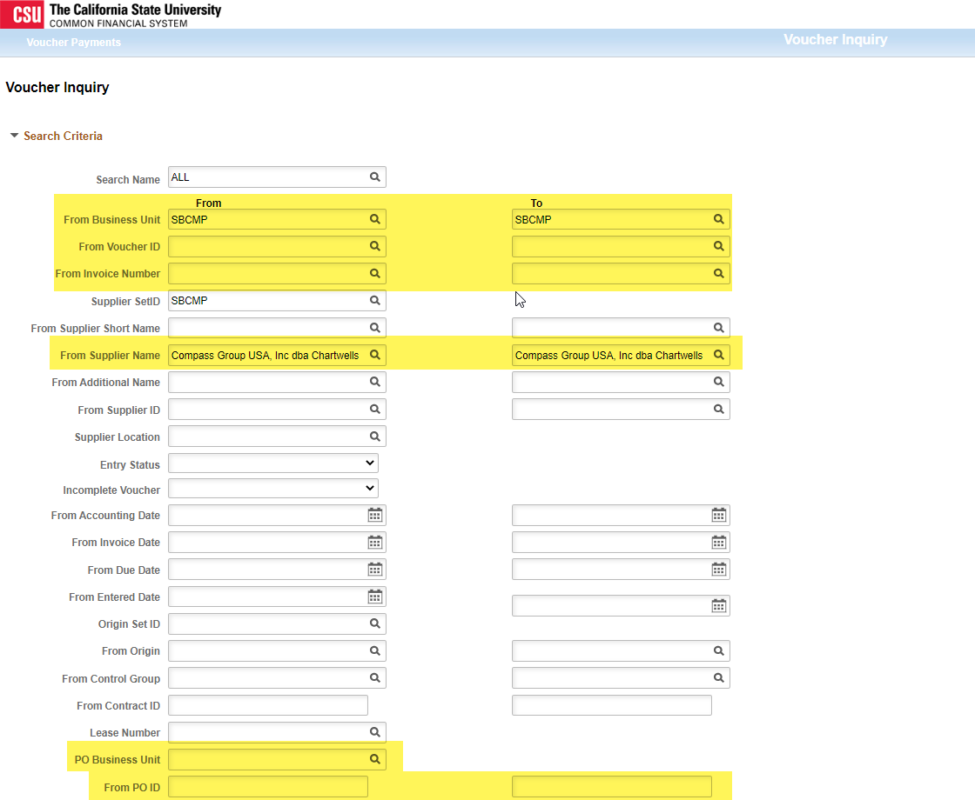

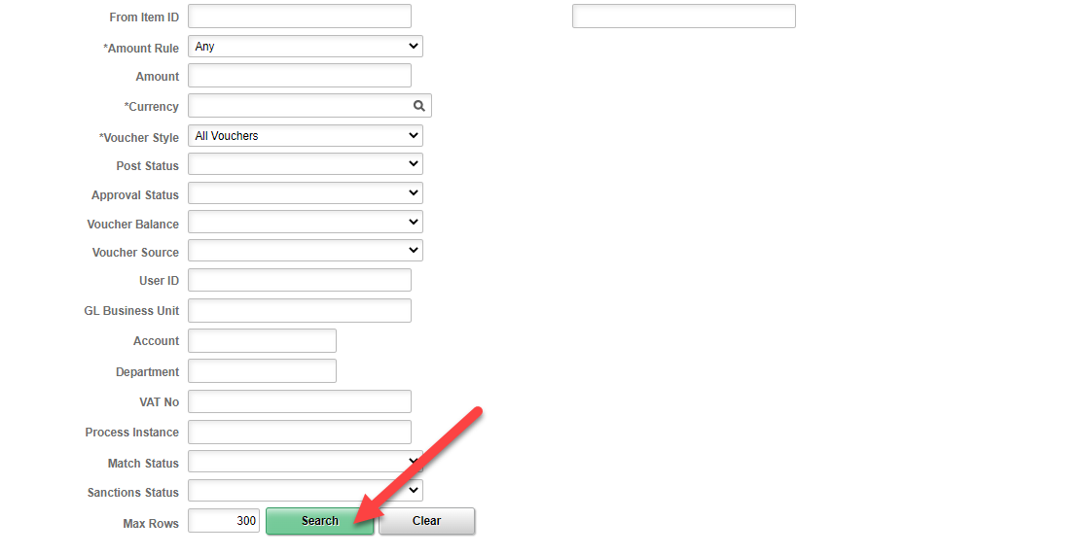

- Find the invoice in the list.

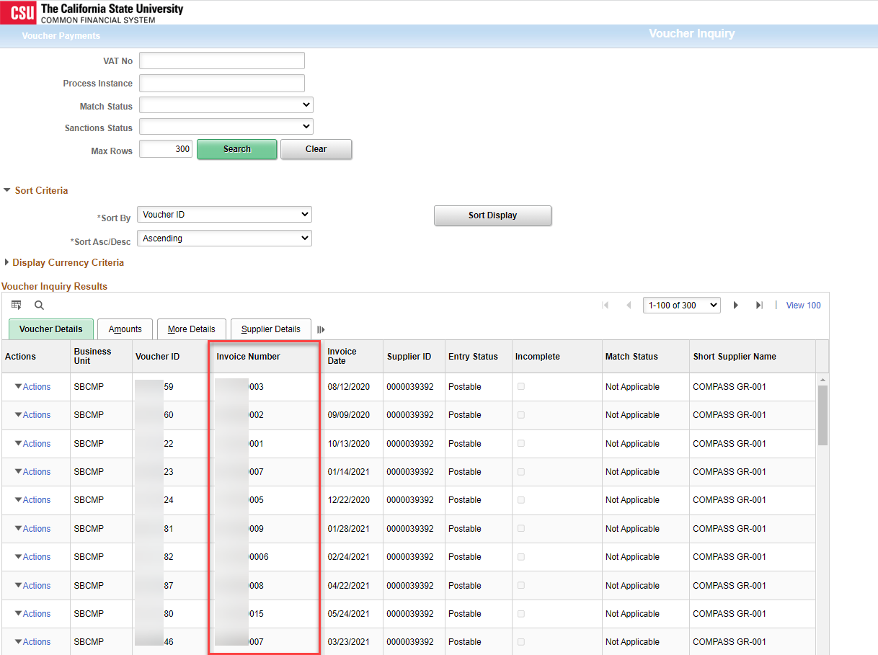

- Click on Actions.

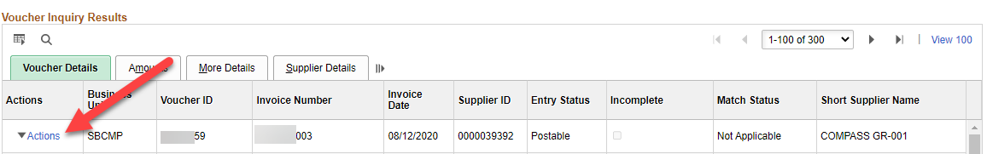

- Click on Payment Information.

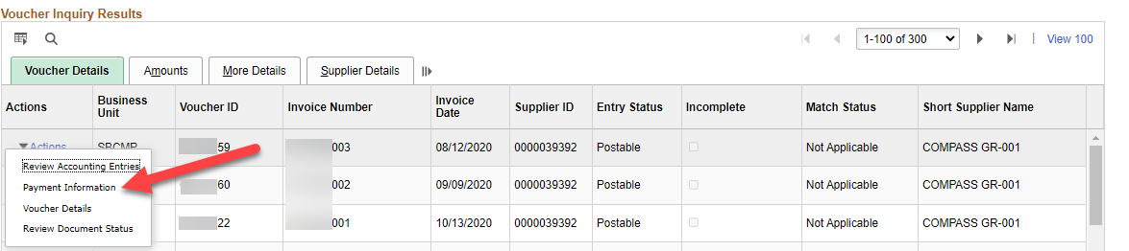

- The Payment Number (check number or EFT/ACH ID) and Payment Date is listed in the highlighted areas below.

