[Principles for Responsible Management Education - PRME Logo](http://www.unprme.org/index.php)

**A BIANNUAL YEARLY REPORT**

**COLLEGE OF BUSINESS & PUBLIC ADMINISTRATION ON PRME INITIATIVES**

**VOL. 1, ISSUE 1, 2012**

**____________________________________________________________________________________**

***CBPA & PRME***

**In Spring 2012, CBPA became a signatory to PRME—Principles for Responsible Management Education.**

***What is PRME?***

**The Principles for Responsible Management Education (PRME) initiative was launched in in 2007 as an initiative of six academic institutions (including AACSB International) and the United Nations Global Compact. The principles were created by an international taskforce of 60 deans, university presidents and official representatives of leading business schools and academic institutions. It is proposed that the CBPA become a signatory to PRME.**

***What Value does PRME Create for our Students*?**

**PRME seeks to establish a process of continuous improvement among institutions of management education in order to develop in our students, a new generation of business leaders. PRME's mission is to inspire and champion ethical and responsible management education, research, and thought for global leadership that takes into account the Triple Bottom Line of people, the planet and profits, in other words we endorse conscious capitalism.**

***How do we Implant PRME at CBPA?***

**We working toward the goal of embedding all PRME values into our Educational Value Chain:**

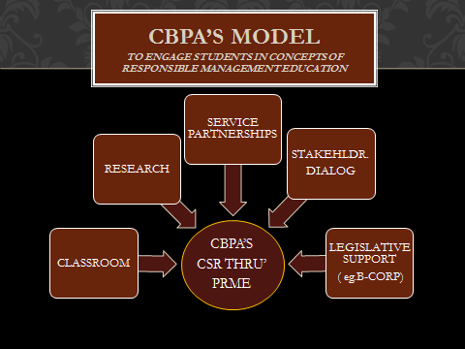

ANCHOR COURSE FOR PRME--MGMT 335

MGMT 335-Business & Society will have a name change to reflect more of the substantive ethics/corporate social responsibility content of this course. The curriculum committee has addressed this in consultation with faculty teaching the 335 course. A C-form change has been submitted to change MGMT 335,”*Business, Ethics, and Society.”*

**CSR Videos to Use in the Classroom**

**C:\Users\bcoates.CBPA\AppData\Local\Microsoft\Windows\Temporary Internet Files\Content.IE5\8Z2IJTKT\MC900295785[1].wmf**

**THE B-CORPORATION IS BORN IN CALIFORNIA!**

**VIDEO**

***The State of California Responds to Investor Demand for a New Type of Corporation, the B-Corp.* Video: http://www.youtube.com/watch?v=99vksspg2GI**

OTHER VIDEOS

“What is the Triple Bottom Line?” Video link: <http://www.youtube.com/watch?v=l5MPOuhmpmk>  
  
“Surprising Benefits for Green Business” Steve Pinetti Video link: <http://www.youtube.com/watch?v=SnBqj8EpQdc>  
  
“A Growing Market for Green Business” Video link: <http://www.youtube.com/watch?v=9zhDEn_ea9c&feature=relmfu>  
  
“Corporate Social Responsibility: The Responsibility Revolution" Video link: <http://www.youtube.com/watch?v=q3LQ2JOc8iE>  
  
“The Tomorrow’s Leader’s Group Speak about CSR” Video link: <http://www.youtube.com/watch?v=Xox7Z0Bq7jY>  
  
“Benefit Corporations Aim to make Profit, with Positive Community Impact” Video link: <http://www.youtube.com/watch?v=99vksspg2GI>

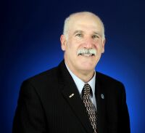

<http://youtu.be/zy3tuDoyabc>

***See Draft Video of Dean Rose speaking about the Principles—to be posted on the CBPA Intranet***

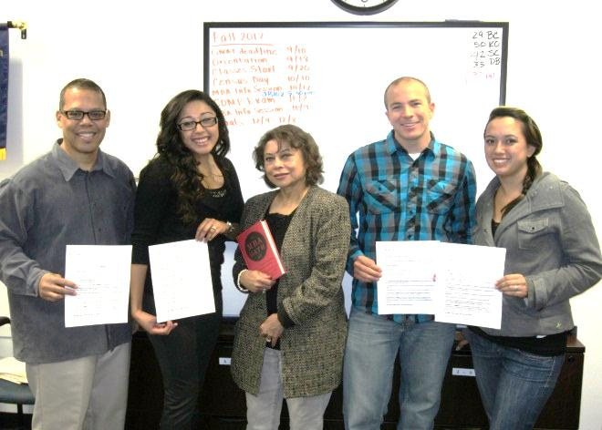

**CBPA MBA STUDENTS TAKE**

**AN OATH OF INTEGRITY**

*What is the MBA OATH?*

A widespread movement begun at Harvard University in 2009, has spread to Schools of Business around the globe. It is an pledge taken by MBA students to act with integrity to the principles of the Triple Bottom Line—people, the planet and profits. The Oath signifies a promise that our graduates will act with integrity and take a broader view of the firm from creating shareholder value alone to wider stakeholder values that involve economics, and ecology of human and environmental rights as well. The Oath is voluntary, but has gained extensive endorsement. A full text of the MBA OATH will be included separately on the PRME website.

Doctors have the Hi

CORPORATE SOCIAL RESPONSIBILITY—MBA Oath:

“In the post Enron and post Madoff era, the issue of ethics and corporate social responsibility has taken on greater urgency among students about to graduate. While this may easily be dismissed as a passing fancy—or simply a defensive reaction to the current business environment—business professors say that this is not the case… Those graduating today , they say, are far more concerned about how corporations can effect the community, the lives of workers, and the environment.” *The New York Times*

**RESPONSE FROM INVESTORS & STOCK MARKETS: **

**GREEN STOCK INDICES:**

Investment markets around the world have created numerous ways that fund managers, and individual investors can invest in Corporate Social Responsibility. There are many indices for speculating “green”, such as the FTSE Japan Green Chip 35 Index, of environmentally-linked stocks; others like the Dow Jones Dharma Index feature faith-based philosophies for social well-being : Some other examples can be found at:

Greenindex.com; Sustainable Business.com; Speculatinggreen.com; FTSE Japan Green Chip 35 Index

*Mark the Date!*

*More to Follow!*

[](javascript:void(0))

**CSUSB GRADUATE STUDIES**

**RESEARCH SYMPOSIUM**

February 27, 2013

PANEL ON CSR—FEATURING CBPA PANELISTS:

UNDERGRADUATE, GRADUATE, EMBA STUDENTS

[](javascript:void(0))

CALL for SUBMISSIONS to the PRME ARCHIVES

[](javascript:void(0))

Faculty: Published Papers/Books

Student: Papers

Depository in Room JB 214

(AACSB Room)

Send to Breena Coates, [bcoates@csusb.edu](mailto:bcoates@csusb.edu)