Accounts Payable Invoice Approval/Payment Process when using a Purchase Order

When Accounts Payable receives an invoice from a supplier/vendor, an Accounts Payable (AP) Technician will enter a voucher into Common Financial Solutions (CFS) PeopleSoft. If, at the time of data entry, the invoice references a Purchase Order number, the voucher is associated or linked to the related PO in CFS.
Invoices for goods that have been flagged as received by the Receiving Department are paid without any additional action by the requesting department. Invoices for services require validation/approval from the requesting department that services were rendered satisfactorily.
When Accounts Payable requires approval for an invoice, the AP Technician will email the department to communicate the need for such approval. The email will look like the following example (exact content may differ between each AP Tech).
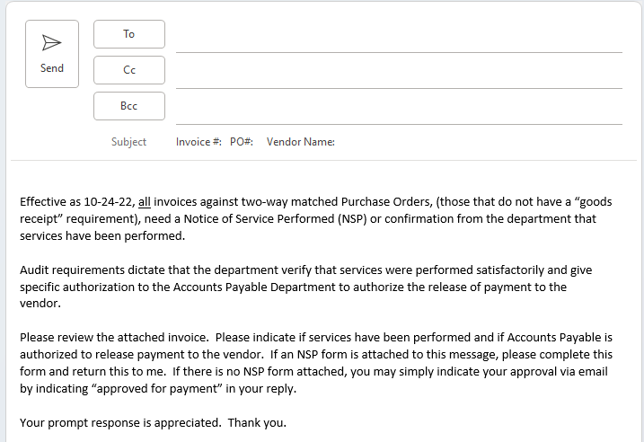

Actions to Approve Invoice

- PO for Services (2-Way PO):
All services require an approval from the department/end user in order for Accounts Payable to pay. This can be accomplished in one the following ways:
- Notice of Service Performed (NSP) form
- Email indicating “approved for payment” submitted by authorized approver
- Wet signature/Adobe Sign from authorized approver on invoice, printed name, and date

- PO for Goods – Receiving Required (3-Way PO):
Occasionally goods are shipped directly to a Campus Department and not to the Receiving dock. You will need to report the goods you have received to the Receiving Department so they can record this information in Peoplesoft. These are the steps:
- Send an email to the Receiving Department at this email address: receiving@csusb.edu
- In the email, provide the Purchase Order number for the invoice in question
- Indicate the line(s) on the PO for which goods were delivered to you and require the recording of a goods receipt in Peoplesoft
- Indicate the quantity or quantities you have received for each line

Important Note: Approval Email Subject Line Format

When sending approved invoices or payment requests to Accounts Payable be certain to follow the below email subject line format.
Business Unit – Vendor Name – Invoice Number (if applicable) – PO Number (if applicable)

Where to submit invoices:

All invoices should be emailed to payables@csusb.edu

